

**Network Infrastructure Penetration Testing Report**

Conducted by:

**Sure Trust**

Submitted by

Nadipena Varunkumar varunnadipena@gmail.com

Submitted to

Nishchay Gaba



NOTICE: The information provided in this document is CONFIDENTIAL

**Table of Contents**

1 Report Overview 2

1.1 Executive Summary 2

1.2 Engagement Overview 3

1.3 Scope of Engagement 3

2 Observations 5

2.1 Summary of Recommendations 6

2.2 Positive Security Measures 6

3 Testing Methodology 7

3.1 Penetration Testing Execution Standard 7

3.2 MITRE ATT&CK Framework 7

3.3 OWASP Top 10 7

3.4 PCI DSS Auditing 8

3.5 NIST SP 800-53 8

4 Technical Findings 10

4.1 Critical Risk 11

4.2 High Risk 27

4.3 Medium Risk 79

4.4 Low Risk 160

5 Conclusion 180

A Tools 182

## Report Overview

### Executive Summary

Sure Trust is a leading organization committed to delivering free educational courses to rural communities nationwide. In response to a growing and diverse enrollment base, it has become critical for Sure Trust to perform a comprehensive analysis of its enrollment data. This project is designed to uncover actionable insights regarding enrollment patterns, course preferences, and participant demographics, thereby enhancing the organization’s service delivery and operational efficiency.

The primary objective of this analysis is to utilize the enrollment data to fine-tune Sure Trust’s educational offerings to better align with the specific needs and aspirations of rural learners. By identifying key trends—such as peak enrollment periods by month and time of day, popular courses, and districts with the highest enrollment—Sure Trust will be better positioned to customize its programs effectively.

Key findings from the analysis include:

* **Enrollment Trends:** Notable spikes in enrollment during particular months and times of day suggest defined periods of high interest.
* **Demographic Insights:** Detailed understanding of the educational backgrounds and qualifications of enrolled students will support the development of tailored course content.
* **Regional Analysis:** Recognizing districts with high enrollment rates will inform future outreach strategies and expansion initiatives.

Expected outcomes from this initiative include practical recommendations for customizing courses, a detailed report on demographic trends, and a strategic roadmap for expanding educational offerings in high-potential regions. These insights will empower Sure Trust to make well-informed decisions that enhance its educational impact on rural communities.

### Engagement Overview

Sure Trust conducted a comprehensive penetration test for the target scope, comprising multiple public IP addresses, beginning on January 1, 2025, based on the provided Request for Proposal.

The engagement focused on the following objectives:

* **Assessment of Internally Developed and Customized Software Packages:**  
  Evaluating the security posture of in-house applications and custom software solutions.
* **Evaluation of Industrial Controls:**  
  Analyzing the security of industrial control systems within the storage, delivery, and packing warehouse facility.
* **Review of APIs:**  
  Assessing APIs related to payment, transaction, billing, and inventory processing systems to identify potential vulnerabilities.
* **Vulnerability Identification:**  
  Discovering weaknesses that could impact the confidentiality, integrity, and availability (CIA) of the information systems.
* **Enhancement of Security Posture:**  
  Providing actionable recommendations to improve the overall security posture of the target environment.
* **PCI-DSS Compliance Evaluation:**  
  Assessing the target’s security measures against the Payment Card Industry – Digital Security Standard (PCI-DSS).

This report consolidates the findings and recommendations derived from the penetration test to help improve the security posture and safeguard the critical systems.

### Scope of Engagement

Sure Trust conducted a comprehensive penetration test for the client on the designated public IP addresses beginning on January 2025. The engagement was executed using non-exploitative scanning techniques to ensure that all testing activities were confined strictly within the defined scope and that no services were disrupted. The public IP addresses tested were:

• 67.20.124.65  
• 191.82.121.191  
• 124.117.225.66  
• 185.146.86.135  
• 194.110.254.16  
• 103.23.227.37  
• 20.239.145.15  
• 102.212.121.116  
• 184.164.141.29  
• 106.225.244.11  
• 103.56.148.203  
• 47.108.37.191  
• 34.54.120.230  
• 185.216.120.11  
• 187.251.108.186  
• 144.217.240.87  
• 51.79.65.16  
• 198.245.53.101  
• 149.56.129.34  
• 184.74.137.227  
• 95.86.76.47  
• 207.148.103.159  
• 2.74.193.188  
• 105.235.122.97  
• 142.132.207.118  
• 219.94.189.215  
• 88.198.137.134  
• 5.135.137.222  
• 128.32.220.18  
• 2.152.66.8

The test was performed with extreme care to ensure that all activities remained within the defined scope, with no data exfiltration, modification, or deletion occurring during the engagement.

Sure Trust is committed to supporting the client in enhancing their security posture by assisting in the implementation of effective mitigation strategies and validating the security controls in place. We look forward to a continued partnership aimed at fortifying the client’s defenses and ensuring a robust and resilient security framework.

## Observations

This section provides a high-level overview of the security posture observed during the penetration test. Our assessment identified a diverse range of vulnerabilities across the tested public IP addresses. Notable issues include misconfigured and outdated SSL/TLS settings (e.g., expired certificates, use of weak ciphers, missing security headers, and incomplete certificate chains), insecure implementations (such as anonymous FTP access and exposed administrative interfaces), and several configuration weaknesses (including missing OCSP stapling, improper certificate key usage, and domain or hostname mismatches). Additionally, outdated software components (e.g., Python, Sendmail, and various web server platforms) and information disclosure issues (e.g., version disclosures and sensitive file exposures) were also detected. Although many of these vulnerabilities are rated as medium severity, they collectively contribute to a significantly weakened security posture. It is important to note that this list is not exhaustive, and additional vulnerabilities may exist that were not identified during the non-exploitative scanning phase of the engagement conducted by Sure Trust..

### Summary of Recommendations

The following is an overview of recommendations which should be implemented:

* Resolve any PCI DSS compliance violations in Section 2.3.1 and ensure that AEC is currently meeting all documentation requirements set by PCI DSS.
* Implement both ingress & egress filtering to reduce attack surface on hosts.
* Ensure all hosts use least privilege principals to reduce attack surface.
* Ensure proper encryption is used for confidential data (e.g. passwords and card holder data).
* Implementation of a strong password policy.
* Implement Multi-Factor authentication to provide defense in depth in addition to pass- words.
* Uses centralized logging to be able to respond to potential incidents faster.
* Ensure null or password-less authentication is not allowed.
* Ensure only necessary services are running within the subnet.

### Positive Security Measures

During the engagement, Sure Trust observed that several security best practices were effectively implemented, limiting lateral movement and reducing the risk of exploitation. Key measures included:

* Implementation of TLS on web services to secure data in transit.
* Proper configuration of Cross-Origin Resource Sharing (CORS) headers to prevent unauthorized cross-domain access.
* Enforcement of authentication on critical applications, such as the marketplace and music player.
* Restriction of API access through mandatory authentication for querying sensitive information.

These controls, as observed on the tested public IP addresses, contribute significantly to the overall security posture and should be continuously monitored and maintained to ensure ongoing protection against emerging threats.

## Testing Methodology

### Penetration Testing Execution Standard

Throughout the engagement New Haven Hacking Inc., references the Penetration Testing Execution Standard (PTES) when conducting security assessments [2].

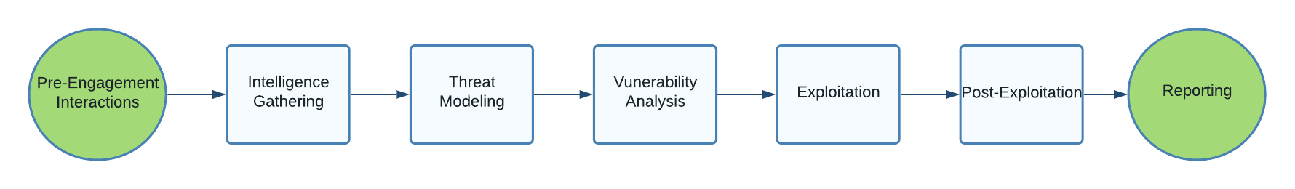

Figure 2: PTES Methodology

### MITRE ATT&CK Framework

MITRE ATT&CK is a knowledge base of Tactics, Techniques, and Procedures (TTPs) based upon real-world observations from security professionals. ATT&CK is a curated knowledge base for cyber adversary behavior, reflecting the attack lifecycle and platforms known to target. New Haven Hacking Inc. uses ATT&CK to aide in understanding TTPs that can be used to conduct an attack against AEC that could be conduct by real world adversaries [3].

### OWASP Top 10

Referenced in this report is the Open Web Application Security Project (OWASP) Top 10 when applications are found within the applicable scope [4]. OWASP Top 10 focuses vulner- abilities focus on common vulnerabilities that pose security risks to web applications:

Table 2: OWASP Top 10

|  |  |
| --- | --- |
| 1. Broken Access Controls | 6. Vulnerable and Outdated Components |
| 2. Cryptographic Failures | 7. Identification and Authentication Failures |
| 3. Injection | 8. Software and Data Integrity Failures |
| 4. Insecure Design | 9. Security Logging and Monitoring Failures |
| 5. Security Misconfiguration | 10. Server-Side Request Forgery |

### PCI DSS Auditing

One of the requests of AEC was for experience in PCI DSS from the RFP. Throughout the engagement, New Haven Hacking Inc. audited PCI DSS compliance in accordance with the proper Self-Assessment Questionnaire (SAQ). By doing this, New Haven Hacking Inc. can ensure which PCI DSS security requirements are met in accordance with the proper SAQ for the type(s) of transactions being performed by AEC. Each PCI DSS compliance failure can be found in Section 2.3.1.

### NIST SP 800-53

NIST SP 800-53 is the National Institute of Standards and Technology Special Publication 800-53, Security and Privacy Controls for Federal Information Systems and Organization. NIST 800-53 is a security compliance standard that offers guidance for how organizations should select then maintain security and privacy controls for information systems. NIST 800-53 is mandatory for all federal agencies however, its guidelines can be adopted by any organization operating information systems with sensitive or regulated data. This standard provides a catalog of privacy and security controls for protecting against various threats.

Table 3 provides security and privacy control methodology which are organized into 20 fami- lies. These control families are referenced throughout the document and are used to constitute common terminology. Additionally, referenced in NIST 800-53 is control families enhance- ments to help provide guidance to aide in securing AEC’s information systems [5].

Table 3: NIST 800-53 Security and Privacy Control Families for Compliance.

|  |  |  |  |
| --- | --- | --- | --- |
| **ID** | **Family** | **ID** | **Family** |
| **AC** | Access Control | **PE** | Physical and Environmental Protec-  tion |
| **AT** | Awareness and Training | **PL** | Planning |
| **AU** | Audit and Accountability | **PM** | Program Management |
| **CA** | Assessment, Authorization, Monitor-  ing | **PS** | Personnel Security |
| **CM** | Configuration Management | **PT** | PII Processing and Transparency |
| **CP** | Contingency Planning | **RA** | Risk Assessment |
| **IA** | Identification and Authentication | **SA** | System & Services Acquisition |
| **IR** | Incident Response | **SC** | System & Communications Protec-  tion |
| **MA** | Maintenance | **SI** | System & Information Integrity |
| **MP** | Media Protection | **SR** | Supply Chain Risk Management |

## Technical Findings

This table shows the total number of vulnerabilities found during the penetration test engagement. The vulnerabilities are categorized based on the risk level. The risk levels were calculated using the Common Vulnerability Scoring System (CVSS) .

**Risk Level and Total Number of Discovered Vulnerabilities**

|  |  |  |  |  |
| --- | --- | --- | --- | --- |
| Severity | Low (0.1-3.9) | Medium (4.0-6.9) | High (7.0-8.9) | Critical (9.0-10.0) |
| Vulnerability Count | 28 | 41 | 28 | 8 |

### Critical Risk

* + 1. **SSLv2 and DROWN   
       Threat Level**: **Critical (9.8)**

**Description**:

The target server supports SSLv2, which makes it vulnerable to the DROWN attack. This vulnerability allows attackers to exploit the outdated and insecure SSLv2 protocol to potentially decrypt TLS sessions and intercept sensitive data..

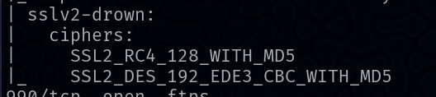

**Potential Business Impact**:

Exploitation of this vulnerability can lead to the decryption of confidential communications, resulting in data breaches, exposure of credentials, and other sensitive information. This could have severe consequences, including financial losses and reputational damage.

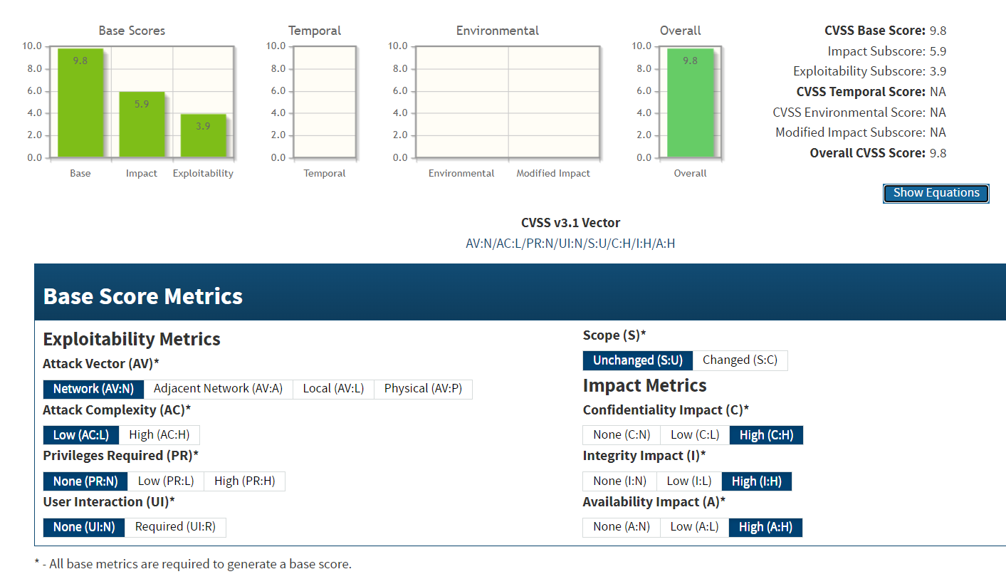**CVSS 3.1 Score**

**Affected Host**:

* 20.239.145.15:443
* 20.239.145.15:80

**Exploitation Details**:

An attacker can leverage the SSLv2 support to conduct a DROWN attack, potentially decrypting intercepted TLS traffic and compromising secure communications.

**Recommended Remediation**:

* **Disable SSLv2:** Reconfigure the server to disable support for SSLv2 and ensure that only secure protocols (e.g., TLS 1.2 or higher) are enabled.
* **Mitigate DROWN:** Confirm that no services are inadvertently supporting SSLv2 that could facilitate the DROWN attack.
* **Regularly Update and Patch:** Keep all cryptographic libraries and server configurations updated to prevent similar vulnerabilities.

**CVE IDs:**

* CVE-2020-28007

**References**:

<https://www.cvedetails.com/cve/CVE-2020-28007/>

<https://blog.qualys.com/vulnerabilities-threat-research/2021/05/04/21nails-multiple-vulnerabilities-in-exim-mail-server>

* + 1. **Outdated Exim Version  
       Threat Level**: **Critical (9.8)**

**Description**:

The mail server is running an outdated version of Exim, which is vulnerable to multiple issues identified by CVE-2020-28007, CVE-2020-28008, and CVE-2020-28017. These vulnerabilities could allow attackers to execute arbitrary code, gain unauthorized access, or disrupt mail services, posing a significant risk to the confidentiality, integrity, and availability of the system.



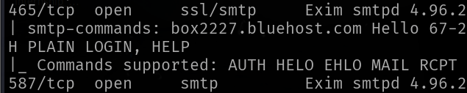

**Potential Business Impact**:

Exploitation of these vulnerabilities can lead to unauthorized control over the mail server, resulting in data breaches, unauthorized email relaying, or service disruptions. Such incidents may incur reputational damage and financial loss.

**CVSS 3.1 Score**



**CVE IDs:**

* CVE-2020-28007
* CVE-2020-28008
* CVE-2020-28017

**Affected Host**:

* 67.20.124.65:26
* 67.20.124.65:465
* 67.20.124.65:587
* 185.146.86.135:26
* 185.146.86.135:465
* 185.146.86.135:587

**Exploitation Details**:

Attackers can exploit the vulnerabilities by sending carefully crafted commands to the Exim server, potentially leading to remote code execution, unauthorized data access, or service disruption:

**Recommended Remediation**:

* **Update Exim:** Immediately upgrade to the latest version that addresses these vulnerabilities.
* **Secure Configuration:** Review and tighten Exim configurations to minimize exposure.
* **Monitoring:** Continuously monitor mail server logs for any signs of malicious activity.
* **Adhere to Best Practices:** Follow vendor security advisories and implement industry-standard security measures.

**References**:

<https://www.qualys.com/2021/05/04/21nails/21nails.txt>

<https://nvd.nist.gov/vuln/detail/cve-2020-28007>

<https://cve.mitre.org/cgi-bin/cvename.cgi?name=CVE-2020-28008>

<https://its.ny.gov/2021-064>

* + 1. **Outdated Windows Operating System  
       Threat Level**: **Critical (9.8)**

**Description**:

The target system is running Windows 7 or Windows Server 2008 R2 (version 6.1.7601), which is outdated and no longer supported by Microsoft. This makes the system vulnerable to multiple known exploits, including the BlueKeep vulnerability (CVE-2019-0708), which allows remote code execution without user interaction.

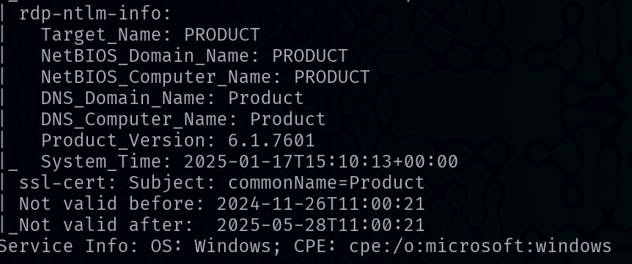

**Potential Business Impact**:

If exploited, this vulnerability could allow attackers to execute arbitrary code remotely, potentially leading to complete system compromise, data breaches, and significant disruption of business operations. The high severity of the vulnerability indicates a pressing need for remediation to avoid costly security incidents.

**CVSS 3.1 Score**

**CVE IDs:**

* CVE-2019-0708

**Affected Host**:

* 194.110.254.16

**Exploitation Details**:

An attacker may leverage vulnerabilities in the outdated Windows operating system, using CVE-2019-0708, to remotely execute code without authentication. This can result in unauthorized access, control over the system, and further exploitation within the network.

**Recommended Remediation**:

* **Update the Operating System**: Immediately upgrade to a supported and secure version of Windows that addresses the vulnerability.
* **Patch Management**: Apply all relevant security patches provided by Microsoft to remediate known vulnerabilities.
* **Network Segmentation**: Implement network segmentation to limit the potential impact of a compromised host.
* **Monitoring and Alerts**: Enhance monitoring of system activity to detect any anomalous behavior indicating exploitation attempts.

**References**:

<https://cve.mitre.org/cgi-bin/cvename.cgi?name=CVE-2019-0708>

<https://nvd.nist.gov/vuln/detail/cve-2019-0708>

* + 1. **HikVision Camera Control Service Exposure  
       Threat Level**: **Critical (9.8)**

**Description**:

The HikVision Camera Control Service is exposed on the affected IP addresses, allowing potential unauthorized access and control over camera functions. This exposure is linked to vulnerabilities identified as CVE-2017-7921 and CVE-2021-3626. An attacker may exploit the improper authentication mechanisms in these devices to escalate privileges or manipulate device configurations, thereby compromising the confidentiality and integrity of surveillance data..



**Potential Business Impact**:

Exploitation can lead to unauthorized control of camera functions, enabling attackers to view, modify, or disable surveillance feeds. Such compromise can result in severe privacy breaches, loss of sensitive information, and disruption of security operations, potentially exposing organizations to regulatory fines and reputational damage.

**CVSS 3.1 Score**

**CVE IDs:**

* CVE-2017-7921
* CVE-2021-3626

**Affected Host**:

* 102.212.121.116:9001
* 102.212.121.116:9002

**Exploitation Details**:

Attackers can target the exposed camera control service by leveraging the identified vulnerabilities. By bypassing authentication (as seen in CVE-2017-7921) or exploiting additional weaknesses (as noted in CVE-2021-3626), malicious actors could remotely execute unauthorized commands or access sensitive camera data.

**Recommended Remediation**:

* **Patch and Update Firmware**: Immediately update the camera firmware to the latest version that addresses these vulnerabilities.
* **Restrict Network Access**: Implement network segmentation and firewall rules to restrict access to the camera control service, ensuring it is not directly accessible from untrusted networks.
* **Enhance Authentication Controls**: Reconfigure the device settings to enforce strong authentication mechanisms and disable any unnecessary services.
* **Conduct Regular Security Audits**: Periodically review and test device configurations and network exposures to detect and remediate vulnerabilities.

**References**:

<https://www.cisa.gov/news-events/ics-advisories/icsa-17-124-01>

<https://nvd.nist.gov/vuln/detail/CVE-2021-3626>

<https://nvd.nist.gov/vuln/detail/cve-2017-7921>

* + 1. **BlueKeep  
       Threat Level**: **Critical (9.8)**

**Description**:

BlueKeep is a critical remote code execution vulnerability in Microsoft’s Remote Desktop Services (RDP) that allows an unauthenticated attacker to send specially crafted requests to the RDP service, potentially leading to full system compromise without any user interaction. Exploitation could facilitate wormable propagation across vulnerable systems, significantly increasing the risk of large-scale network intrusions.

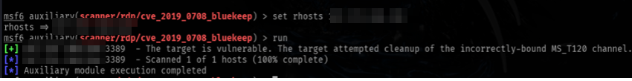

**Potential Business Impact**:

If exploited, BlueKeep can lead to unauthorized access, data breaches, and disruption of critical services. The ability to execute code remotely could allow attackers to pivot within the network, install malware, or launch further attacks, thereby exposing organizations to significant operational and financial risks.

**CVSS 3.1 Score**



**CVE IDs:**

* CVE-2019-0708

**Affected Host**:

* 187.251.108.186:3389

**Exploitation Details**:

An attacker can exploit this vulnerability by sending malicious RDP requests to the target system, bypassing authentication mechanisms. This may enable them to execute arbitrary code, gain administrative control, and propagate the attack to other systems within the network.

**Recommended Remediation**:

* **Apply Security Patches**: Immediately install the latest patches released by Microsoft to remediate BlueKeep.
* **Restrict RDP Access**: Disable RDP if not needed or restrict access via firewalls and network segmentation.
* **Enhance Monitoring**: Implement robust monitoring for unusual RDP activity and intrusion detection systems to identify potential exploitation attempts.

**References**:

<https://nvd.nist.gov/vuln/detail/CVE-2019-0708>

<https://msrc.microsoft.com/update-guide/vulnerability/CVE-2019-0708>

<https://cve.mitre.org/cgi-bin/cvename.cgi?name=CVE-2019-0708>

* + 1. **phpMyAdmin Local File Inclusion  
       Threat Level**: **Critical (9.8)**

**Description**:

A PHP file inclusion vulnerability exists in phpMyAdmin 2.6.4 and 2.6.4-pl1 due to insufficient sanitization in the file grab_globals.lib.php. The flaw allows remote attackers to include local files by manipulating the $__redirect parameter (possibly via the subform array), which could lead to exposure of sensitive system files and configuration details.

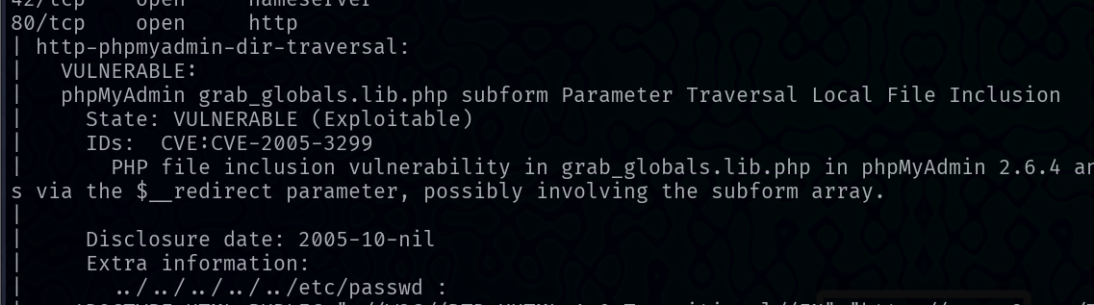

**Potential Business Impact**:

Exploitation of this vulnerability may allow an attacker to read critical files (such as configuration files, password files, etc.), leading to further compromise of the affected system. Sensitive data disclosure and potential remote code execution can result in unauthorized access and significant disruption of services.

**CVSS 3.1 Score**



**CVE IDs:**

* CVE-2005-3299

**Affected Host**:

* 207.148.103.159:80

**Exploitation Details**:

An attacker can remotely craft a URL or POST request that leverages the insecure 'subform' parameter to include arbitrary local files. This may allow disclosure of system files, escalating the overall risk profile of the target environment.

**Recommended Remediation**:

* **Upgrade phpMyAdmin**: Immediately update to phpMyAdmin version 2.6.4-pl2 or later where the vulnerability has been addressed.
* **Input Validation**: Implement strict input validation and sanitization for parameters used in file inclusion routines.
* **Access Controls**: Restrict external network access to the phpMyAdmin interface to limit exposure.

**References**:

<https://nvd.nist.gov/vuln/detail/CVE-2005-3299>

<https://www.flexera.com/products/security/software-vulnerability-research/secunia-research?referrer=secunia>

<https://www.phpmyadmin.net/security/PMASA-2005-4/>

* + 1. **Open MySQL Database (No Authentication Detected)  
       Threat Level**: **Critical (9.8)**

**Description**:

The affected MySQL server is vulnerable to an authentication bypass flaw identified as CVE-2012-2122. Due to improper validation in the authentication process, remote attackers can send specially crafted authentication requests to bypass the login mechanism and gain unauthorized access to the MySQL database. This vulnerability can be exploited without valid credentials, compromising the confidentiality, integrity, and availability of the database.

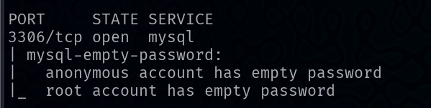

**Potential Business Impact**:

Exploitation of this vulnerability can lead to unauthorized access to sensitive data stored in the database, potential data manipulation, and lateral movement within the network. This may result in data breaches, loss of customer trust, regulatory non-compliance, and significant financial repercussions.

**CVSS 3.1 Score**



**CVE IDs:**

* CVE-2012-2122

**Affected Host**:

* 207.148.103.159:3306

**Exploitation Details**:

An attacker can exploit this flaw by sending a crafted authentication packet that bypasses the normal password verification process. Once inside, the attacker gains administrative access to the MySQL database, potentially leading to further system compromise.

**Recommended Remediation**:

* **Patch and Update**: Immediately apply the vendor-supplied patch or upgrade to a MySQL version that addresses CVE-2012-2122.
* **Network Segmentation**: Restrict access to the MySQL port using firewalls or network segmentation to limit exposure to trusted hosts only.
* **Strong Authentication**: Enforce additional authentication measures and regularly audit database access controls.
* **Monitoring**: Implement continuous monitoring and logging of database activities to detect and respond to any suspicious access attempts.

**References**:

<https://nvd.nist.gov/vuln/detail/CVE-2012-2122>

<https://dev.mysql.com/doc/relnotes/mysql/5.6/en/news-5-6-21.html>

<https://www.oracle.com/security-alerts/cpuoct2020.html>

* + 1. **JBoss JMX Console Authentication Bypass  
       Threat Level**: **Critical (9.8)**

**Description**:

The JMX Console web application in JBoss Application Server is vulnerable to an authentication bypass flaw, identified as CVE-2010-0738. This vulnerability arises because the JMX console enforces access control only for GET and POST requests, allowing attackers to bypass authentication by using alternative HTTP methods (such as HEAD). Exploitation can lead to arbitrary code execution in the context of the JBoss server, compromising system confidentiality, integrity, and availability.



**Potential Business Impact**:

Exploitation of this vulnerability may enable an attacker to execute arbitrary code on the affected system, gain full administrative privileges, and potentially compromise connected network resources. This can lead to data breaches, service disruptions, and significant reputational and financial damage.

**CVSS 3.1 Score**



**CVE IDs:**

* CVE-2010-0738

**Affected Host**:

* 207.148.103.159:8080

**Exploitation Details**:

An attacker can exploit this vulnerability by sending HTTP requests with a method other than GET or POST (e.g., HEAD) to the JMX console URL. This bypasses the standard authentication checks and grants unauthorized access, allowing remote execution of administrative functions.

**Recommended Remediation**:

* **Apply Patches/Updates**: Immediately update JBoss Application Server to a patched version (e.g., JBoss EAP 4.2 CP09, 4.3 CP08, or later) that addresses this vulnerability.
* **Restrict Access**: Limit network access to the JMX console via firewalls or network segmentation.
* **Modify Security Constraints**: Adjust the JMX console security configuration to enforce authentication for all HTTP methods, not just GET and POST.
* **Monitor and Audit**: Continuously monitor logs for unusual activity and regularly audit access to administrative interfaces.

**References**:

<https://nvd.nist.gov/vuln/detail/cve-2010-0738>

<https://www.cvedetails.com/cve/CVE-2010-0738/>

<https://access.redhat.com/security/cve/cve-2010-0738>

### High Risk

* + 1. **Use of Deprecated TLS Protocols (TLS 1.0 and TLS 1.1)  
       Threat Level**: **High (7.3)**

**Description**:

The systems are configured to use outdated TLS protocols (TLS 1.0 and TLS 1.1), which are known to have significant cryptographic weaknesses. These protocols lack robust security features available in later versions and are susceptible to downgrade and interception attacks. Their continued use increases the risk of data exposure and non-compliance with modern security standards, such as PCI DSS, which mandate the use of TLS 1.2 or higher.



**Potential Business Impact**:

Exploitation of these deprecated protocols may allow attackers to intercept, eavesdrop, or modify sensitive data in transit. This can lead to unauthorized access to confidential information, data breaches, compliance violations, and damage to the organization’s reputation.

**CVSS 3.1 Score**

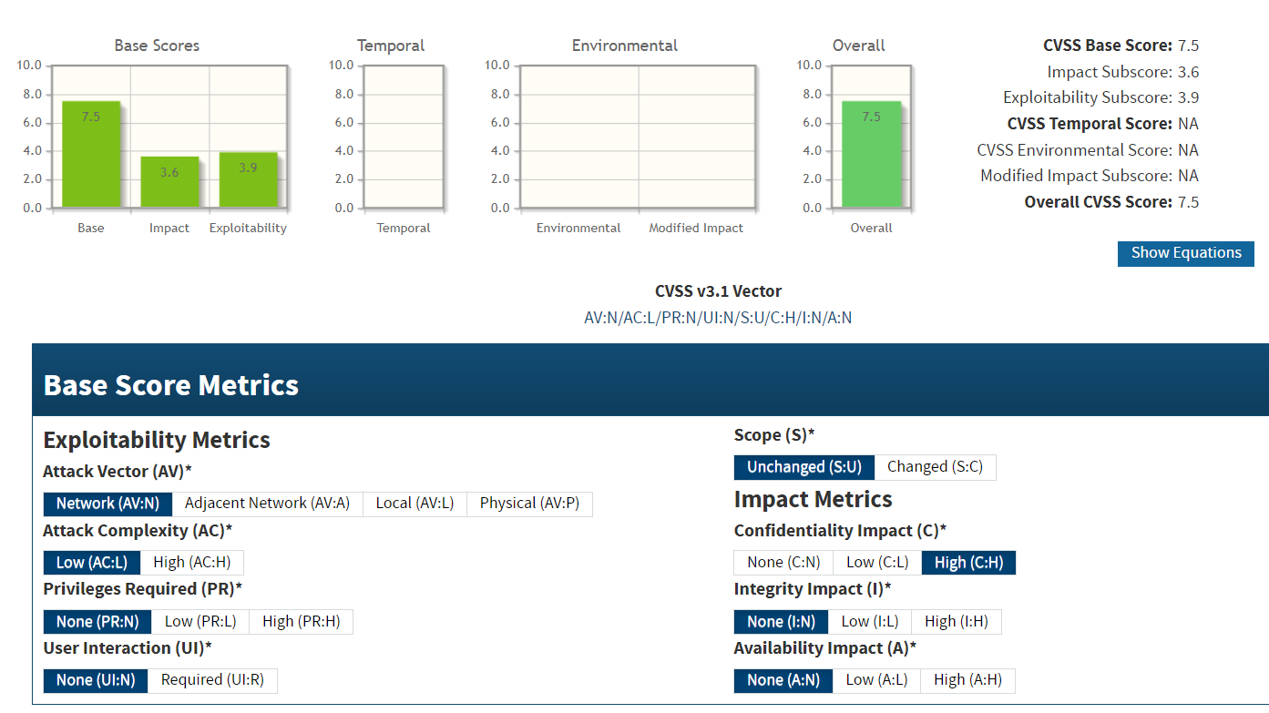

**CVE IDs:**

* N/A

**Affected Host**:

• 47.241.101.3:50001 • 124.117.225.66:44333 • 124.117.225.66:44344

• 103.56.148.203:443 • 103.56.148.203:887 • 103.56.148.203:36583

• 47.108.37.191:443 • 185.216.120.11:483  • 187.251.108.186:3389

• 2.74.193.188:9001 • 207.148.103.159:443

**Exploitation Details**:

Attackers can exploit the inherent weaknesses of TLS 1.0 and TLS 1.1 to force secure connections to downgrade, enabling man-in-the-middle attacks that compromise the confidentiality and integrity of transmitted data.

**Recommended Remediation**:

* Disable TLS 1.0 and TLS 1.1 on all servers and client systems.
* Enforce the use of TLS 1.2 or higher for all secure communications.
* Update server cipher suites to support only strong, modern cryptographic algorithms.
* Regularly audit security configurations to ensure compliance with industry best practices.

**References**:

<https://csrc.nist.gov/pubs/sp/800/52/r2/final>

<https://venafi.com/blog/why-its-dangerous-use-outdated-tls-security-protocols/>

<https://www.invicti.com/web-vulnerability-scanner/vulnerabilities/insecure-transportation-security-protocol-supported-tls-10/>

* + 1. **Use of Weak Ciphers (RC4, 3DES, and Low-Strength Ciphers)  
       Threat Level**: **High (7.3)**

**Description**:

The systems are configured to support weak ciphers such as RC4, 3DES, and other low-strength algorithms. These ciphers are vulnerable to various cryptographic attacks—including RC4 biases and SWEET32 attacks—that can compromise the confidentiality and integrity of encrypted communications. Their use not only undermines data security but may also lead to compliance issues with current industry standards.



**Potential Business Impact**:

Exploitation of weak cipher usage can allow attackers to intercept, decrypt, or manipulate sensitive data in transit. This may result in data breaches, regulatory non-compliance, and significant reputational and financial damage..

**CVSS 3.1 Score**



**CVE IDs:**

* CVE-2013-2566
* CVE-2016-2183
* CVE-2015-2808

**Affected Host**:

• 47.241.101.3:50001 • 47.241.101.3:8083 • 124.117.225.66:44333

• 185.216.120.11:5001  • 187.251.108.186:3389

**Exploitation Details**:

Attackers can exploit the known vulnerabilities in RC4, 3DES, and other weak ciphers to perform man-in-the-middle attacks or decrypt data passing through these channels, thereby bypassing the intended security of encrypted communications.

**Recommended Remediation**:

* Disable weak ciphers (e.g., RC4, 3DES, and other low-strength algorithms) on all servers and network devices.
* Enforce the use of strong cryptographic protocols (such as TLS 1.2 or TLS 1.3) with robust cipher suites.
* Regularly review and update security configurations to ensure compliance with modern standards.
* Conduct periodic vulnerability assessments to verify that only secure ciphers are enabled.

**References**:

<https://csrc.nist.gov/pubs/sp/800/52/r2/final>

<https://venafi.com/blog/why-its-dangerous-use-outdated-tls-security-protocols/>

<https://www.invicti.com/web-vulnerability-scanner/vulnerabilities/insecure-transportation-security-protocol-supported-tls-10/>

* + 1. **Exposed Microsoft Terminal Services (RDP)  
       Threat Level**: **High (8.6)**

**Description**:

Microsoft Terminal Services (RDP) is exposed on the affected hosts, allowing remote connections without requiring network-level authentication. This misconfiguration enables an attacker to directly connect to the RDP service without encountering additional security barriers such as Network Level Authentication (NLA). As verified by the ability to connect from a remote PC, the absence of NLA considerably increases the risk of unauthorized access and potential exploitation of the service.



**Potential Business Impact**:

Exploitation of the exposed RDP service may enable an attacker to:

* Gain unauthorized remote access to critical systems.
* Bypass authentication barriers, leading to potential data breaches or unauthorized system changes.
* Disrupt services or compromise system integrity, resulting in financial loss and reputational damage.

**CVSS 3.1 Score**

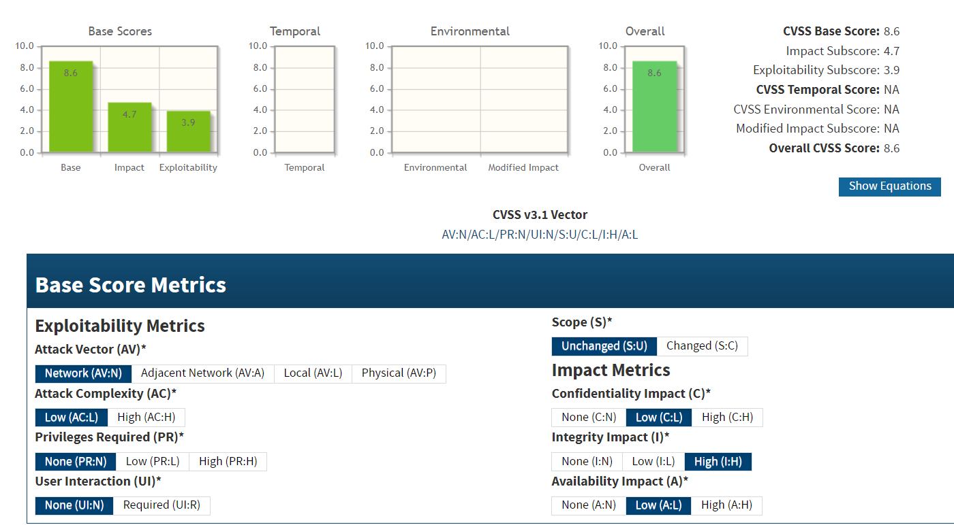

**CVE IDs:**

* N/A

**Affected Host**:

• 47.241.101.3:50001 • 142.132.207.118:3389 • 20.239.145.15:3389

**Exploitation Details**:

* The RDP service is openly accessible, as confirmed by successful connection attempts from an external PC.
* The lack of Network Level Authentication (NLA) allows an attacker to bypass pre-connection security checks, making it easier to gain unauthorized access.

**Recommended Remediation**:

* **Enable Network Level Authentication (NLA):** Configure RDP to require NLA so that users are authenticated before a full connection is established.
* **Restrict RDP Exposure:** Use firewalls, VPNs, or IP whitelisting to limit RDP access exclusively to trusted networks.
* **Apply Patches/Updates:** Ensure all relevant Microsoft security updates for RDP are applied promptly.
* **Monitor RDP Activity:** Implement logging and real-time monitoring to detect and respond to any unauthorized access attempts.

**References**:

<https://www.coalitioninc.com/blog/remote-desktop-protocol-risks>

<https://www.cloudflare.com/learning/access-management/rdp-security-risks/>

<https://thehackernews.com/2023/07/a-few-more-reasons-why-rdp-is-insecure.html>

<https://www.zengrc.com/blog/what-you-should-know-about-rdp-security-vulnerabilities/>

<https://www.fastly.com/learning/what-are-rdp-vulnerabilities>

<https://www.techtarget.com/searchsecurity/tip/10-RDP-security-best-practices-to-prevent-cyberattacks>

* + 1. **Exposed Administrative Interfaces  
       Threat Level**: **High (8.2)**

**Description**:

Multiple administrative interfaces are exposed to the public without adequate protection, making them vulnerable to exploitation via several known vulnerabilities. In particular, these interfaces are affected by CVE-2018-11776, CVE-2017-5638, CVE-2019-9670, and CVE-2020-2547. An attacker can leverage these flaws to bypass authentication, execute arbitrary code, or gain unauthorized administrative control, thereby compromising sensitive configurations and data.

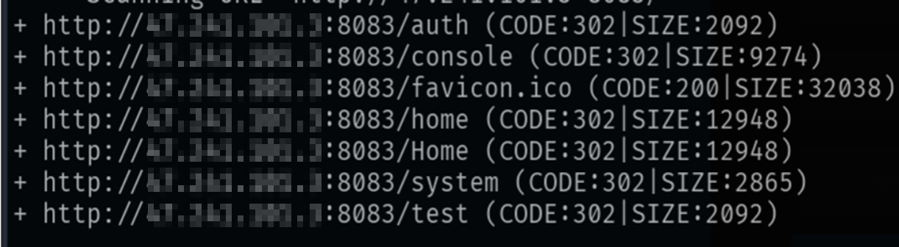

**Potential Business Impact**:

Exploitation may result in full administrative takeover of affected systems, leading to unauthorized data access, system modifications, and service disruptions. This could incur regulatory penalties, financial losses, and severe reputational damage.

**CVSS 3.1 Score**

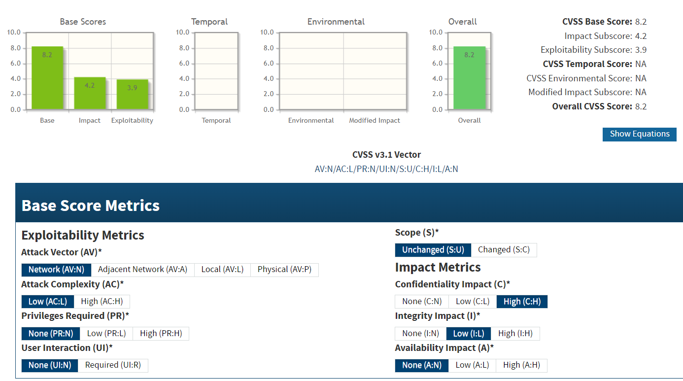

**CVE IDs:**

* CVE-2018-11776
* CVE-2017-5638
* CVE-2019-9670
* CVE-2020-2547

**Affected Host**:

• 47.241.101.3:8083 • 67.20.124.65:443 • 142.132.207.118:443

**Exploitation Details**:

Remote attackers can target these exposed administrative interfaces by exploiting vulnerabilities such as CVE-2018-11776 and CVE-2017-5638 (commonly associated with Apache Struts misconfigurations) along with other weaknesses identified by CVE-2019-9670 and CVE-2020-2547. This may allow them to bypass authentication and execute arbitrary commands or code on the vulnerable systems.

**Recommended Remediation**:

* **Patch and Update**: Immediately apply the vendor-supplied patches or updates for the affected components to remediate these vulnerabilities.
* **Restrict Access**: Limit access to administrative interfaces through firewalls, VPNs, or IP whitelisting to ensure they are only accessible by authorized personnel.
* **Enhance Authentication**: Implement strong authentication mechanisms and enforce role-based access controls on all administrative interfaces.
* **Regular Auditing**: Conduct frequent security assessments and audits to verify that administrative interfaces are properly secured and not exposed to unauthorized access.

**References**:

<https://nvd.nist.gov/vuln/detail/CVE-2018-11776>

<https://nvd.nist.gov/vuln/detail/CVE-2017-5638>

<https://nvd.nist.gov/vuln/detail/CVE-2019-9670>

<https://nvd.nist.gov/vuln/detail/CVE-2020-2547>

* + 1. **Outdated OpenSSH Version  
       Threat Level**: **High (7.3)**

**Description**:

The affected systems are running an outdated version of OpenSSH that remains vulnerable to several critical issues. These include CVE-2020-15778 (a directory traversal vulnerability in the scp client), CVE-2018-15473 (an authentication user enumeration flaw), CVE-2019-6111 (a vulnerability allowing arbitrary file overwrites via scp), and CVE-2021-41617 (a further security issue affecting scp or authentication). Exploitation of these vulnerabilities can enable attackers to access or modify files on the client side, potentially leading to a broader system compromise.



**Potential Business Impact**:

Exploitation of these vulnerabilities can result in unauthorized file access, manipulation, or arbitrary file writes. An attacker might leverage these issues to bypass intended security controls, leading to data breaches, system integrity compromise, and potentially enabling further escalation of privileges.

**CVSS 3.1 Score**

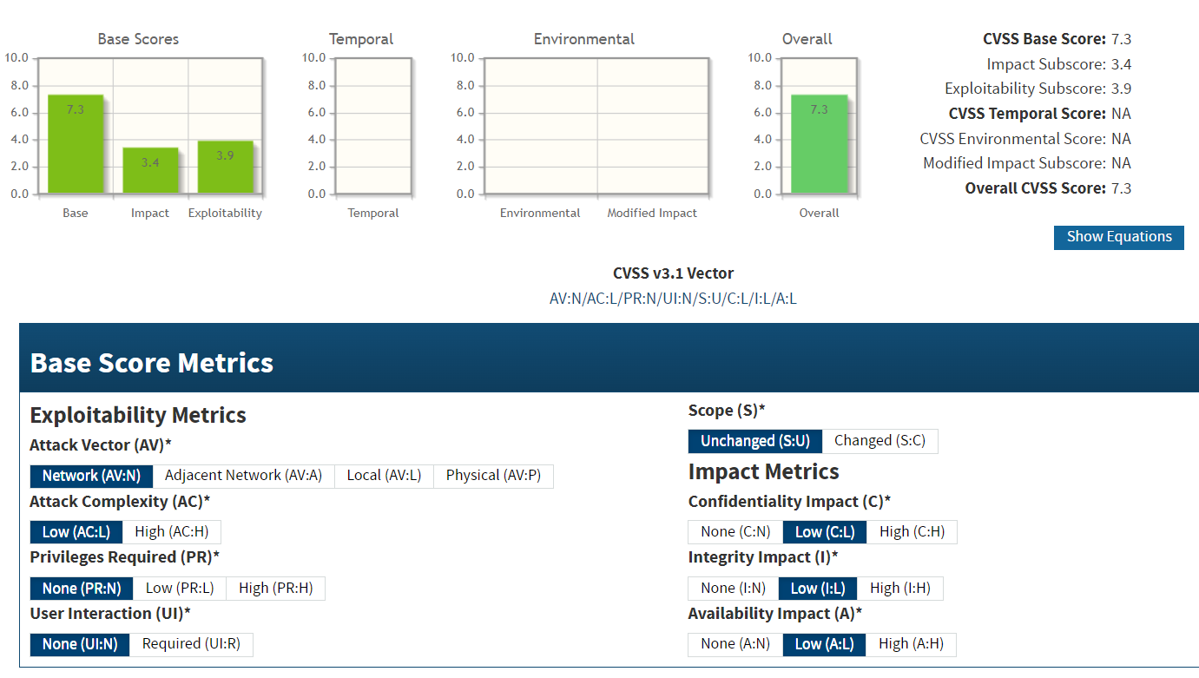

**CVE IDs:**

* CVE-2020-15778
* CVE-2018-15473
* CVE-2019-6111
* CVE-2021-41617

**Affected Host**:

• 67.20.124.65:22 • 185.146.86.135:22 • 184.164.141.29:22

• 144.217.240.87:22 • 51.79.65.16:22 • 198.245.53.101:22 • 149.56.129.34:22

• 142.132.207.118:23 • 219.94.189.215:22 • 5.135.137.222 • 47.108.37.191

**Exploitation Details**:

Attackers can exploit the outdated OpenSSH scp and authentication mechanisms by sending crafted requests that trigger directory traversal, file overwrite, or username enumeration flaws. Successful exploitation could allow remote adversaries to read or alter files, paving the way for further system compromise.

**Recommended Remediation**:

* Update OpenSSH to a version that includes fixes for CVE-2020-15778, CVE-2018-15473, CVE-2019-6111, and CVE-2021-41617.
* Harden SSH configuration settings by disabling insecure options and enforcing best practices.
* Monitor SSH logs for anomalous activity and consider implementing multi-factor authentication (MFA) for additional protection.

**References**:

<https://nvd.nist.gov/vuln/detail/CVE-2018-11776>

<https://nvd.nist.gov/vuln/detail/CVE-2017-5638>

<https://nvd.nist.gov/vuln/detail/CVE-2019-9670>

<https://nvd.nist.gov/vuln/detail/CVE-2020-2547>

* + 1. **Outdated ISC BIND Version  
       Threat Level**: **High (7.5)**

**Description**:

The DNS server is running an outdated version of ISC BIND that is affected by multiple vulnerabilities (CVE-2021-25216, CVE-2020-8625, and CVE-2019-6477). These vulnerabilities can be exploited remotely by sending specially crafted DNS queries, which may result in denial of service, remote code execution, or unauthorized disclosure of DNS data. The outdated software exposes critical DNS infrastructure to risks that can compromise service availability and integrity.



**Potential Business Impact**:

Exploitation of these vulnerabilities can lead to:

* Denial of service, disrupting domain name resolution.
* Remote code execution, potentially enabling attackers to compromise the DNS server.
* Unauthorized information disclosure, affecting the confidentiality and integrity of DNS data. This can result in widespread service disruption, misdirection of network traffic, and damage to the organization’s reputation.

**CVSS 3.1 Score**

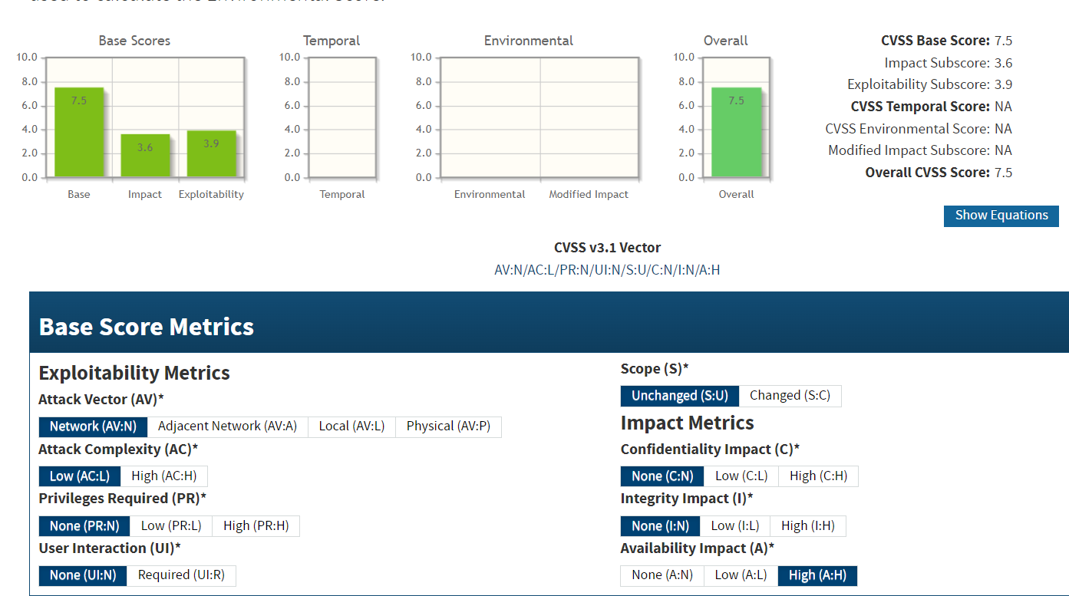

**CVE IDs:**

* CVE-2021-25216
* CVE-2020-8625
* CVE-2019-6477

**Affected Host**:

• 67.20.124.65:53

**Exploitation Details**:

Remote attackers can exploit the outdated ISC BIND installation by sending crafted DNS requests that trigger the known vulnerabilities. Successful exploitation might lead to service interruptions or further compromise of the network infrastructure.

**Recommended Remediation**:

* **Upgrade ISC BIND:** Update the DNS server software to the latest version that addresses CVE-2021-25216, CVE-2020-8625, and CVE-2019-6477.
* **Harden DNS Configurations:** Review and adjust the DNS server settings to minimize exposure (e.g., restrict query sources, apply rate limiting).
* **Monitor DNS Activity:** Implement logging and continuous monitoring to detect suspicious DNS queries or anomalies.

**References**:

<https://nvd.nist.gov/vuln/detail/CVE-2021-25216>

<https://nvd.nist.gov/vuln/detail/CVE-2020-8625>

<https://nvd.nist.gov/vuln/detail/CVE-2019-6477>

* + 1. **Outdated MySQL Version  
       Threat Level**: **High (7.5)**

**Description**:

The MySQL server is running an outdated version that remains vulnerable to several critical issues. The identified vulnerabilities include CVE-2021-27928, CVE-2020-14765, and CVE-2019-2503. Exploitation of these vulnerabilities may allow attackers to bypass authentication controls, disrupt database services, or even execute arbitrary code, thereby compromising the confidentiality and integrity of stored data.



**Potential Business Impact**:

Exploitation of these vulnerabilities can lead to unauthorized access to sensitive data, data manipulation, or service disruption. A successful attack might compromise the overall integrity of the database environment, resulting in regulatory non-compliance, financial losses, and reputational damage.

**CVSS 3.1 Score**

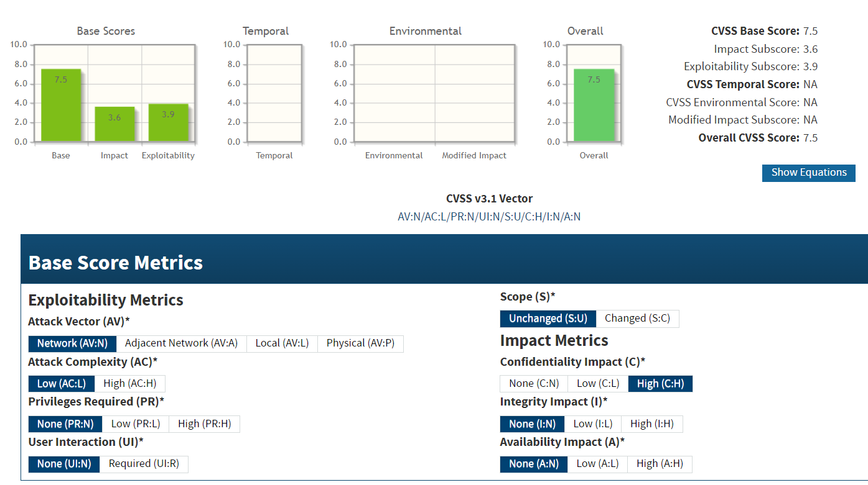

**CVE IDs:**

* CVE-2021-27928
* CVE-2020-14765
* CVE-2019-2503

**Affected Host**:

• 67.20.124.65:3306

**Exploitation Details**:

Attackers may target the outdated MySQL server by sending specially crafted requests that trigger the vulnerabilities. This could result in bypassing authentication or causing denial-of-service conditions, thereby providing a foothold for further compromise of the database and connected systems.

**Recommended Remediation**:

* **Upgrade MySQL**: Update the MySQL server to the latest version that includes fixes for CVE-2021-27928, CVE-2020-14765, and CVE-2019-2503.
* **Harden Configuration**: Review and strengthen MySQL security configurations, enforcing strong authentication methods and restricting unnecessary privileges.
* **Implement Monitoring**: Continuously monitor database activity for signs of exploitation and conduct regular security assessments.

**References**:

<https://nvd.nist.gov/vuln/detail/CVE-2021-27928>

<https://nvd.nist.gov/vuln/detail/CVE-2020-14765>

<https://nvd.nist.gov/vuln/detail/CVE-2019-2503>

* + 1. **Outdated PostgreSQL Version  
       Threat Level**: **High (7.5)**

**Description**:

The PostgreSQL server is running an outdated version that remains vulnerable to several critical issues. In particular, the system is affected by CVE-2021-23214, CVE-2019-9193, and CVE-2020-25695. These vulnerabilities can allow remote attackers to bypass authentication controls, disclose sensitive data, or even manipulate database contents. Exploitation of these issues can compromise the confidentiality and integrity of critical information stored in the database.



**Potential Business Impact**:

Exploitation can result in unauthorized disclosure or alteration of sensitive data, potentially leading to data breaches, loss of data integrity, and compliance violations. Attackers might leverage these vulnerabilities to bypass normal authentication mechanisms and gain control over the database, thereby affecting overall business operations and reputation.

**CVSS 3.1 Score**



**CVE IDs:**

* CVE-2021-23214
* CVE-2019-9193,
* CVE-2020-25695

**Affected Host**:

• 67.20.124.65:5432

**Exploitation Details**:

Remote attackers can exploit these vulnerabilities by sending crafted queries or bypassing authentication controls, allowing them to enumerate or modify database contents. The outdated PostgreSQL version fails to implement the latest security enhancements, leaving it susceptible to such attacks.

**Recommended Remediation**:

* **Upgrade PostgreSQL**: Immediately update to a version that includes patches for CVE-2021-23214, CVE-2019-9193, and CVE-2020-25695.
* **Harden Configurations**: Review and strengthen PostgreSQL security settings, enforce strict access controls, and disable unnecessary services.
* **Implement Monitoring**: Regularly monitor database logs and network traffic for signs of suspicious activity, and conduct periodic vulnerability assessments.

**References**:

<https://nvd.nist.gov/vuln/detail/CVE-2021-27928>

<https://nvd.nist.gov/vuln/detail/CVE-2020-14765>

<https://nvd.nist.gov/vuln/detail/CVE-2019-2503>

* + 1. **Outdated Apache HTTP Server  
       Threat Level**: **High (7.5)**

**Description**:

The Apache HTTP Server is running an outdated version that is affected by multiple known vulnerabilities. These include recent issues such as CVE-2021-40438, CVE-2021-42013, and CVE-2021-41773, as well as legacy vulnerabilities like CVE-2004-0493, CVE-2003-1307, CVE-2003-0987, CVE-2002-0392, and CVE-2004-0113. The combination of these flaws can allow attackers to exploit path traversal, remote code execution, and information disclosure issues, thereby compromising the confidentiality, integrity, and availability of the server.





**Potential Business Impact**:

Exploitation of these vulnerabilities can enable an attacker to:

* Gain unauthorized access to sensitive files or execute arbitrary code.
* Disrupt normal server operations, leading to service outages.
* Compromise data integrity and confidentiality, resulting in regulatory and reputational repercussions.

**CVSS 3.1 Score**



**CVE IDs:**

•CVE-2021-40438  •CVE-2021-42013  •CVE-2004-0493  •CVE-2003-1307  •CVE-2021-41773  •CVE-2003-0987  •CVE-2002-0392  •CVE-2004-0113

**Affected Host**:

•67.20.124.65:80 •67.20.124.65:443 • 207.148.103.159:80 • 207.148.103.159:443 •207.148.103.159:8080 •207.148.103.159:80 •128.32.220.18:443

**Exploitation Details**:

Attackers can remotely exploit these vulnerabilities by crafting malicious HTTP requests that bypass security controls. Successful exploitation may lead to unauthorized file access, remote code execution, or other malicious activities that compromise the server.

**Recommended Remediation**:

* **Upgrade Apache HTTP Server**: Immediately update to a current version that has addressed the vulnerabilities (e.g., a version that remediates CVE-2021-40438, CVE-2021-42013, CVE-2021-41773, etc.).
* **Harden Server Configurations**: Review and adjust server settings to disable unnecessary modules and restrict access to administrative interfaces.
* **Restrict Network Access**: Use firewalls, VPNs, or IP whitelisting to limit public exposure of the HTTP server.
* **Ongoing Monitoring**: Implement logging and continuous monitoring to detect and respond to anomalous activities.

**References**:

<https://nvd.nist.gov/vuln/detail/CVE-2021-40438>

<https://nvd.nist.gov/vuln/detail/CVE-2021-42013>

<https://nvd.nist.gov/vuln/detail/CVE-2004-0493>

<https://nvd.nist.gov/vuln/detail/CVE-2003-1307>

<https://nvd.nist.gov/vuln/detail/CVE-2021-41773>

<https://nvd.nist.gov/vuln/detail/CVE-2003-0987>

<https://nvd.nist.gov/vuln/detail/CVE-2002-0392>

<https://nvd.nist.gov/vuln/detail/CVE-2004-0113>

* + 1. **Sensitive Files Exposed  
       Threat Level**: **High (7.3)**

**Description**:

The affected systems are misconfigured or running vulnerable software that exposes sensitive files to unauthorized access. This vulnerability is associated with several known issues: CVE-2021-41773, CVE-2018-13057, CVE-2021-3129, and CVE-2020-5902. An attacker exploiting these vulnerabilities may be able to view or download confidential files—such as configuration files, logs, or other sensitive data—without proper authentication. This file disclosure can lead to further exploitation, data breaches, and unauthorized access to critical system information.

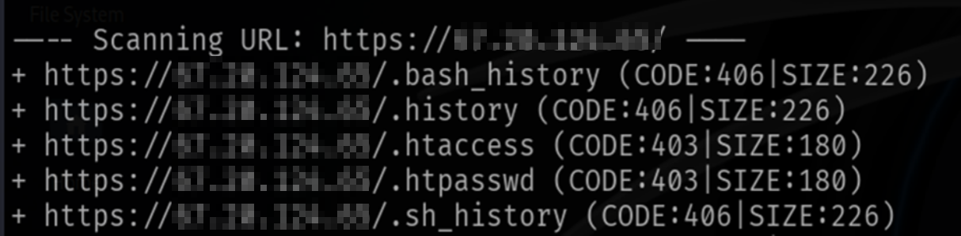

**Potential Business Impact**:

Exploitation can result in unauthorized access to sensitive data that may include configuration settings, authentication credentials, and other critical files. This may facilitate further attacks, lead to data breaches, and significantly compromise the confidentiality and integrity of organizational information, with consequent financial and reputational damage.

**CVSS 3.1 Score**

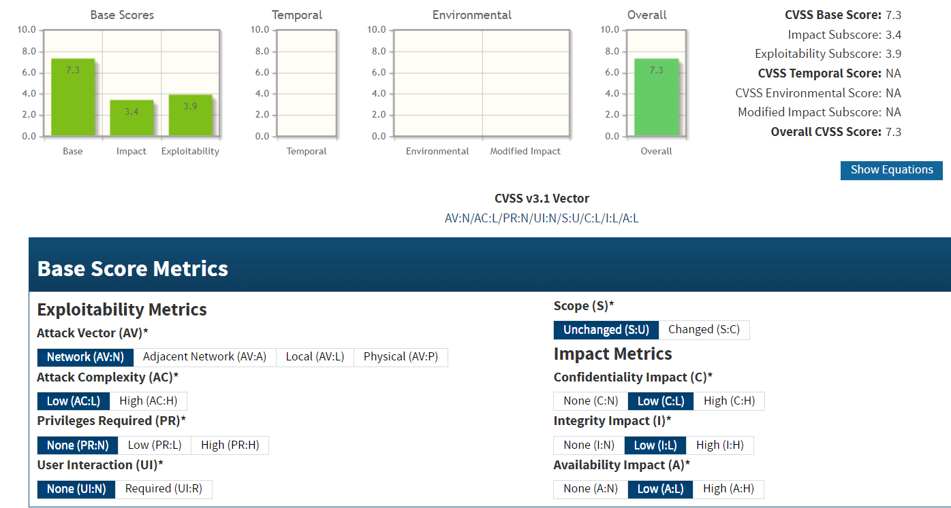

**CVE IDs:**

•CVE-2021-41773  •CVE-2018-13057  •CVE-2021-3129  •CVE-2020-5902

**Affected Host**:

• 67.20.124.65:443 • 207.148.103.159:80 • 198.245.53.101:4444

**Exploitation Details**:

Attackers can remotely trigger these vulnerabilities by sending specially crafted requests (such as HTTP requests) that bypass security controls and expose sensitive files. Once exploited, the attacker gains direct access to files that should otherwise be protected, paving the way for additional malicious activities.

**Recommended Remediation**:

* **Patch Vulnerabilities**: Update all affected software to versions that address CVE-2021-41773, CVE-2018-13057, CVE-2021-3129, and CVE-2020-5902.
* **Harden Configurations**: Implement strict file access controls and ensure sensitive directories are properly secured against unauthorized access.
* **Restrict Access**: Limit exposure of administrative interfaces and sensitive file repositories using firewalls, VPNs, or IP whitelisting.
* **Regular Auditing**: Conduct periodic security audits and vulnerability assessments to identify and remediate misconfigurations and exposure issues.

**References**:

<https://nvd.nist.gov/vuln/detail/CVE-2021-41773>

<https://nvd.nist.gov/vuln/detail/CVE-2018-13057>

<https://nvd.nist.gov/vuln/detail/CVE-2021-3129>

<https://nvd.nist.gov/vuln/detail/CVE-2020-5902>

* + 1. **Exposed UPnP Service  
       Threat Level**: **High (7.5)**

**Description**:

The device at the affected IP is exposing its UPnP service on port 2869. UPnP (Universal Plug and Play) is designed for local network discovery and management, but when exposed to the Internet, it can be exploited by attackers. This exposure can enable unauthorized remote control or configuration manipulation of networked devices, potentially leading to further compromise of the internal network.

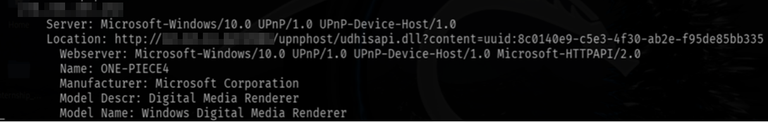

**Potential Business Impact**:

Exploitation of an exposed UPnP service may allow attackers to:

* Discover and enumerate devices on the network.
* Manipulate device configurations or trigger unintended actions.
* Use the service as a stepping stone to launch further attacks against the network infrastructure. These outcomes can lead to unauthorized access, data leakage, or service disruption.

**CVSS 3.1 Score**

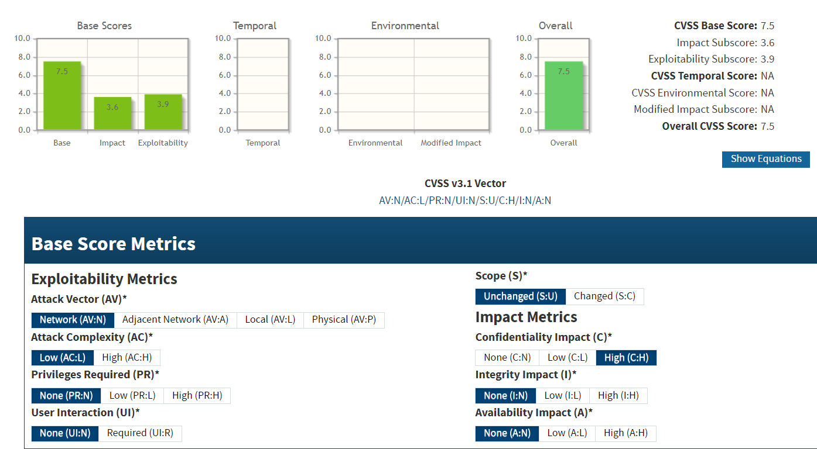

**CVE IDs:**

•N/A

**Affected Host**:

• 191.82.121.191:2869

**Exploitation Details**:

Attackers can remotely send specially crafted UPnP requests to the exposed service, bypassing intended local-use restrictions. This can result in unauthorized control over networked devices, potentially enabling the attacker to alter configurations or disrupt network services.

**Recommended Remediation**:

* **Restrict UPnP Exposure**: Configure network firewalls to block external access to UPnP ports, ensuring UPnP is only available within the local network.
* **Disable UPnP if Unnecessary**: If UPnP is not required for business operations, disable the service entirely.
* **Update Device Firmware**: Ensure that devices running UPnP have the latest firmware and security patches applied to mitigate known vulnerabilities.
* **Regular Security Audits**: Periodically review network exposure and device configurations to confirm that UPnP and other management services are not inadvertently accessible from the Internet.

**References**:

<https://www.lepide.com/blog/what-is-upnp-and-is-it-safe/>

<https://jumpcloud.com/blog/what-is-upnp>

<https://www.upguard.com/blog/what-is-upnp>

* + 1. **Insecure Telnet Service  
       Threat Level**: **High (7.5)**

**Description**:

The system is running an insecure Telnet service on port 2323. Telnet transmits data, including authentication credentials, in plaintext, making it highly susceptible to interception and eavesdropping. The use of Telnet in a publicly accessible environment exposes the system to potential unauthorized access and other malicious activities.

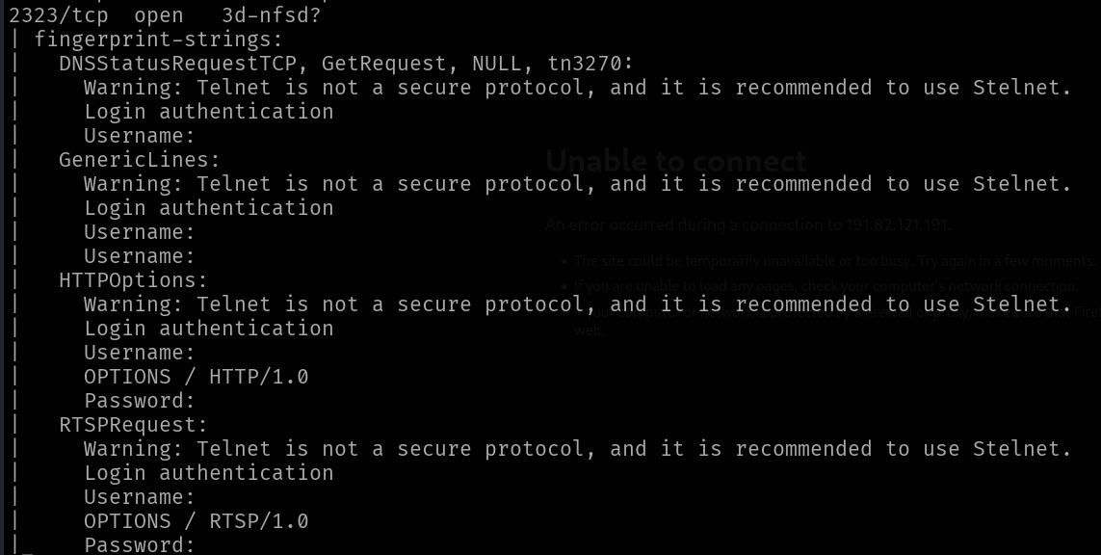

**Potential Business Impact**:

Exploitation of this insecure service may lead to:

* Interception of credentials and sensitive data.
* Unauthorized remote access to the system.
* Facilitation of subsequent attacks on the network. Such outcomes can result in data breaches, service disruption, and significant reputational and financial damage.

**CVSS 3.1 Score**



**CVE IDs:**

•N/A

**Affected Host**:

• 124.117.225.66:2323 • 184.74.137.227:23 • 2.74.193.188:23 •105.235.122.97:23

• 207.148.103.159:23 • 207.148.103.159:2323

**Exploitation Details**:

Because Telnet transmits information in plaintext, attackers can easily capture login credentials and other data using network sniffing techniques. The service’s exposure on a public port further increases the risk of brute force or other automated attacks.

**Recommended Remediation**:

* **Disable Telnet**: Replace Telnet with a secure alternative such as SSH.
* **Restrict Access**: If Telnet must be used, restrict access via firewalls, VPNs, or IP whitelisting to limit exposure.
* **Encrypt Communications**: Consider tunneling Telnet sessions through secure channels to protect data in transit.
* **Regular Monitoring**: Continuously monitor network traffic for unauthorized Telnet activity and enforce strong authentication measures.

**References**:

<https://www.lepide.com/blog/what-is-upnp-and-is-it-safe/>

<https://jumpcloud.com/blog/what-is-upnp>

<https://www.upguard.com/blog/what-is-upnp>

* + 1. **Open SNMP Service  
       Threat Level**: **High (7.5)**

**Description**:

The SNMP service is exposed on the affected devices, and the running implementation is vulnerable to known issues. Specifically, the vulnerabilities CVE-2017-6736 and CVE-2012-0386 can be exploited by remote attackers to gather sensitive information or potentially perform unauthorized operations. An attacker leveraging these vulnerabilities might be able to enumerate device configurations or access confidential network management data, increasing the risk of further compromise of the network. The SNMP service is exposed on the affected devices, and the running implementation is vulnerable to known issues. Specifically, the vulnerabilities CVE-2017-6736 and CVE-2012-0386 can be exploited by remote attackers to gather sensitive information or potentially perform unauthorized operations. An attacker leveraging these vulnerabilities might be able to enumerate device configurations or access confidential network management data, increasing the risk of further compromise of the network..



**Potential Business Impact**:

Exploitation of these vulnerabilities may result in unauthorized disclosure of network and system information, which can facilitate further attacks against the infrastructure. This may lead to a compromise of device configurations, unauthorized network mapping, and potentially serve as a stepping stone for deeper network intrusions, impacting overall system confidentiality and integrity.

**CVSS 3.1 Score**



**CVE IDs:**

• CVE-2017-6736 • CVE-2012-0386

**Affected Host**:

• 124.117.225.66:161 • 105.235.122.97:161

**Exploitation Details**:

Attackers can remotely send SNMP requests crafted to trigger the vulnerabilities CVE-2017-6736 and CVE-2012-0386, bypassing normal authentication or validation checks. This may enable them to retrieve sensitive configuration details or perform unauthorized modifications on network devices.

**Recommended Remediation**:

* **Restrict SNMP Access**: Configure network devices to restrict SNMP access using firewalls or access control lists, limiting it to trusted IP ranges.
* **Secure SNMP Configuration**: Change default community strings to strong, non-guessable values and consider using SNMPv3 for improved authentication and encryption.
* **Patch and Update**: Apply vendor updates or patches that remediate the vulnerabilities associated with CVE-2017-6736 and CVE-2012-0386.
* **Monitor SNMP Traffic**: Implement logging and monitoring of SNMP queries to detect any unusual or unauthorized activity.

**References**:

<https://nvd.nist.gov/vuln/detail/CVE-2017-6736>

<https://nvd.nist.gov/vuln/detail/CVE-2012-0386>

* + 1. **RC4 Vulnerability  
       Threat Level**: **High (7.5)**

**Description**:

The affected systems are vulnerable due to the continued use of the RC4 cipher, which is known to have significant cryptographic weaknesses. Vulnerabilities such as CVE-2013-2566 and CVE-2015-2808 highlight issues like RC4 biases that can be exploited to compromise the confidentiality of encrypted communications. These flaws can allow attackers to perform ciphertext analysis and potentially decrypt sensitive data transmitted over the network.



**Potential Business Impact**:

Exploitation of these RC4 vulnerabilities may enable attackers to decrypt sensitive communications, leading to unauthorized disclosure of confidential information. This breach of data confidentiality can have serious consequences, including regulatory non-compliance, financial loss, and reputational damage.

**CVSS 3.1 Score**



**CVE IDs:**

• CVE-2013-2566 • CVE-2015-2808

**Affected Host**:

• 124.117.225.66:44333 • 20.239.145.15:443

**Exploitation Details**:

Attackers can exploit the inherent weaknesses in the RC4 cipher by analyzing biases in ciphertexts generated during SSL/TLS sessions. This approach may allow them to recover portions of plaintext data from encrypted communications, even when transmitted over secure channels..

**Recommended Remediation**:

* Disable RC4 support in SSL/TLS configurations and remove it from the list of allowed cipher suites.
* Update software and cryptographic libraries to versions that enforce stronger, modern ciphers (e.g., AES-GCM).
* Audit and update server configurations to ensure compliance with current security best practices and industry standards.

**References**:

<https://nvd.nist.gov/vuln/detail/CVE-2013-2566>

<https://nvd.nist.gov/vuln/detail/CVE-2015-2808>

* + 1. **cPanel Unauthorized Access  
       Threat Level**: **High (7.5)**

**Description**:

The cPanel interface is exposed on the affected host without proper access controls, allowing unauthorized users to gain administrative access. This misconfiguration can enable attackers to manage accounts, view sensitive data, and modify server configurations. Unauthorized access to cPanel could lead to the compromise of hosted websites and the underlying infrastructure, resulting in significant operational, financial, and reputational damage.



**Potential Business Impact**:

Exploitation of this vulnerability can result in full administrative control over the hosting environment, which may lead to:

* Unauthorized access and modification of sensitive data.
* Disruption or complete takeover of web hosting services.
* Deployment of malware or unauthorized applications on affected servers.

**CVSS 3.1 Score**



**CVE IDs:**

• CVE-2013-2566 • CVE-2015-2808

**Affected Host**:

• 185.146.86.135:2078

**Exploitation Details**:

An attacker can connect directly to the exposed cPanel interface, bypassing authentication due to improper configuration. This direct access may allow the attacker to execute administrative commands, alter configurations, and compromise hosted websites.

**Recommended Remediation**:

* **Restrict Access:** Limit access to the cPanel interface by implementing firewall rules, VPNs, or IP whitelisting so that only authorized users can connect.
* **Enhance Authentication:** Enforce strong authentication measures, such as complex passwords and multi-factor authentication (MFA), to secure the administrative interface.
* **Secure Configuration:** Regularly audit and update the cPanel configuration to ensure that no unauthorized access is possible.
* **Monitor Activity:** Implement logging and continuous monitoring to detect and respond to any unauthorized access attempts.

**References**:

<https://cpanel.net/blog/products/intro-to-server-security/>

<https://clouddestinations.com/blog/real-threat-of-unauthorized-access.html>

<https://blog.imunify360.com/17-ways-to-improve-cpanel-security-in-2021>

* + 1. **Anonymous Diffie-Hellman Key Exchange  
       Threat Level**: **High (7.4)**

**Description**:

The FTP services running on the affected IP addresses are using an anonymous Diffie-Hellman key exchange mechanism, which does not authenticate the communicating parties. Without proper authentication, this key exchange is vulnerable to man-in-the-middle (MITM) attacks. An attacker can intercept and alter the key exchange process, potentially decrypting and modifying the data transmitted over FTP, thereby compromising the confidentiality and integrity of sensitive information.



**Potential Business Impact**:

Exploitation of this vulnerability can allow attackers to:

* Intercept and read sensitive data transmitted via FTP.
* Modify data in transit, leading to data integrity issues.
* Potentially use the compromised session as a pivot point for further attacks on the network.

**CVSS 3.1 Score**

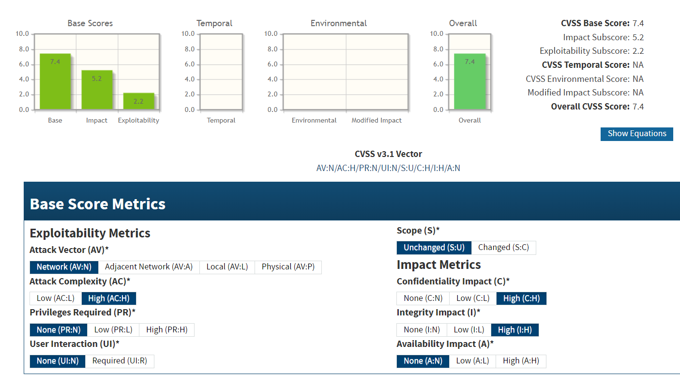

**CVE IDs:**

• N/A

**Affected Host**:

• 185.146.86.135:21 • 194.110.254.16:21 • 20.239.145.15:21

**Exploitation Details**:

Attackers can remotely intercept the anonymous Diffie-Hellman key exchange process used by the FTP service. By performing a MITM attack, they can establish their own encryption keys, decrypt the session, and potentially inject malicious commands or modify data.

**Recommended Remediation**:

* Disable the use of anonymous Diffie-Hellman key exchange on FTP servers.
* Configure the service to use authenticated key exchange mechanisms (e.g., those that require certificates or pre-shared keys).
* Update the FTP server software to a version that supports secure key exchange protocols.
* Restrict FTP access using firewall rules, VPNs, or IP whitelisting to limit exposure to trusted networks.
* Monitor network traffic for signs of MITM attacks.

**References**:

<https://security.stackexchange.com/questions/123413/is-authorisation-of-ftp-safe-against-sniffing-and-vulnerable-to-man-in-the-middl>

<https://www.a2hosting.com/blog/is-ftp-secure-the-complete-breakdown-of-ftp-hosting-and-if-its-right-for-you/>

<https://infosecwriteups.com/exploring-ftp-vulnerabilities-through-hands-on-testing-in-a-virtual-lab-environment-48a44be3a73>

<https://www.jscape.com/blog/countering-packet-sniffers-using-encrypted-ftp>

* + 1. **Expired SSL/TLS Certificate  
       Threat Level**: **High (7.5)**

**Description**:

The affected systems are using an SSL/TLS certificate that has expired. An expired certificate undermines the security of encrypted communications by invalidating the trust chain between the client and the server. This misconfiguration may result in clients receiving security warnings or, in worse cases, an attacker exploiting the situation to perform man-in-the-middle (MITM) attacks if clients bypass certificate validation. Furthermore, an expired certificate may cause connection failures and non-compliance with industry regulations.



**Potential Business Impact**:

The use of an expired certificate can lead to:

* Loss of client trust due to security warnings and potential connection refusals.
* Increased risk of MITM attacks if users ignore warning prompts.
* Non-compliance with security standards, potentially resulting in regulatory penalties.
* Exposure of sensitive data if encrypted communications are intercepted and decrypted.

**CVSS 3.1 Score**

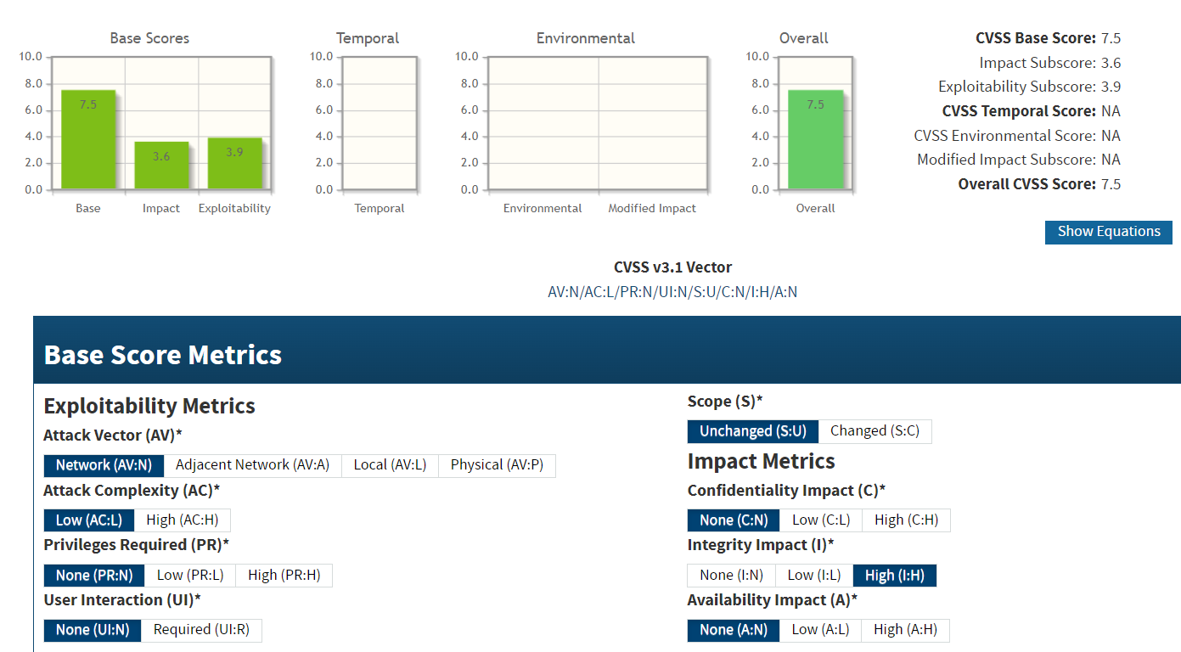

**CVE IDs:**

• N/A

**Affected Host**:

•185.146.86.135:443 •194.110.254.16:443 •207.148.103.159 •124.117.225.66:44333

• 207.148.103.159:443

**Exploitation Details**:

Attackers might take advantage of an expired certificate by impersonating the server or intercepting data, particularly if clients are configured to bypass certificate warnings. This can lead to unauthorized access or manipulation of data transmitted over the supposedly secure connection.

**Recommended Remediation**:

* **Renew the Certificate:** Immediately obtain and install a valid SSL/TLS certificate from a trusted Certificate Authority.
* **Update Configuration:** Ensure that the new certificate is correctly installed and that the certificate chain is complete.
* **Enforce Strict Validation:** Configure client applications to enforce strict certificate validation and to reject expired certificates.
* **Monitor Expiration Dates:** Implement automated monitoring to alert administrators before certificates expire in the future.

**References**:

<https://infosec.mozilla.org/guidelines/web_security>

<https://csrc.nist.gov/publications/detail/sp/800-57/rev-5/final>

* + 1. **SSL POODLE Vulnerability  
       Threat Level**: **High (7.4)**

**Description**:

The SSL POODLE vulnerability (CVE-2014-3566) exploits a weakness in the SSLv3 protocol’s padding mechanism. An attacker can perform a padding oracle attack to decrypt encrypted traffic that falls back to SSLv3. Although SSLv3 is deprecated, its continued support on some servers exposes them to potential decryption of sensitive data. This vulnerability undermines the confidentiality of secure communications and can lead to further system compromise.

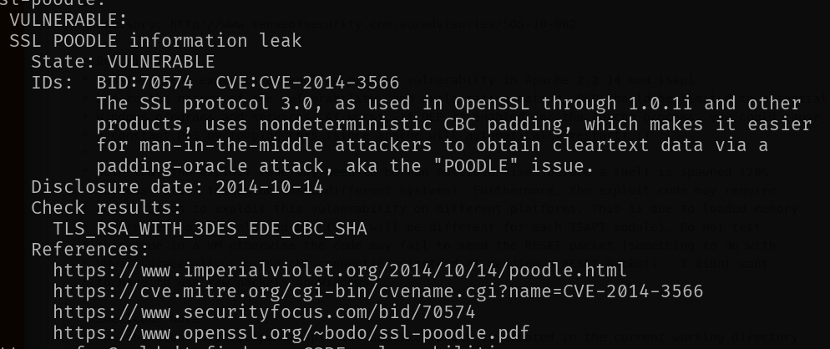

**Potential Business Impact**:

Exploitation of this vulnerability may result in:

* Decryption of sensitive information such as credentials and confidential data.
* Unauthorized access to secure communications.
* Increased risk of data breaches and system compromise, leading to potential financial and reputational losses.

**CVSS 3.1 Score**

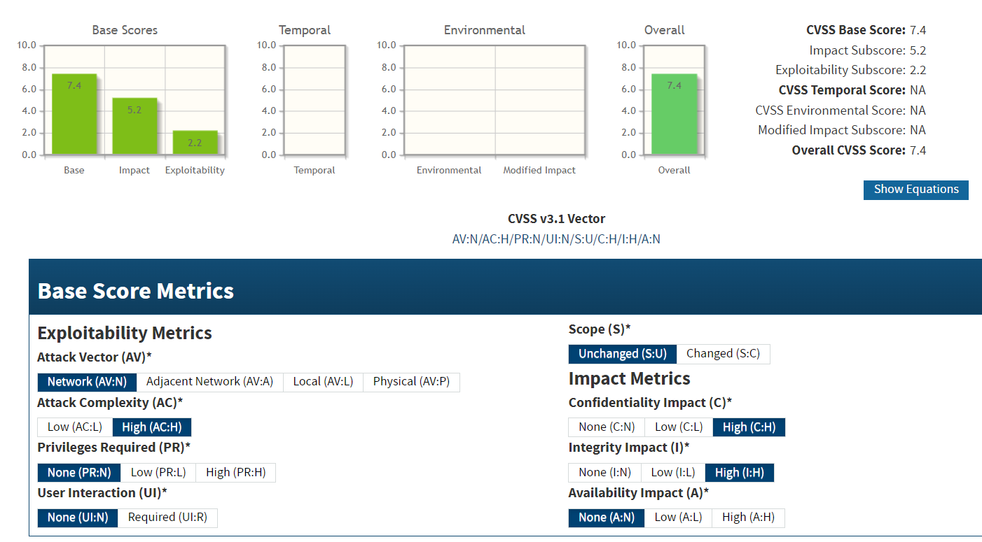

**CVE IDs:**

• CVE-2014-3566

**Affected Host**:

• 20.239.145.15:443 • 207.148.103.159:443

**Exploitation Details**:

Attackers can exploit the vulnerability by forcing a downgrade of secure connections to SSLv3, then leveraging the padding oracle attack to decrypt intercepted traffic. This requires the attacker to be positioned to intercept communications (e.g., via a man-in-the-middle attack) and relies on clients or servers supporting SSLv3 fallback.

**Recommended Remediation**:

* **Disable SSLv3**: Remove support for SSLv3 on all servers.
* **Enforce Modern TLS Versions**: Configure servers to use TLS 1.2 or higher exclusively.
* **Client Configuration**: Update client software to prevent fallback to SSLv3.
* **Regular Audits**: Periodically review and update SSL/TLS configurations to ensure compliance with current security standards.

**References**:

<https://beaglesecurity.com/blog/vulnerability/poodle-attack.html>

<https://nvd.nist.gov/vuln/detail/CVE-2014-3566>

* + 1. **Insecure Rsync Service  
       Threat Level**: **High (7.3)**

**Description**:

The rsync daemon on the affected system is running in a vulnerable configuration, exposing it to exploitation as defined in the following CVE(s). This vulnerability (CVE-2017-17433) can allow remote attackers to perform unauthorized operations—such as reading, writing, or modifying files—and potentially execute arbitrary commands. Because the service is accessible on port 873, attackers can leverage this exposure to compromise system integrity and confidentiality.



**Potential Business Impact**:

Exploitation of the vulnerable rsync service can lead to:

* Unauthorized disclosure or modification of sensitive files.
* Possible remote command execution.
* A broader compromise of the affected network infrastructure. These outcomes may result in significant financial loss, data breaches, and reputational damage.

**CVSS 3.1 Score**



**CVE IDs:**

• CVE-2017-17433

**Affected Host**:

• 184.164.141.29:873

**Exploitation Details**:

Remote attackers can exploit this vulnerability by sending specially crafted rsync requests to the exposed service. Successful exploitation may allow the attacker to bypass authentication controls and access or modify files on the server.

**Recommended Remediation**:

* **Upgrade rsync**: Update to a version that patches CVE-2017-17433.
* **Harden Configuration**: Disable anonymous access and restrict rsync service access to trusted IP addresses using firewalls or access control lists.
* **Monitor Activity**: Implement logging and monitoring of rsync traffic to detect and respond to suspicious activity.

**References**:

<https://nvd.nist.gov/vuln/detail/CVE-2017-17433>

* + 1. **Apache Byte-Range Filter Denial of Service  
       Threat Level**: **High (7.5)**

**Description**:

The Apache HTTP Server is vulnerable to a denial-of-service (DoS) attack through its byte-range filter mechanism. This vulnerability (CVE-2011-3192) is triggered when the server processes crafted HTTP Range headers with overlapping or otherwise malformed byte ranges. The resulting excessive resource consumption can lead to service degradation or complete unavailability, disrupting normal operations.

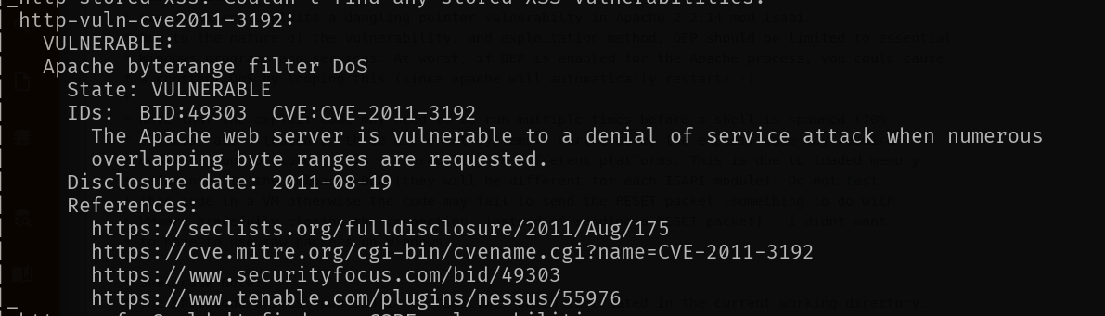

**Potential Business Impact**:

Exploitation can result in:

* A denial of service, rendering the affected Apache server unresponsive.
* Disruption of critical web services, leading to operational downtime.
* Increased vulnerability as attackers may use the DoS condition as a precursor for further attacks.

**CVSS 3.1 Score**

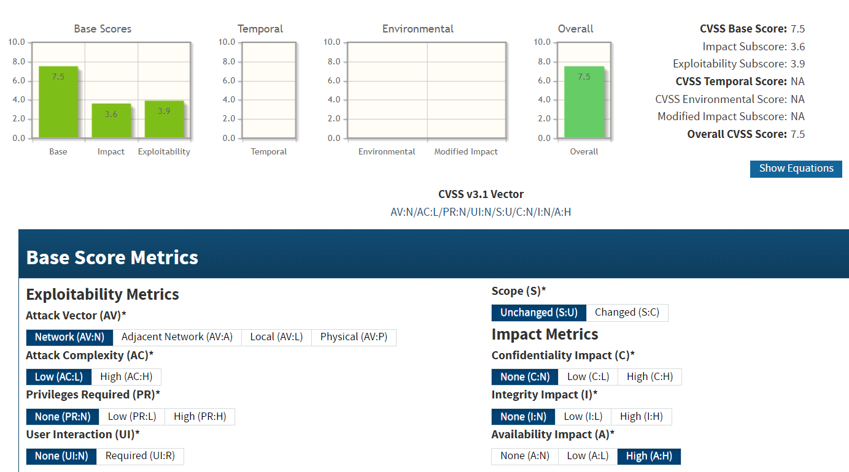

**CVE IDs:**

• CVE-2011-3192

**Affected Host**:

• 103.56.148.203:443 • 185.216.120.11

**Exploitation Details**:

Remote attackers can exploit this vulnerability by sending a series of HTTP requests with specially crafted Range headers. This forces the server to allocate excessive processing and memory resources, ultimately leading to resource exhaustion and service disruption.

**Recommended Remediation**:

* **Upgrade Apache**: Apply patches or update to a version of Apache HTTP Server that has addressed CVE-2011-3192.
* **Adjust Configuration**: Configure the server to limit or properly validate byte-range requests, reducing the risk of resource exhaustion.
* **Implement a WAF**: Deploy a web application firewall to filter out malicious Range header requests.
* **Monitor Traffic**: Regularly audit server logs and network traffic for anomalous Range header patterns indicative of an attack.

**References**:

<https://nvd.nist.gov/vuln/detail/CVE-2011-3192>

<https://httpd.apache.org/security/vulnerabilities_24.html>

* + 1. **Obsoleted CBC Ciphers Offered  
       Threat Level**: **High (7.5)**

**Description**:

The server is configured to offer obsolete CBC-mode cipher suites, which are known to have significant cryptographic weaknesses. These outdated cipher suites can be exploited using techniques that target vulnerabilities inherent to CBC (Cipher Block Chaining) modes—such as predictable initialization vectors and padding oracle attacks—potentially enabling attackers to decrypt sensitive communications. This exposure undermines the overall security of TLS/SSL connections.



**Potential Business Impact**:

Exploitation may result in:

* Decryption of sensitive data transmitted over secure channels.
* Unauthorized access to confidential information.
* Increased risk of data breaches and subsequent regulatory or reputational damage.

**CVSS 3.1 Score**

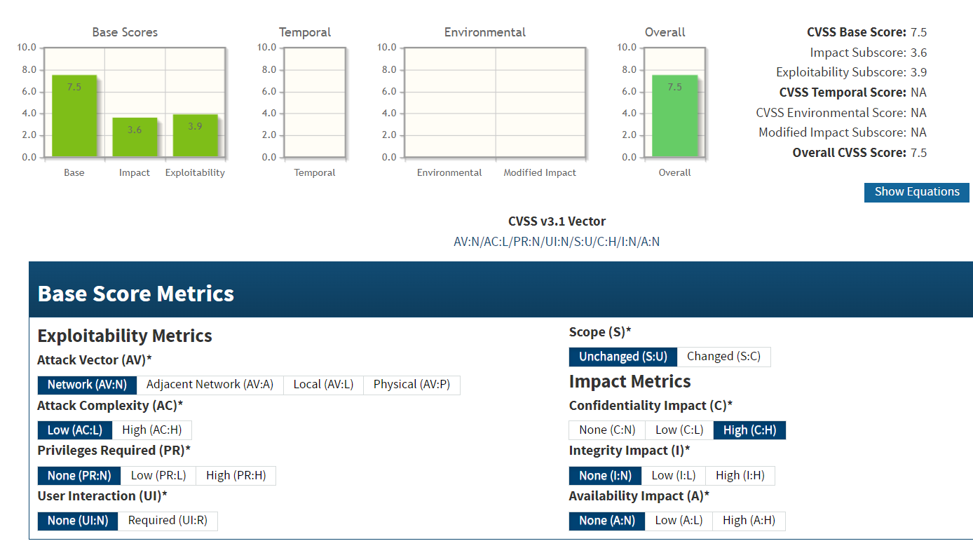

**CVE IDs:**

• N/A

**Affected Host**:

• 47.108.37.191:443 • 103.56.148.203:443 • 219.94.189.215:443

**Exploitation Details**:

Attackers can intercept encrypted communications and leverage the weaknesses of CBC-mode ciphers to perform decryption or modification of data. This is particularly dangerous if clients or services accept connections from servers offering these obsolete ciphers, thereby exposing sensitive data to potential interception.

**Recommended Remediation**:

* **Disable Obsolete Ciphers**: Remove support for obsolete CBC-mode cipher suites from the server configuration.
* **Enforce Secure Cipher Suites**: Configure the server to use modern ciphers, such as those based on AES in GCM mode, which provide robust security guarantees.
* **Update Software**: Ensure the server software is updated to the latest version that does not support legacy cipher suites.
* **Regular Auditing**: Periodically review and update cryptographic configurations to align with current security best practices.

**References**:

<https://csrc.nist.gov/pubs/sp/800/52/r2/final>

* + 1. **Litespeed Web Server Source Code Disclosure  
       Threat Level**: **High (7.5)**

**Description**:

The LiteSpeed Web Server is vulnerable to a source code disclosure flaw (CVE-2010-2333). This vulnerability allows remote attackers to send crafted HTTP requests that lead to the unintended exposure of sensitive source code. Disclosed source code may contain critical information such as application logic, configuration details, and potential hard-coded credentials, which could be leveraged for further attacks.

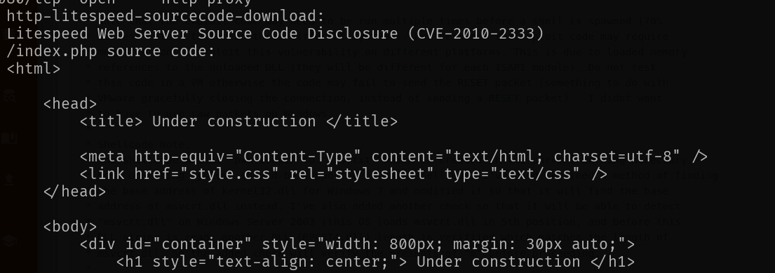

**Potential Business Impact**:

Exploitation of this vulnerability may result in:

* Unauthorized access to sensitive source code.
* Exposure of application logic and configuration details, enabling further targeted attacks.
* Increased risk of data breaches and compromise of critical systems, leading to financial and reputational damage.

**CVSS 3.1 Score**



**CVE IDs:**

• CVE-2010-2333

**Affected Host**:

• 207.148.103.159

**Exploitation Details**:

Remote attackers can exploit this vulnerability by sending specially crafted HTTP requests to the server. When successfully exploited, the server discloses parts of its source code, revealing sensitive information that can facilitate further exploitation.

**Recommended Remediation**:

* **Patch or Update**: Upgrade to a patched version of LiteSpeed Web Server that addresses CVE-2010-2333.
* **Secure Configuration**: Review and adjust server configurations to prevent unauthorized file access.
* **Access Controls**: Implement strict access control measures to ensure that sensitive files are accessible only by authorized users.
* **Monitoring**: Regularly monitor server logs for anomalous requests and signs of exploitation attempts.

**References**:

<https://xenforo.com/community/threads/dealing-with-mod_security-with-lightspeed-web-server.51245/>

<https://nvd.nist.gov/vuln/detail/CVE-2010-2333>

* + 1. **IRC Botnet Detection  
       Threat Level**: **High (8.2)**

**Description**:

The affected system (207.148.103.159:6666) is running an IRC service that appears to be associated with botnet command and control activity. Although no CVE ID is assigned, the presence of this open IRC channel can indicate unauthorized remote control and coordination among compromised hosts. Attackers may leverage such services to manage botnet operations, distribute malware, and launch coordinated attacks, thereby compromising the confidentiality and integrity of the network.

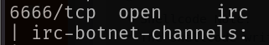

**Potential Business Impact**:

Exploitation of the open IRC service may result in:

* Unauthorized remote control of compromised hosts.
* Coordination and propagation of botnet activities leading to widespread network compromise.
* Exposure and potential manipulation of sensitive data exchanged over the IRC channel, resulting in financial and reputational losses.

**CVSS 3.1 Score**

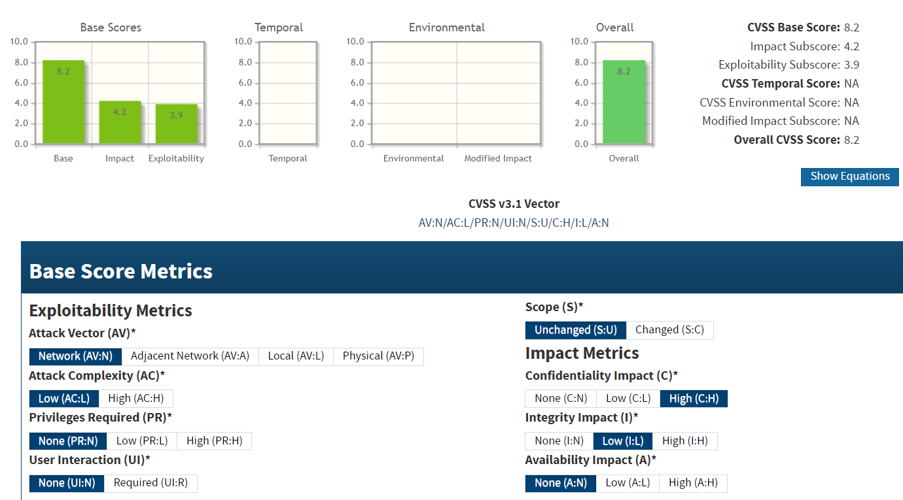

**CVE IDs:**

• CVE-2010-2333

**Affected Host**:

• 207.148.103.159:6666

**Exploitation Details**:

Attackers can exploit the open IRC channel by connecting to the service without any authentication. Once connected, they can send commands and receive data, effectively using the channel to control a botnet. This exposure makes it easier to coordinate attacks and distribute malware across the compromised network.

**Recommended Remediation**:

* **Restrict IRC Access**: Block or restrict external access to IRC ports (e.g., via firewalls or VPNs) so that only authorized internal systems can communicate over these channels.
* **Disable Unnecessary Services**: If the IRC service is not required, disable it entirely to eliminate the attack vector.
* **Monitor Network Traffic**: Implement intrusion detection systems (IDS) and continuously monitor network traffic for suspicious IRC activity.
* **Conduct Regular Audits**: Periodically review exposed services and configurations to ensure that only necessary and secured services are accessible.

**References**:

<https://www.ijcaonline.org/archives/volume178/number17/malik-2019-ijca-918967.pdf>

<https://www.xournals.com/assets/publications/AJIS_V01_I01_P06-10_01-2019.pdf>

<https://iaeme.com/MasterAdmin/Journal_uploads/IJARET/VOLUME_11_ISSUE_12/IJARET_11_12_024.pdf>

<https://www.ijert.org/a-survey-of-botnet-and-botnet-detection-methods>

* + 1. **Slowloris DoS Attack  
       Threat Level**: **High (7.3)**

**Description**:

The target systems are vulnerable to a Slowloris denial-of-service (DoS) attack, as identified by CVE-2007-6750. Slowloris is an application-layer DoS attack that exploits the way some web servers handle incomplete HTTP requests. By maintaining numerous open connections with partial requests, an attacker can exhaust the server’s resources, leading to service degradation or complete unavailability. This vulnerability is particularly dangerous because it does not require high bandwidth and can be executed with minimal resources.

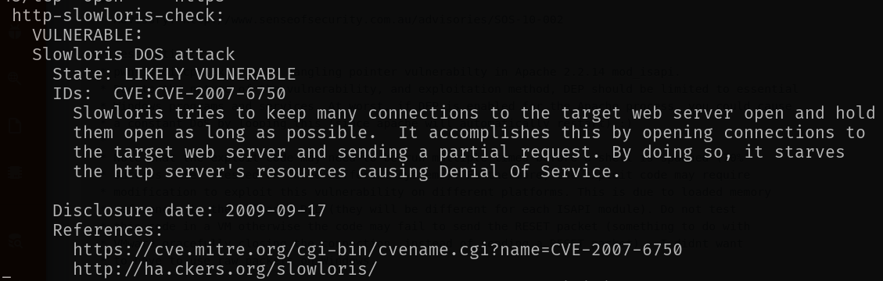

**Potential Business Impact**:

Exploitation of this vulnerability can lead to:

* Denial of service, rendering the affected web server unresponsive.
* Disruption of online services, potentially causing financial loss and reputational damage.
* Increased risk of cascading failures if the DoS condition is used as a smokescreen for further attacks.

**CVSS 3.1 Score**



**CVE IDs:**

• CVE-2007-6750

**Affected Host**:

• 207.148.103.159 • 5.135.137.222 • 128.32.220.18

**Exploitation Details**:

Attackers can execute a Slowloris attack by opening numerous HTTP connections and sending incomplete requests to the web server. As these connections remain open, the server’s available connection slots are exhausted, preventing legitimate users from accessing the service. This attack is particularly effective against servers that do not implement proper connection timeouts or resource management strategies.

**Recommended Remediation**:

* **Increase Connection Timeouts**: Configure the server to detect and close idle or incomplete connections more quickly.
* **Limit Concurrent Connections**: Set limits on the number of simultaneous connections from a single IP address.
* **Deploy a Web Application Firewall (WAF)**: Use a WAF to detect and block patterns indicative of Slowloris attacks.
* **Optimize Server Configuration**: Ensure the web server is tuned for high concurrency and can efficiently manage partial connections.

**References**:

<https://owasp.org/www-community/attacks/Denial_of_Service>

<https://nvd.nist.gov/vuln/detail/CVE-2007-6750>

* + 1. **Outdated PHP Version  
       Threat Level**: **High (7.5)**

**Description**:

The affected server is running an outdated version of PHP, which lacks the latest security patches and improvements. Running an obsolete PHP version exposes the system to various vulnerabilities that have been fixed in newer releases. Attackers may exploit these known weaknesses to execute arbitrary code, bypass security controls, or escalate privileges, leading to potential data breaches and system compromise.



**Potential Business Impact**:

Exploitation of vulnerabilities in an outdated PHP installation may result in unauthorized code execution, data leakage, and complete system compromise. Such outcomes can lead to service disruption, financial losses, and severe reputational damage.

**CVSS 3.1 Score**

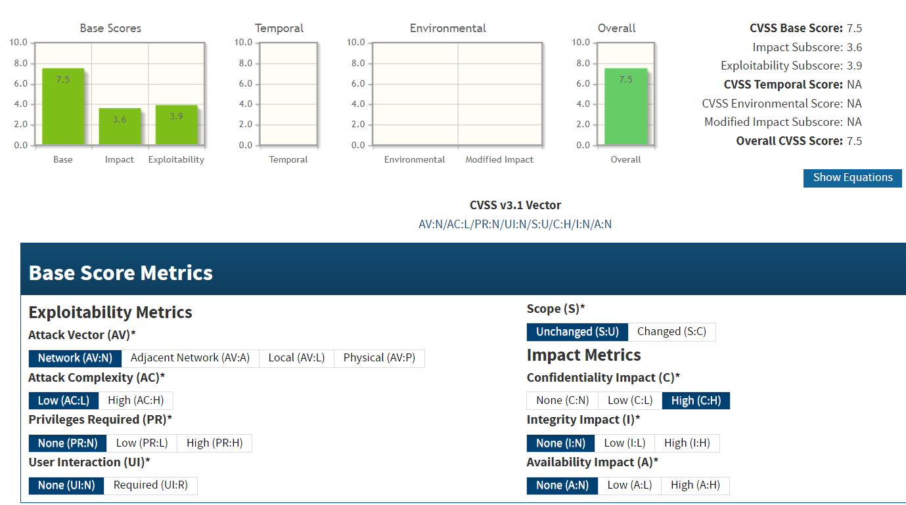

**CVE IDs:**

• CVE-2007-6750

**Affected Host**:

• 219.94.189.215:80

**Exploitation Details**:

Attackers can leverage the weaknesses inherent in older PHP versions by sending specially crafted HTTP requests that trigger known vulnerabilities. This may allow them to run malicious scripts or escalate privileges on the compromised server..

**Recommended Remediation**:

* **Upgrade PHP**: Update to the latest stable PHP release that includes all recent security patches.
* **Review Configuration**: Audit PHP configurations to disable dangerous functions and enforce security best practices.
* **Regular Vulnerability Assessments**: Conduct periodic security audits to identify and remediate outdated software components.
* **Patch Management**: Establish a robust patch management process to ensure PHP and related software remain up to date.

**References**:

<https://www.php.net/manual/en/security>

<https://cheatsheetseries.owasp.org/cheatsheets/PHP_Configuration_Cheat_Sheet.html>

* + 1. **Potential Admin Account Insertion Vulnerability  
       Threat Level**: **High (7.5)**

**Description**:

The affected application appears vulnerable to an admin account insertion flaw, as identified by CVE-2002-0995. This vulnerability allows an attacker to create a new administrative account without proper authorization. Successful exploitation can result in the attacker gaining full administrative control, which may lead to unauthorized access to sensitive data, modification of critical settings, and potential system compromise.



**Potential Business Impact**:

Exploitation of this vulnerability may result in:

* Unauthorized administrative access and full control over the application.
* Compromise of sensitive data and system configurations.
* Potential for further lateral movement and deeper network compromise.
* Significant operational, financial, and reputational damage.

**CVSS 3.1 Score**

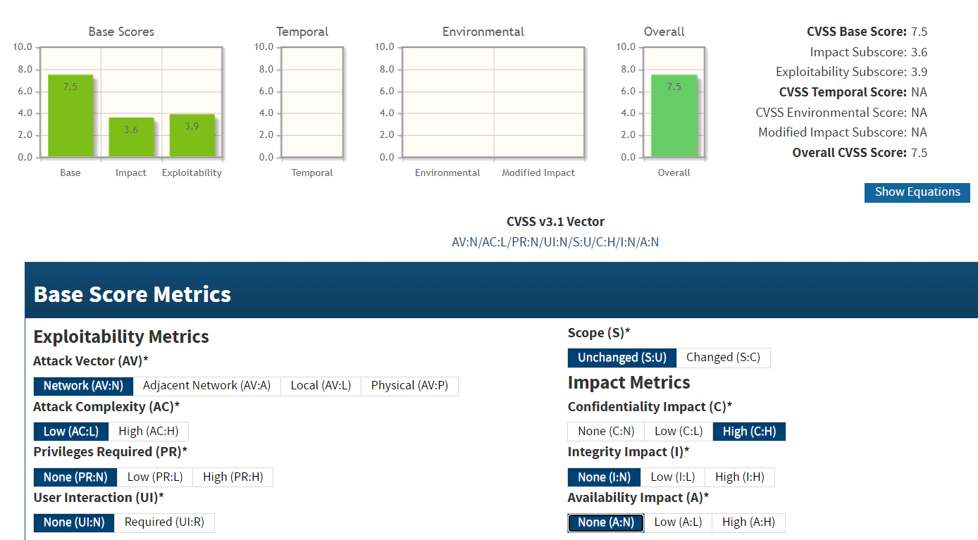

**CVE IDs:**

• CVE-2002-0995

**Affected Host**:

• 219.94.189.215:80

**Exploitation Details**:

An attacker can send specially crafted requests to the vulnerable application, exploiting the account insertion flaw to add an unauthorized admin account. Once the account is created, the attacker gains persistent administrative access, enabling them to manipulate settings, extract sensitive data, and execute additional attacks.

**Recommended Remediation**:

* **Patch/Upgrade**: Update the application to a version that has addressed CVE-2002-0995.
* **Harden Input Validation**: Ensure that all account creation functions enforce strict input validation and proper authorization checks.
* **Access Controls**: Implement strong access control measures to restrict administrative functionalities to authorized users only.
* **Monitoring and Auditing**: Regularly review logs for unauthorized account creation and conduct periodic security audits of the account management process.

**References**:

<https://nvd.nist.gov/vuln/detail/CVE-2002-0995>

### Medium Risk

* + 1. **Self-Signed Certificate and Chain of Trust Issues  
       Threat Level**: **Medium (5.3)**

**Description**:

The affected systems are configured with self-signed SSL/TLS certificates or with improper chain of trust. This misconfiguration means that the certificate cannot be verified by a trusted Certificate Authority, potentially leading to warnings or insecure connections. When clients bypass these warnings, attackers can perform man-in-the-middle attacks to intercept or modify sensitive data. Although self-signed certificates might be acceptable in closed environments, their presence on publicly accessible systems undermines secure communications.



**Potential Business Impact**:

Exploitation can lead to:

* Clients receiving misleading security warnings, potentially leading them to bypass certificate checks.
* Increased risk of man-in-the-middle attacks, resulting in data interception or modification.
* Loss of data confidentiality and integrity along with regulatory non-compliance and damage to reputation.

**CVSS 3.1 Score**

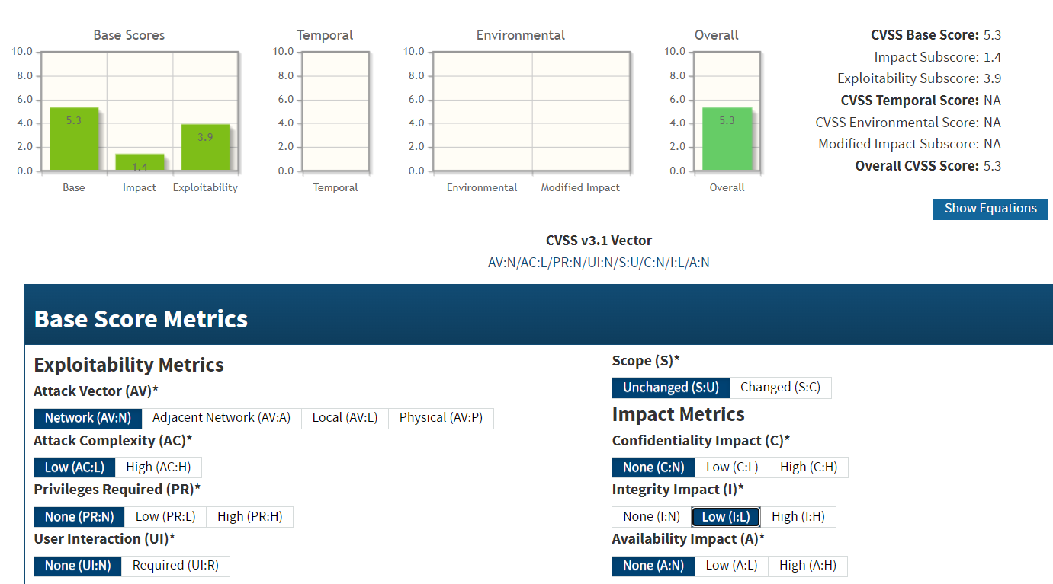

**CVE IDs:**

• N/A

**Affected Host**:

•47.241.101.3:50001 • 185.146.86.135:443 •103.56.148.203:887 •103.56.148.203:36583 • 185.216.120.11:483 • 187.251.108.186:3389

• 184.74.137.227:443 • 207.148.103.159:443 • 219.94.189.215:443

• 5.135.137.222:443 • 142.132.207.118:443

**Exploitation Details**:

Attackers may intercept communications by exploiting the insecure certificate chain. Users who ignore browser warnings could be redirected to malicious sites where sensitive information is captured, enabling further network compromise.

**Recommended Remediation**:

* Replace self-signed certificates with certificates issued by a trusted Certificate Authority.
* Ensure that the entire certificate chain is correctly configured and complete.
* Monitor certificate expiration dates and configuration to maintain an up-to-date chain of trust.
* Educate users about the risks of bypassing security warnings regarding certificate validity.

**References**:

<https://csrc.nist.gov/publications/detail/sp/800-57/rev-5/final>

<https://developer.mozilla.org/en-US/docs/Web/Security/Certificate_Transparency>

<https://cheatsheetseries.owasp.org/cheatsheets/Transport_Layer_Security_Cheat_Sheet.html>

* + 1. **Lack of OCSP Stapling Revocation Checking  
       Threat Level**: **Medium (6.5)**

**Description**:

The affected systems are not configured to perform OCSP stapling revocation checking, meaning that during the TLS handshake the server does not provide up-to-date certificate revocation information to the client. Without this mechanism, clients must individually query the certificate authority’s OCSP server, which may fail or be delayed, increasing the risk that revoked certificates might be trusted. This weakens the overall trust in the TLS connection and can leave communications vulnerable to man-in-the-middle attacks using compromised or revoked certificates.

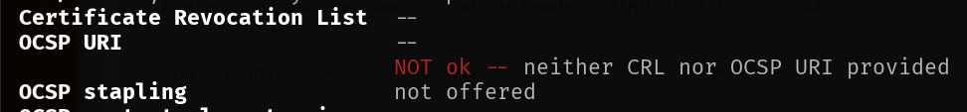

**Potential Business Impact**:

Failure to perform OCSP stapling revocation checking may allow clients to accept revoked certificates, increasing the risk of unauthorized interception of sensitive communications. This can lead to data breaches and compromise of confidential information if an attacker exploits a revoked certificate in a man-in-the-middle scenario.

**CVSS 3.1 Score**

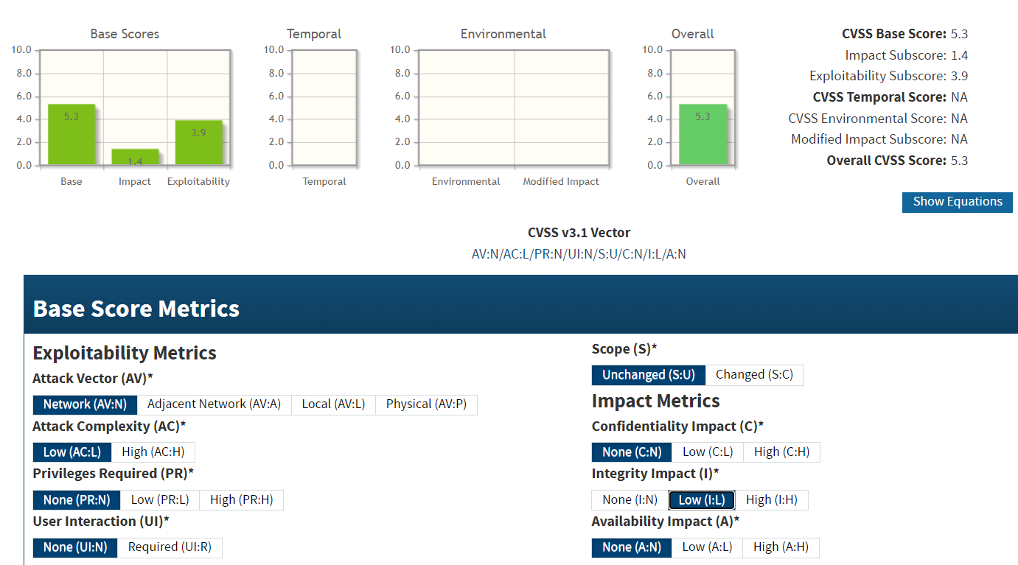

**CVE IDs:**

• N/A

**Affected Host**:

• 47.241.101.3:50001 • 142.132.207.118:8006

**Exploitation Details**:

Attackers may take advantage of this misconfiguration by performing MITM attacks that use revoked certificates. Since clients might not receive timely revocation status information, an attacker can intercept and manipulate encrypted communications without triggering security warnings.

**Recommended Remediation**:

* Enable OCSP stapling on the affected servers and ensure proper configuration of OCSP responder URLs.
* Update TLS/SSL configurations to enforce revocation checking during the handshake.
* Audit and monitor certificate validation processes to ensure clients are not bypassing revocation checks.
* Educate users and administrators about the importance of certificate revocation and proper TLS configuration.

**References**:

<https://datatracker.ietf.org/doc/html/rfc6066>

<https://www.ssl.com/article/ocsp-stapling-secure-and-efficient-certificate-validation/>

<https://cheatsheetseries.owasp.org/cheatsheets/Transport_Layer_Security_Cheat_Sheet.html>

* + 1. **SWEET32 Vulnerability  
       Threat Level**: **Medium (5.9)**

**Description**:

The SWEET32 vulnerability exploits the inherent weaknesses in 64‑bit block ciphers—such as 3DES and Blowfish—used in some TLS/SSL implementations. By leveraging a birthday attack, an adversary can capture and analyze large volumes of encrypted traffic to eventually recover parts of the plaintext. This vulnerability undermines the security of encrypted communications, potentially exposing sensitive data.



**Potential Business Impact**:

Exploitation of SWEET32 can lead to the decryption of sensitive information from TLS connections, resulting in unauthorized data disclosure, potential breaches of confidentiality, and subsequent exploitation of compromised data for further attacks. This may also affect compliance with current security standards.

**CVSS 3.1 Score**

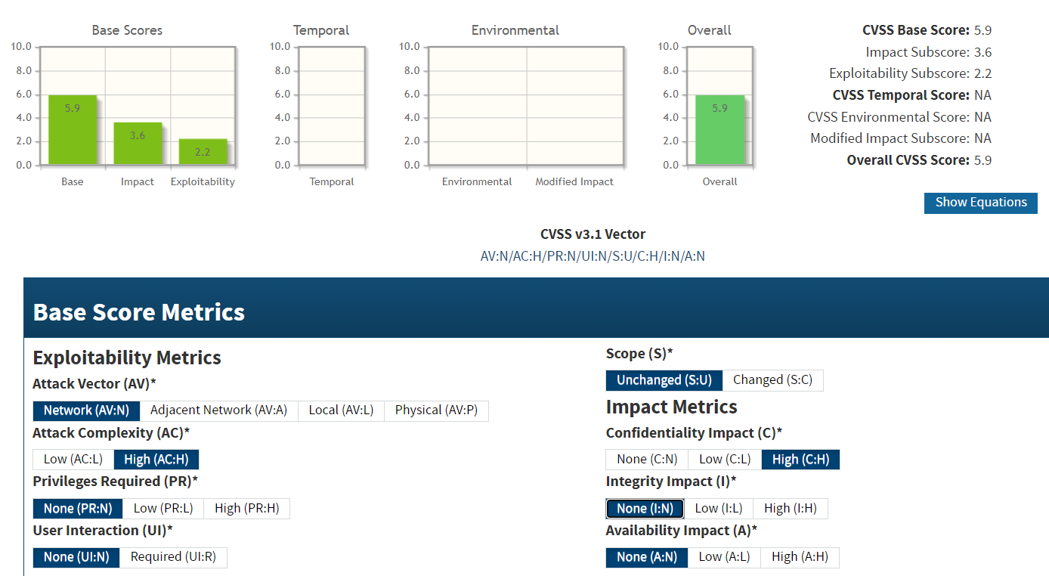

**CVE IDs:**

• CVE-2016-2183

• CVE-2016-6329

**Affected Host**:

•47.241.101.3:50001 •124.117.225.66:44333 •20.239.145.15:443 •187.251.108.186:3389

**Exploitation Details**:

Attackers can perform a birthday attack on the weak cipher block size by capturing a significant amount of encrypted traffic. Over time, this statistical analysis can reveal parts of the plaintext, enabling the attacker to compromise the confidentiality of the communication.

**Recommended Remediation**:

* Disable support for vulnerable 64‑bit block ciphers (e.g., 3DES, Blowfish) in TLS/SSL configurations.
* Enforce the use of modern, robust ciphers (such as AES-GCM) that provide stronger security guarantees.
* Regularly review and update cryptographic settings to ensure compliance with current best practices and standards.

**References**:

<https://datatracker.ietf.org/doc/html/rfc6066>

<https://www.ssl.com/article/ocsp-stapling-secure-and-efficient-certificate-validation/>

<https://cheatsheetseries.owasp.org/cheatsheets/Transport_Layer_Security_Cheat_Sheet.html>

* + 1. **BEAST Vulnerability  
       Threat Level**: **Medium (5.3)**

**Description**:

The BEAST vulnerability (CVE-2011-3389) affects legacy TLS 1.0 implementations by exploiting weaknesses in the CBC (Cipher Block Chaining) mode. Attackers can leverage this vulnerability to perform a chosen-plaintext attack, potentially decrypting parts of the encrypted traffic. Although modern TLS versions have mitigations in place, systems still using TLS 1.0 remain vulnerable.

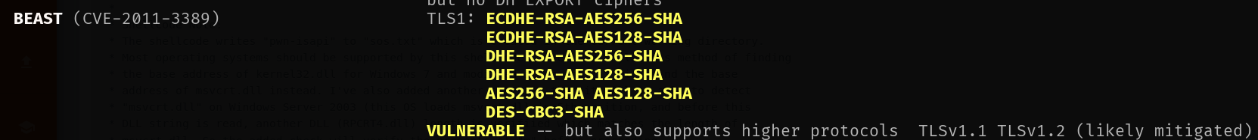

**Potential Business Impact**:

Exploitation may result in the partial decryption of confidential data such as session cookies, credentials, or other sensitive information, which can lead to further unauthorized access or information leakage.

**CVSS 3.1 Score**

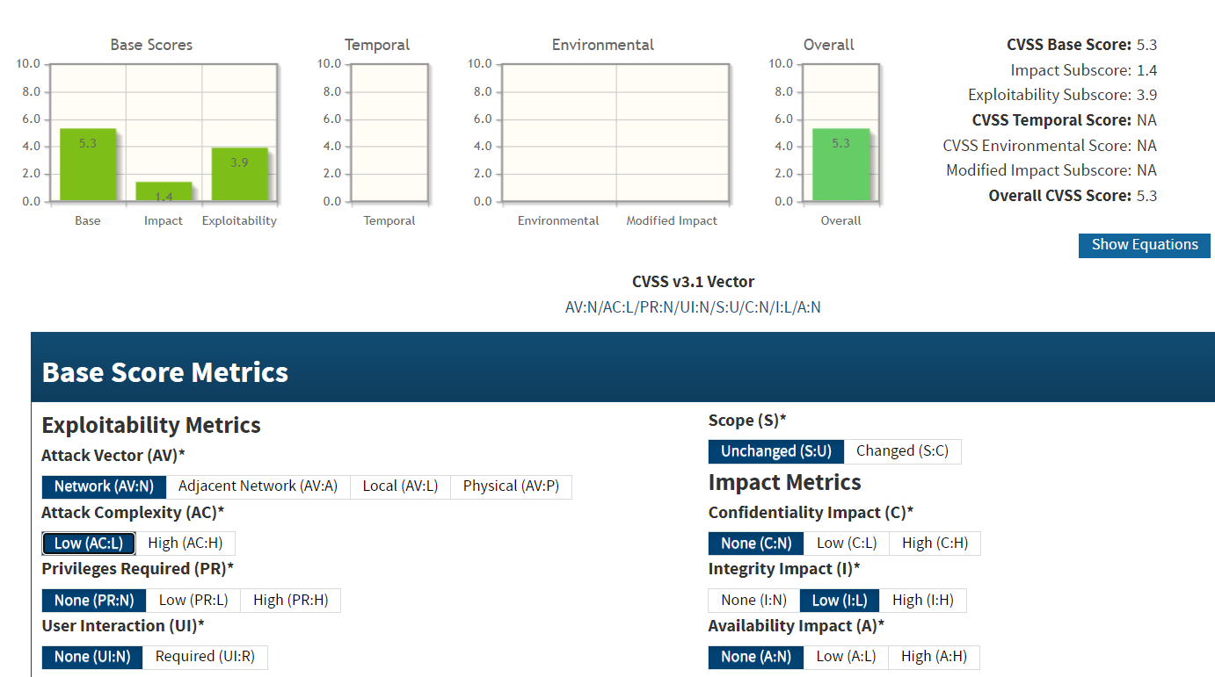

**CVE IDs:**

• CVE-2011-3389

**Affected Host**:

•47.241.101.3:50001 •124.117.225.66:44333 •103.56.148.203:887 •47.108.37.191:443 •185.216.120.11:483 •187.251.108.186:3389 •2.74.193.188:9001

**Exploitation Details**:

Attackers exploit the BEAST vulnerability by intercepting TLS connections and performing a chosen-plaintext attack to recover segments of the encrypted data. This requires the attacker to be in a position to eavesdrop on the connection (e.g., via a man-in-the-middle attack) and depends on the use of vulnerable TLS 1.0 implementations.

**Recommended Remediation**:

* **Upgrade TLS Protocols:** Disable TLS 1.0 and enforce the use of TLS 1.2 or later.
* **Disable Vulnerable Cipher Suites:** Remove support for cipher suites that rely on CBC mode in TLS 1.0.
* **Apply Patches/Updates:** Update software to versions that include mitigations against the BEAST attack.
* **Implement Additional Security Controls:** Use network-level security measures (e.g., VPNs, firewalls) to reduce the likelihood of interception.

**References**:

<https://www.veracode.com/products/dynamic-analysis-dast>

<https://nvd.nist.gov/vuln/detail/CVE-2011-3389>

* + 1. **LUCKY 13 Vulnerability  
       Threat Level**: **Medium (5.9)**

**Description**:

The LUCKY 13 vulnerability (CVE-2013-0169) is a timing side-channel attack that targets CBC-mode ciphers used in TLS/SSL implementations. By measuring subtle differences in decryption times, an attacker can potentially infer information about the plaintext. Although this attack does not always lead to full plaintext recovery, it undermines the confidentiality of encrypted communications and poses a risk when sensitive data is transmitted.



**Potential Business Impact**:

Exploitation of the LUCKY 13 vulnerability can lead to:

* Partial decryption of confidential data transmitted over TLS/SSL.
* Increased risk of data breaches if sensitive information is exposed.
* Undermining of overall encryption security, potentially facilitating further attacks.

**CVSS 3.1 Score**

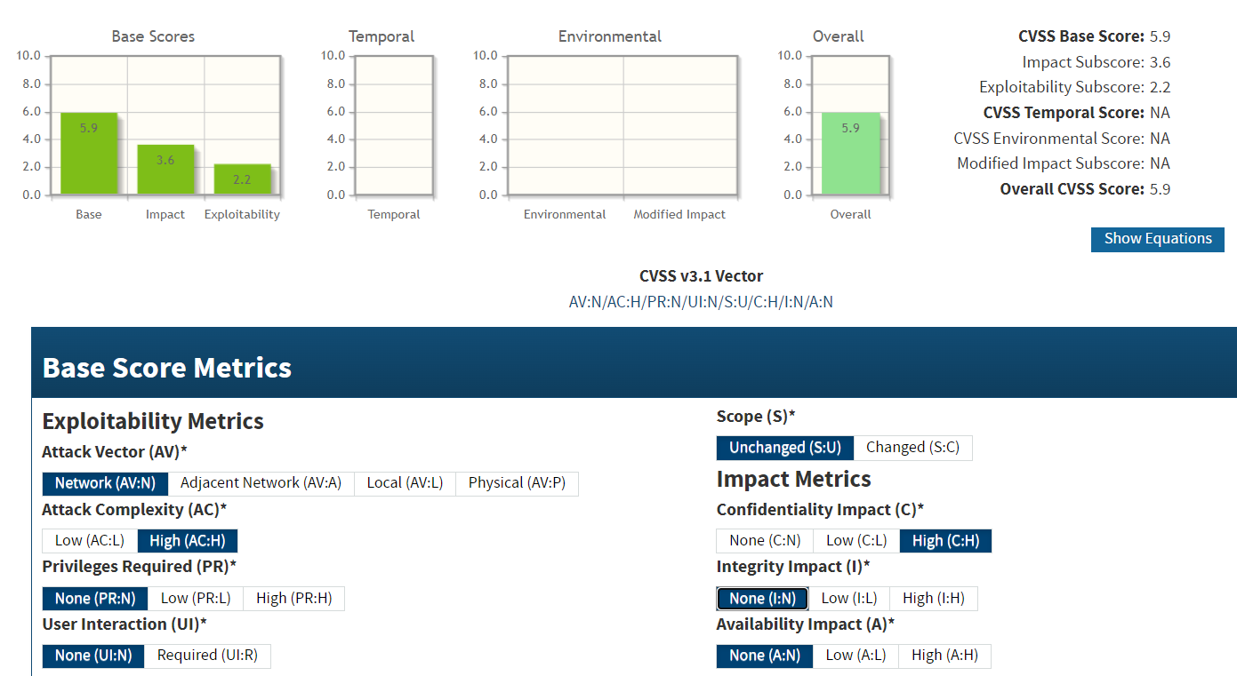

**CVE IDs:**

• CVE-2013-0169

**Affected Host**:

•47.241.101.3:8083 •124.117.225.66:44333 •124.117.225.66:44344 •185.146.86.135:443 •103.56.148.203:887 •103.56.148.203:36583 •47.108.37.191:443 •185.216.120.11:483 •142.132.207.118 •219.94.189.215:443

**Exploitation Details**:

Attackers exploit the BEAST vulnerability by intercepting TLS connections and performing a chosen-plaintext attack to recover segments of the encrypted data. This requires the attacker to be in a position to eavesdrop on the connection (e.g., via a man-in-the-middle attack) and depends on the use of vulnerable TLS 1.0 implementations.

**Recommended Remediation**:

* **Upgrade TLS Protocols:** Disable TLS 1.0 and enforce the use of TLS 1.2 or later.
* **Disable Vulnerable Cipher Suites:** Remove support for cipher suites that rely on CBC mode in TLS 1.0.
* **Apply Patches/Updates:** Update software to versions that include mitigations against the BEAST attack.
* **Implement Additional Security Controls:** Use network-level security measures (e.g., VPNs, firewalls) to reduce the likelihood of interception.

**References**:

<https://www.veracode.com/products/dynamic-analysis-dast>

<https://nvd.nist.gov/vuln/detail/CVE-2011-3389>

* + 1. **Lack of TLS FALLBACK SCSV Support  
       Threat Level**: **Medium (5.9)**

**Description**:

The affected system is not configured to support TLS_FALLBACK_SCSV—a mechanism designed to prevent protocol downgrade attacks. Without this protection, an attacker can force a TLS connection to fall back to a lower, less secure protocol version (such as SSL 3.0), making the connection vulnerable to known attacks like POODLE. This misconfiguration undermines the trustworthiness of the secure channel and exposes sensitive data to potential interception.



**Potential Business Impact**:

Exploitation of this vulnerability can lead to:

* Forced downgrade of secure connections to less secure protocols.
* Increased risk of man-in-the-middle attacks that can intercept or alter sensitive data.
* Compromised data confidentiality and integrity, potentially resulting in regulatory non-compliance and reputational damage.

**CVSS 3.1 Score**



**CVE IDs:**

• CVE-2013-0169

**Affected Host**:

• 47.241.101.3:8083 • 187.251.108.186:3389 • 124.117.225.66:44333

**Exploitation Details**:

Attackers can exploit the lack of TLS_FALLBACK_SCSV by manipulating the TLS handshake. By intercepting and modifying connection requests, an attacker may force the use of a lower protocol version that is more vulnerable to cryptographic attacks, thereby compromising the security of the communication channel.

**Recommended Remediation**:

* **Enable TLS_FALLBACK_SCSV**: Update server configurations to support TLS_FALLBACK_SCSV, ensuring that fallback attempts are properly signaled and rejected.
* **Restrict Protocol Versions**: Disable legacy protocols (e.g., SSL 3.0, TLS 1.0, and TLS 1.1) and enforce the use of TLS 1.2 or higher.
* **Update Software**: Ensure that the server software and cryptographic libraries are up to date and support modern TLS configurations.
* **Audit and Monitor**: Regularly review security configurations and monitor TLS handshakes for signs of protocol downgrade attempts**.**

**References**:

<https://datatracker.ietf.org/doc/rfc7507/>

<https://csrc.nist.gov/publications/detail/sp/800-52/rev-2/final>

* + 1. **Missing Subject Alternative Name (SAN)  
       Threat Level**: **Medium (5.3)**

**Description**:

When SSL/TLS certificates are issued without the Subject Alternative Name (SAN) field, clients must rely solely on the Common Name (CN) for hostname validation. Modern browsers and security standards require the SAN field for proper certificate validation, and its absence can lead to validation errors or security warnings. This misconfiguration may undermine the trust in the certificate and can increase the risk of man-in-the-middle (MITM) attacks if users are prompted to bypass warnings. Although it does not directly lead to remote code execution, the lack of SAN weakens the overall security posture of the encrypted connection.



**Potential Business Impact**:

Exploitation may lead to:

* Clients misidentifying the server’s identity, which increases the risk of MITM attacks.
* Users receiving persistent security warnings, which can erode trust in the organization’s online services.
* Overall degradation of the encrypted connection’s security and possible non-compliance with modern security requirements.

**CVSS 3.1 Score**

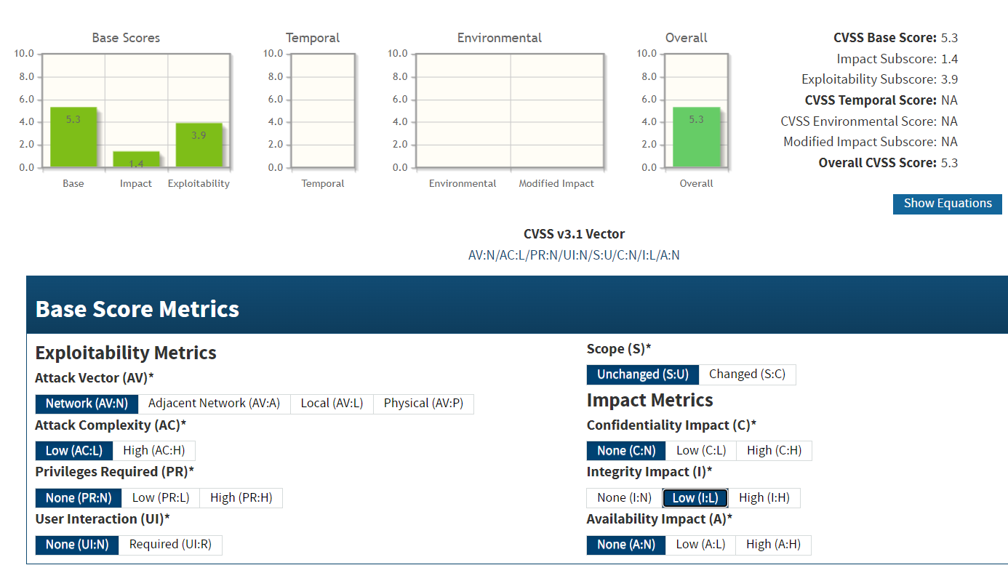

**CVE IDs:**

• CVE-2013-0169

**Affected Host**:

•47.241.101.3:8083 •124.117.225.66:44333 •124.117.225.66:44344 •187.251.108.186:3389 • 184.74.137.227 • 2.74.193.188:9001

**Exploitation Details**:

While the missing SAN does not directly allow code execution, it causes improper certificate validation. This may permit attackers to intercept or redirect traffic if clients are configured to ignore certificate errors, thereby facilitating MITM attacks.

**Recommended Remediation**:

* Issue SSL/TLS certificates that include a properly configured SAN field covering all relevant domain names and IP addresses.
* Update certificate issuance policies to align with modern security practices and client requirements.
* Replace any certificates lacking SAN with ones from a trusted Certificate Authority that includes a complete chain of trust.
* Regularly audit certificate configurations to ensure they meet current industry standards.

**References**:

<https://csrc.nist.gov/publications/detail/sp/800-57/rev-5/final>

<https://developer.mozilla.org/en-US/docs/Web/Security/Certificate_Transparency>

<https://cheatsheetseries.owasp.org/cheatsheets/Transport_Layer_Security_Cheat_Sheet.html>

* + 1. **Incorrect Certificate Key Usage  
       Threat Level**: **Medium (5.3)**

**Description**:

The SSL/TLS certificate used by the affected server is misconfigured with an incorrect key usage extension. This misconfiguration means that the certificate may be used for purposes that it was not intended for, undermining the trust and security of the TLS connection. Improper key usage can lead to improper validation by clients, potentially allowing for certificate misuse or an increased risk of man-in-the-middle (MITM) attacks if the certificate is accepted for unintended purposes.



**Potential Business Impact**:

Exploitation of this misconfiguration can result in:

* Clients incorrectly trusting the certificate for unauthorized uses.
* Increased susceptibility to MITM attacks if attackers exploit the certificate’s inappropriate usage.
* Degradation of overall trust in the secure communications, potentially affecting user confidence and compliance with security standards.

**CVSS 3.1 Score**



**CVE IDs:**

• N/A

**Affected Host**:

• 47.241.101.3:8083

**Exploitation Details**:

Attackers might leverage the incorrect key usage settings to misrepresent the certificate’s purpose, potentially tricking client applications into accepting the certificate for operations it is not meant to support. Although this vulnerability does not directly lead to code execution or data loss, it undermines the integrity of the certificate validation process and can contribute to broader security weaknesses.

**Recommended Remediation**:

* **Correct Certificate Configuration:** Reissue the certificate with the correct key usage extensions that align with its intended purpose.
* **Validate Certificate Policies:** Review and update certificate policies to ensure that key usage and extended key usage fields are properly set.
* **Monitor Certificate Validity:** Regularly audit certificates to ensure they comply with current security best practices and industry standards.

**References**:

<https://cheatsheetseries.owasp.org/cheatsheets/Transport_Layer_Security_Cheat_Sheet.html>

<https://forums.openvpn.net/viewtopic.php?t=10386>

<https://security.stackexchange.com/questions/244200/csr-with-no-keyusage-or-extendedkeyusage-specified-and-invalid-dns-in-commonname>

<https://stackoverflow.com/questions/44426745/certificate-key-usage-inadequate-for-attempted-operation-error-code-sec-error>

* + 1. **Missing Security Headers (X-Frame-Options and X-Content-Type-Options)  
       Threat Level**: **Medium (5.3)**

**Description**:

The affected systems are missing critical HTTP security headers—specifically, X-Frame-Options and X-Content-Type-Options. Without these headers, browsers do not have explicit instructions to prevent clickjacking (via X-Frame-Options) or to enforce strict MIME type checking (via X-Content-Type-Options). This misconfiguration can lead to security issues such as UI redress attacks and content sniffing vulnerabilities, which may expose users to unintended interactions or allow malicious content to be interpreted incorrectly. Although this vulnerability does not directly allow remote code execution, it undermines the overall security posture and can facilitate further attacks.



**Potential Business Impact**:

Exploitation of this misconfiguration may lead to:

* Increased risk of clickjacking attacks, where attackers trick users into performing unintended actions.
* Content sniffing issues that may cause browsers to misinterpret the nature of delivered content, potentially leading to security bypasses.
* Overall degradation of the security of the web application, reducing user trust and possibly causing compliance issues.

**CVSS 3.1 Score**



**CVE IDs:**

• N/A

**Affected Host**:

•47.241.101.3:83 •67.20.124.65:443 •185.146.86.135:80 •185.146.86.135:443  
•20.239.145.15:80 •20.239.145.15:443 •184.164.141.29:80 •103.56.148.203:443  
•103.56.148.203:80 •185.216.120.11:80 •185.216.120.11:443

•185.216.120.11:483 •51.79.65.16:9100 •51.79.65.16:4444

•51.79.65.16:8081 •198.245.53.101:4444 •198.245.53.101:8081  
•198.245.53.101:8005 •184.74.137.227:1112 •184.74.137.227:1111  
•207.148.103.159:80 •2.74.193.188:80 •142.132.207.118:80  
•142.132.207.118:443 •219.94.189.215:80 •219.94.189.215:443

•5.135.137.222:80 • 5.135.137.222:443

**Exploitation Details**:

Attackers might leverage the incorrect key usage settings to misrepresent the certificate’s purpose, potentially tricking client applications into accepting the certificate for operations it is not meant to support. Although this vulnerability does not directly lead to code execution or data loss, it undermines the integrity of the certificate validation process and can contribute to broader security weaknesses.

**Recommended Remediation**:

* **Correct Certificate Configuration:** Reissue the certificate with the correct key usage extensions that align with its intended purpose.
* **Validate Certificate Policies:** Review and update certificate policies to ensure that key usage and extended key usage fields are properly set.
* **Monitor Certificate Validity:** Regularly audit certificates to ensure they comply with current security best practices and industry standards.

**References**:

<https://developer.mozilla.org/en-US/docs/Web/HTTP/Headers/X-Frame-Options>

<https://developer.mozilla.org/en-US/docs/Web/HTTP/Headers/X-Content-Type-Options>

<https://owasp.org/www-project-secure-headers/>

* + 1. **Anonymous FTP Login  
       Threat Level**: **Medium (5.3)**

**Description**:

The FTP servers on the affected hosts are configured to allow anonymous login, meaning that users can access the FTP service without providing authentication credentials. This misconfiguration may enable unauthorized users to browse, download, or even upload files, depending on the server's permission settings. While anonymous FTP access might be acceptable in controlled environments, its presence on publicly accessible systems can expose sensitive data and facilitate further attacks.



**Potential Business Impact**:

Exploitation of this vulnerability can result in:

* Unauthorized access to files and directories hosted on the FTP server.
* Potential disclosure of sensitive information if confidential data is stored in the accessible directories.
* The possibility of file modifications or unauthorized uploads if write permissions are enabled.
* A stepping stone for further attacks on internal systems if sensitive information is exposed.

**CVSS 3.1 Score**

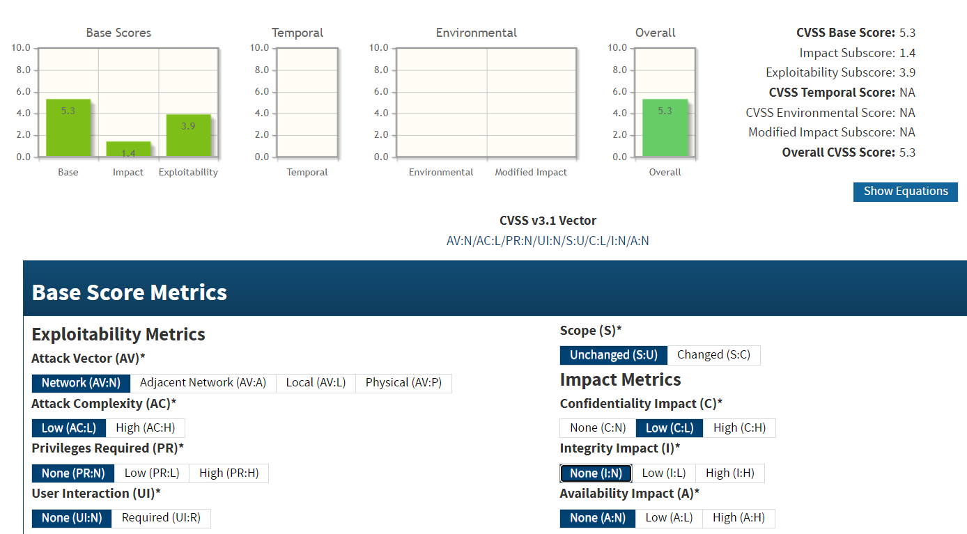

**CVE IDs:**

• N/A

**Affected Host**:

• 67.20.124.65:21 • 207.148.103.159:21

**Exploitation Details**:

An attacker can connect to the FTP service using a generic "anonymous" login without any password, then browse and interact with the files on the server. The ease of access may allow the attacker to gather sensitive data or modify server contents, leading to further compromise.

**Recommended Remediation**:

* **Disable Anonymous FTP Access**: If anonymous access is not required, configure the FTP server to require authentication for all users.
* **Restrict Access**: Limit FTP access to known and trusted IP addresses using firewalls or access control lists.
* **Review Permissions**: Audit and tighten file and directory permissions to ensure that sensitive data is not accessible to unauthorized users.
* **Monitor and Log**: Implement comprehensive logging of FTP activities and monitor for any unauthorized access attempts.

**References**:

<https://owasp.org/www-project-web-security-testing-guide/assets/archive/OWASP_Testing_Guide_v4.pdf>

<https://learn.microsoft.com/en-us/biztalk/core/best-practices-and-recommendations-for-the-ftp-adapter>

* + 1. **Reflective Denial of Service  
       Threat Level**: **Medium (5.3)**

**Description**:

The FTP service on the affected system is vulnerable to a reflective denial of service (DoS) attack. In a reflective DoS attack, an attacker sends spoofed requests to the FTP server, causing it to generate responses that are reflected to a target. This can lead to resource exhaustion and temporary unavailability of the service. Although no CVE ID has been assigned, the risk remains significant when the service is publicly accessible.

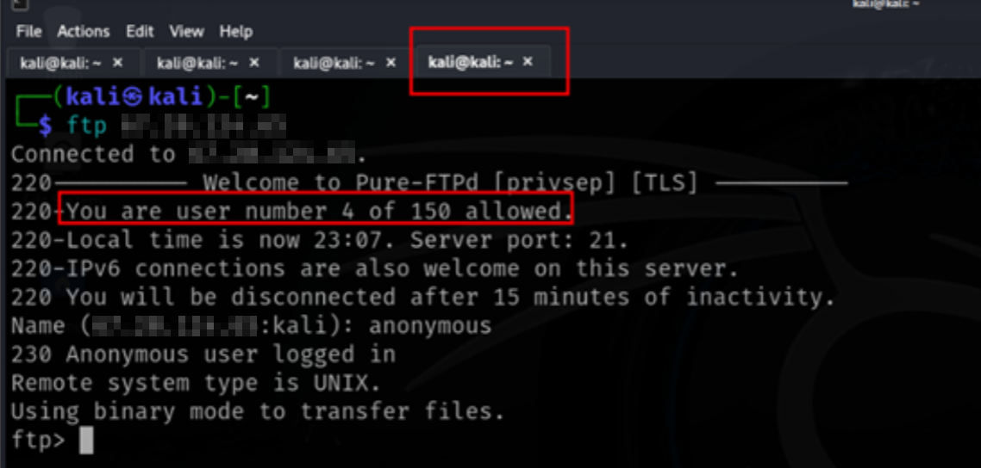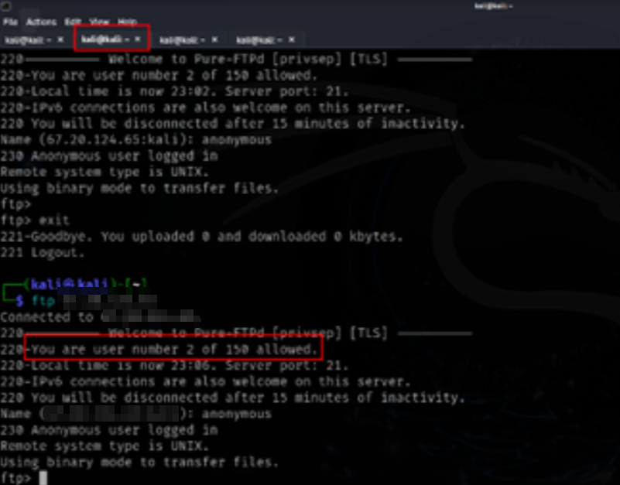**Potential Business Impact**:

Exploitation may result in:

* Service disruption due to resource exhaustion.
* Temporary unavailability of the FTP service.
* Indirect facilitation of further attacks if the service is used as a reflector in larger-scale DoS campaigns.

**CVSS 3.1 Score**

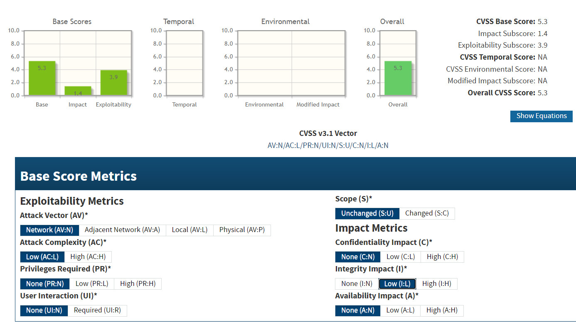

**CVE IDs:**

• N/A

**Affected Host**:

• 67.20.124.65:21

**Exploitation Details**:

Attackers can launch a reflective DoS attack by sending spoofed requests to the FTP server. The server, in turn, reflects large responses toward the victim, potentially overwhelming its network capacity and causing denial of service.

**Recommended Remediation**:

* **Rate Limiting**: Implement rate limiting on the FTP service to reduce the impact of high-volume requests.
* **Firewall Rules**: Configure firewalls to filter out spoofed traffic and block reflective attack patterns.
* **Disable Unnecessary Services**: If the FTP service is not required externally, consider restricting its access or disabling it.
* **Monitor Traffic**: Continuously monitor network traffic for anomalies indicative of a reflective DoS attack.

**References**:

<https://cheatsheetseries.owasp.org/cheatsheets/Denial_of_Service_Cheat_Sheet.html>

<https://datatracker.ietf.org/doc/html/rfc2663>

* + 1. **PostgreSQL Unsupported Frontend Protocol  
       Threat Level**: **Medium (5.3)**

**Description**:

The affected PostgreSQL server is misconfigured to accept connections using an unsupported frontend protocol version. Under normal circumstances, PostgreSQL clients and servers negotiate a protocol version from a defined set of supported versions. Allowing unsupported versions may lead to unexpected behavior—such as improper handling of connection requests, error disclosures, or service instability—which could be exploited to disrupt service or leak sensitive configuration details.

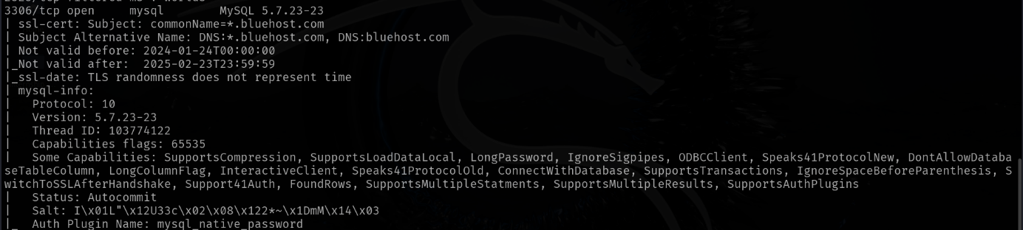

**Potential Business Impact**:

Exploitation of this vulnerability may lead to:

* Exposure of internal error messages or configuration details that could aid further attacks.
* Denial of service if the server enters an unstable state due to handling unexpected protocol versions.
* Overall degradation of the secure communication process, weakening trust in the system's ability to enforce standard protocol operations.

**CVSS 3.1 Score**

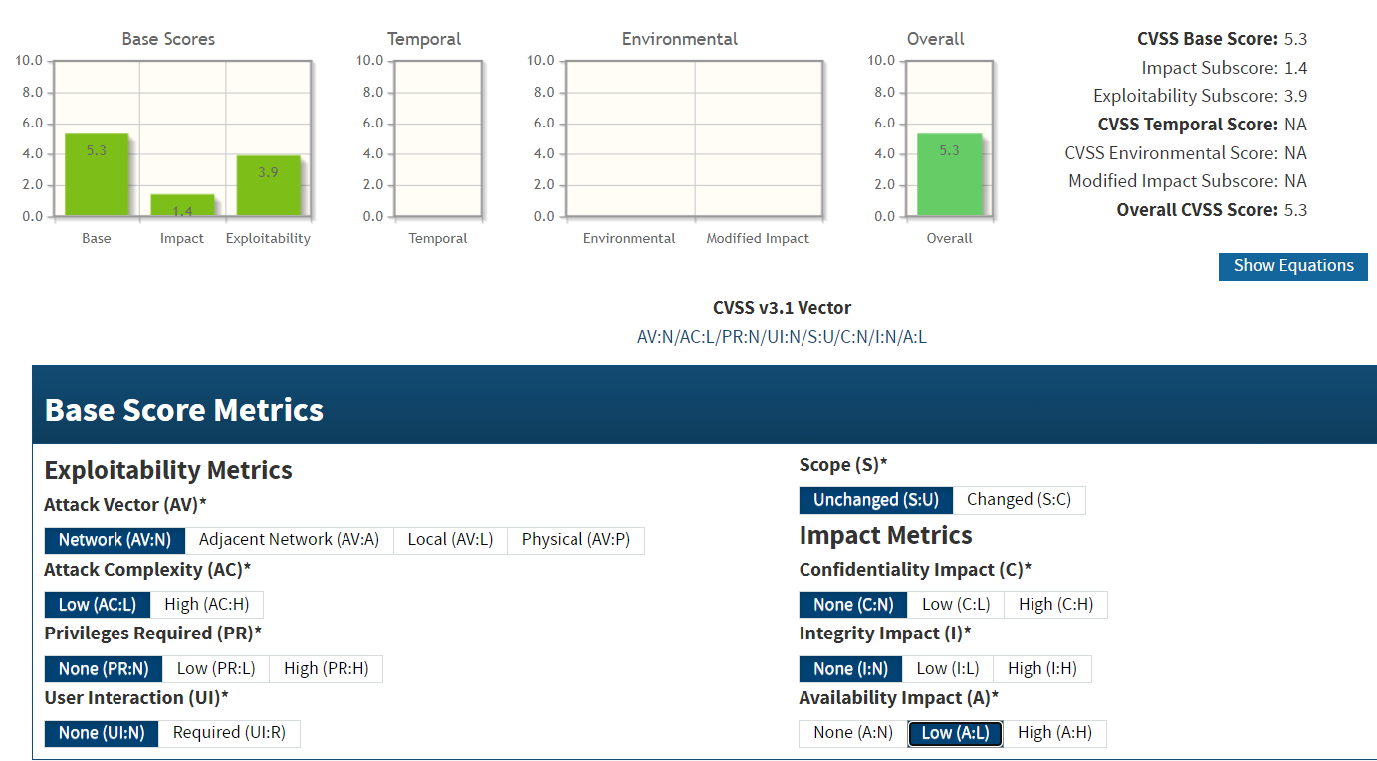

**CVE IDs:**

• N/A

**Affected Host**:

• 67.20.124.65:5432

**Exploitation Details**:

Attackers may send specially crafted connection requests using unsupported protocol versions. This can force the PostgreSQL server into an undefined state, potentially causing it to return error messages that expose internal details or to become unresponsive, thus enabling denial-of-service conditions.

**Recommended Remediation**:

* **Restrict Protocol Versions**: Configure the PostgreSQL server to accept only standardized, supported frontend protocol versions and to reject any unsupported connection attempts with secure error handling.
* **Upgrade or Harden Configuration**: Ensure that the PostgreSQL server is running a version that adheres strictly to the supported protocol standards, and review configuration settings to disable any fallback mechanisms that may allow unsupported protocols.
* **Regular Auditing**: Periodically audit the server's protocol settings and logs to detect any abnormal connection attempts and ensure compliance with best practices.

**References**:

<https://www.postgresql.org/docs/current/protocol.html>

<https://owasp.org/www-project-secure-coding-practices-quick-reference-guide/>

* + 1. **MySQL SSL Certificate Mismatch  
       Threat Level**: **Medium (5.3)**

**Description**:

The MySQL server is presenting an SSL certificate that does not match the expected hostname or domain, resulting in a certificate mismatch. This misconfiguration can cause clients to receive security warnings or fail to establish a secure connection. If users ignore these warnings, it may facilitate man-in-the-middle (MITM) attacks, thereby compromising the confidentiality and integrity of data transmitted over the connection.

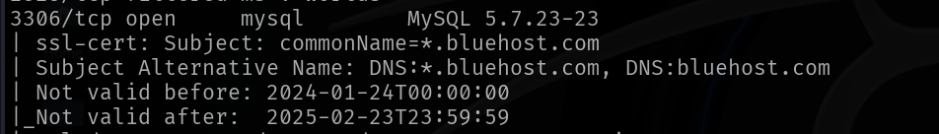

**Potential Business Impact**:

Exploitation can lead to:

* Clients potentially bypassing certificate warnings, exposing data to MITM attacks.
* Interception or alteration of sensitive data during transmission.
* Connection failures that may disrupt MySQL services.

**CVSS 3.1 Score**



**CVE IDs:**

• N/A

**Affected Host**:

• 67.20.124.65:3306

**Exploitation Details**:

Attackers may exploit this certificate mismatch by intercepting the connection when clients ignore the mismatch warnings. This can enable an attacker to impersonate the MySQL server and eavesdrop on or alter data in transit.

**Recommended Remediation**:

* **Correct the Certificate**: Reissue and install an SSL certificate with the correct Common Name (CN) and Subject Alternative Name (SAN) fields that match the server’s hostname.
* **Update Configuration**: Ensure that both the MySQL server and client configurations enforce strict certificate validation.
* **Monitor and Audit**: Regularly review SSL/TLS configurations and audit for certificate mismatches to maintain secure connections.

**References**:

<https://developer.mozilla.org/en-US/docs/Web/HTTP/Headers/Strict-Transport-Security>

<https://dev.mysql.com/doc/refman/8.0/en/using-encrypted-connections.html>

<https://cheatsheetseries.owasp.org/cheatsheets/Transport_Layer_Security_Cheat_Sheet.html>

* + 1. **Weak TLS Randomness in IMAP and POP3  
       Threat Level**: **Medium (5.3)**

**Description**:

The affected system is running IMAP and POP3 services that employ TLS for secure communications. However, the TLS implementation suffers from weak randomness during key generation, which can undermine the strength of the encryption keys established during the handshake. Insufficient randomness makes it easier for an attacker to predict or reproduce key material, potentially compromising the confidentiality of transmitted data. Although no CVE ID has been assigned, this misconfiguration poses a medium risk to the security of the affected services.



**Potential Business Impact**:

Exploitation of weak TLS randomness can lead to:

* Reduced confidentiality of data transmitted over IMAP/POP3 sessions.
* Increased risk of man-in-the-middle (MITM) attacks, as attackers might derive encryption keys.
* Potential exposure of sensitive information if encrypted sessions are compromised.

**CVSS 3.1 Score**



**CVE IDs:**

• N/A

**Affected Host**:

• 67.20.124.65

**Exploitation Details**:

Attackers can target the weak randomness by capturing multiple TLS handshake sessions and performing statistical analysis to infer parts of the encryption keys. Although this process may require significant computational effort and may not result in complete decryption, it undermines the intended security of the TLS-encrypted IMAP and POP3 communications.

**Recommended Remediation**:

* **Upgrade TLS Libraries**: Update to a TLS implementation that utilizes a robust source of randomness and adheres to current cryptographic standards.
* **Enforce Secure Configurations**: Reconfigure the IMAP and POP3 services to use modern, secure cipher suites and ensure proper randomness is applied during key generation.
* **Regular Auditing**: Conduct periodic security assessments of TLS configurations to verify compliance with best practices and industry standards.

**References**:

<https://csrc.nist.gov/pubs/sp/800/90/a/r1/final>

<https://datatracker.ietf.org/doc/html/rfc5246>

<https://cheatsheetseries.owasp.org/cheatsheets/Transport_Layer_Security_Cheat_Sheet.html>

* + 1. **Missing HTTP Strict Transport Security (HSTS)  
       Threat Level**: **Medium (5.3)**

**Description**:

The affected web servers do not implement the HTTP Strict Transport Security (HSTS) header. HSTS instructs browsers to enforce HTTPS-only connections for a specified period, preventing downgrade attacks and reducing the risk of man-in-the-middle interception. Without HSTS, clients may unknowingly connect over insecure HTTP, making them vulnerable to interception and data manipulation.



**Potential Business Impact**:

Exploitation can result in attackers forcing insecure connections, intercepting sensitive data, and potentially modifying the transmitted information. This degrades the overall security of user communications, leads to loss of confidentiality and integrity, and may cause compliance issues or reputational damage.

**CVSS 3.1 Score**



**CVE IDs:**

• N/A

**Affected Host**:

•67.20.124.65:443  •67.20.124.65:2087 •67.20.124.65:2083 •67.20.124.65:2096 •185.146.86.135:443 •20.239.145.15:443 •184.164.141.29:443 •103.56.148.203:887 •103.56.148.203:36583 •47.108.37.191:443 •185.216.120.11:443 •185.216.120.11:483 •185.216.120.11:5001 •184.74.137.227:1112 •207.148.103.159:443 •142.132.207.118:443 •219.94.189.215:443 • 5.135.137.222:443 • 5.135.137.222:443

**Exploitation Details**:

Attackers can take advantage of the missing HSTS header by intercepting or redirecting insecure HTTP requests, even when an HTTPS option is available. Users who ignore browser warnings might be tricked into connecting over HTTP, enabling man-in-the-middle attacks that capture or alter sensitive data.

**Recommended Remediation**:

* **Implement HSTS**: Configure web servers to include the HSTS header (e.g., Strict-Transport-Security: max-age=31536000; includeSubDomains; preload).
* **Enforce HTTPS**: Ensure that all website resources are exclusively served over HTTPS.
* **Regular Auditing**: Continuously review server configurations to maintain compliance with current security best practices.

**References**:

<https://www.checkbot.io/guide/security/hsts/>

<https://developer.mozilla.org/en-US/docs/Web/HTTP/Headers/Strict-Transport-Security>

* + 1. **Domain Name Mismatch in SSL Certificate  
       Threat Level**: **Medium (5.3)**

**Description**:

The SSL/TLS certificate installed on the affected servers does not match the domain name used to access the service. This misconfiguration results in a broken chain of trust, leading browsers to display certificate warnings. When users bypass these warnings, attackers can perform man-in-the-middle (MITM) attacks by impersonating the intended server. Although this vulnerability does not directly enable code execution, it compromises the integrity of secure connections and may lead to data disclosure.



**Potential Business Impact**:

* Clients may encounter persistent security warnings, which can erode user trust and lead to insecure practices such as ignoring certificate errors.
* Increased risk of MITM attacks, where attackers intercept or modify data transmitted over the supposedly secure connection.
* Overall degradation of secure communication, potentially exposing sensitive data to unauthorized access.

**CVSS 3.1 Score**



**CVE IDs:**

• N/A

**Affected Host**:

• 67.20.124.65:443 • 67.20.124.65:2087 • 67.20.124.65:2083 • 67.20.124.65:2096 •124.117.225.66:44344 •185.146.86.135:443 •185.146.86.135:2096 •20.239.145.15:443 •103.56.148.203:443 •185.216.120.11:443 •185.216.120.11:5001 •142.132.207.118:443 •219.94.189.215:443 •5.135.137.222:443 • 5.135.137.222:443

**Exploitation Details**:

Attackers can take advantage of the certificate mismatch by setting up a rogue server with a certificate that appears valid for the expected domain. If users proceed past browser warnings, the attacker can intercept and potentially modify the data exchanged, compromising confidentiality and integrity.

**Recommended Remediation**:

* **Reissue the Certificate**: Obtain a new SSL/TLS certificate with the correct Common Name (CN) and Subject Alternative Name (SAN) fields matching the server’s domain.
* **Update Certificate Management**: Ensure that all certificates are properly configured and regularly audited to avoid mismatches in the future.
* **Enforce Strict Validation**: Configure client applications to strictly enforce certificate validation and not allow bypassing of security warnings.
* **User Education**: Inform users of the risks associated with bypassing certificate warnings.

**References**:

<https://developer.mozilla.org/en-US/docs/Web/Security/Certificate_errors>

<https://cheatsheetseries.owasp.org/cheatsheets/Transport_Layer_Security_Cheat_Sheet.html>

* + 1. **Secure Client-Initiated Renegotiation  
       Threat Level**: **Medium (5.3)**

**Description**:

The affected system supports client-initiated TLS renegotiation that is not securely implemented, as described by CVE-2011-1473. Insecure renegotiation can allow a malicious client to initiate repeated or manipulated renegotiation processes that bypass proper security checks. This vulnerability may be exploited to interfere with the secure communication channel—potentially enabling man-in-the-middle attacks or causing resource exhaustion on the server.



**Potential Business Impact**:

Exploitation of insecure client-initiated renegotiation may result in:

* Unauthorized manipulation of the secure connection through MITM attacks.
* Denial of service via resource exhaustion if the renegotiation is abused.
* Potential data injection or alteration during renegotiation phases, undermining communication integrity.

**CVSS 3.1 Score**

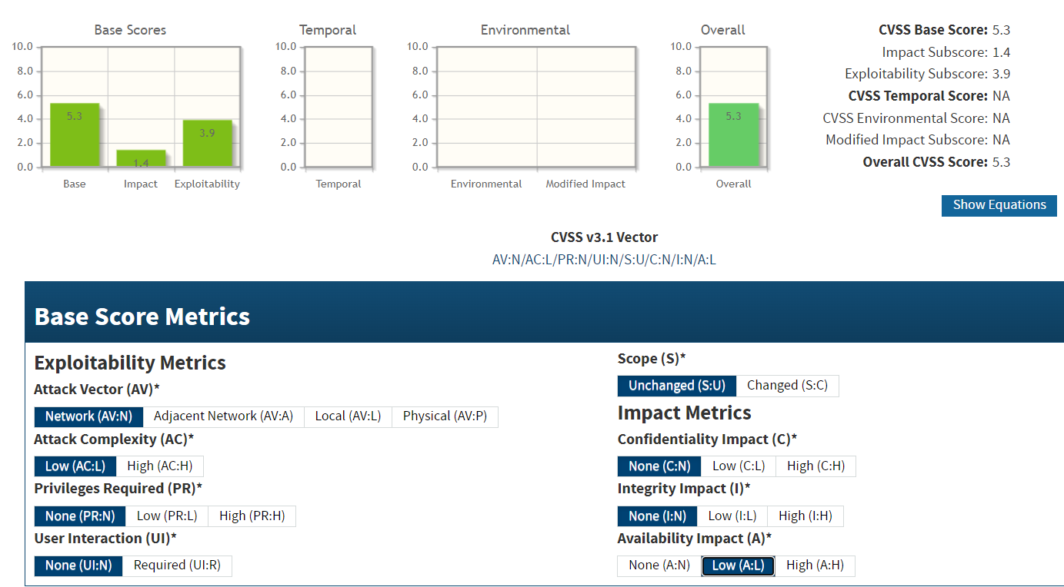

**CVE IDs:**

• CVE-2011-1473

**Affected Host**:

•67.20.124.65:2087 •67.20.124.65:2096 •185.146.86.135:2096 •207.148.103.159:443

**Exploitation Details**:

Attackers can exploit this vulnerability by sending specially crafted renegotiation requests that bypass standard security measures. By triggering insecure renegotiation, an attacker might either degrade the performance of the server (DoS) or manipulate the data transmitted during the TLS session.

**Recommended Remediation**:

* **Disable Insecure Renegotiation**: If client-initiated renegotiation is not required, disable it entirely.
* **Apply Software Updates**: Upgrade to versions of TLS libraries and server software that implement secure renegotiation per RFC 5746.
* **Enforce Secure TLS Policies**: Configure the server to enforce strict renegotiation requirements, ensuring that renegotiation requests are properly authenticated and validated.
* **Monitor TLS Activity**: Continuously audit and monitor TLS connection behavior for anomalous renegotiation patterns.

**References**:

<https://nvd.nist.gov/vuln/detail/CVE-2011-1473>

<https://www.rfc-editor.org/rfc/rfc5746>

<https://owasp.org/www-project-web-security-testing-guide/latest/4-Web_Application_Security_Testing/09-Testing_for_Weak_Cryptography/01-Testing_for_Weak_Transport_Layer_Security>

* + 1. **Directory Listing  
       Threat Level**: **Medium (5.3)**

**Description**:

The affected web servers are misconfigured to allow directory listing, exposing the contents of directories that should remain private. This vulnerability enables attackers to view and enumerate files and subdirectories, potentially revealing sensitive information such as configuration files, source code, and other confidential data. The exposure of these details can facilitate further targeted attacks on the system.

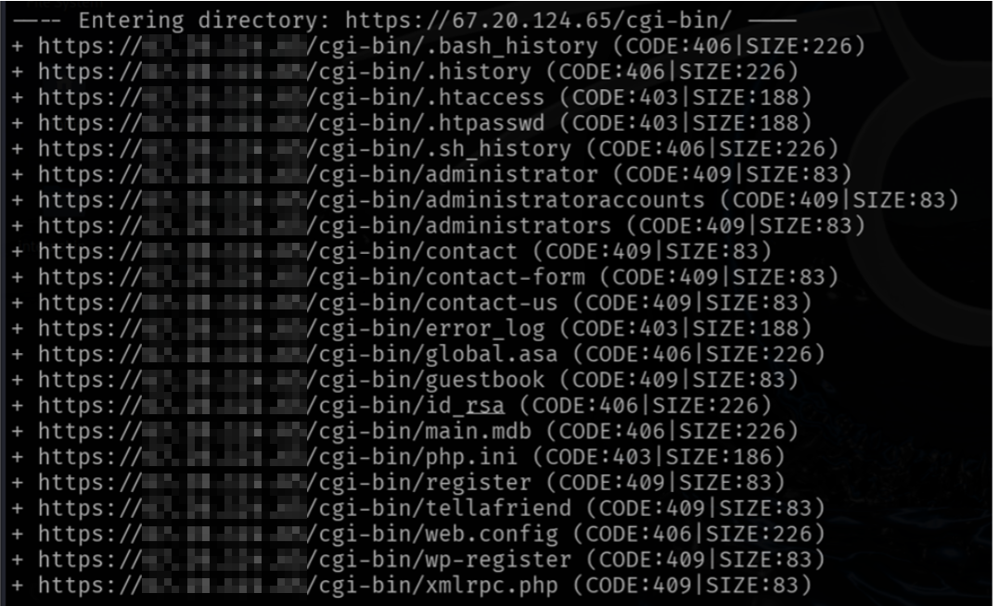

**Potential Business Impact**:

Exploitation can lead to unauthorized disclosure of sensitive information, which might include:

* Exposure of configuration files and credentials
* Leakage of application source code
* Facilitation of further attacks due to increased insight into the server's structure  
  This can result in regulatory non-compliance, financial losses, and damage to reputation.

**CVSS 3.1 Score**



**CVE IDs:**

•CVE-2001-0500 •CVE-2017-11610 •CVE-2021-22156 • CVE-2019-0227

**Affected Host**:

• 67.20.124.65:443 • 185.146.86.135:80 • 20.239.145.15:443

• 207.148.103.159

**Exploitation Details**:

Attackers can simply navigate to the affected directories via a web browser or automated tools, bypassing authentication if directory listing is enabled. This unintentional disclosure provides attackers with valuable information that can be used to plan more sophisticated attacks.

**Recommended Remediation**:

* Disable directory listing in the web server configuration files (e.g., using "Options -Indexes" in Apache).
* Restrict access to sensitive directories through proper authentication and authorization controls.
* Regularly audit file permissions and server configurations to ensure that only intended files are publicly accessible.
* Use a web application firewall (WAF) to detect and block unauthorized directory enumeration attempts.

**References**:

<https://httpd.apache.org/docs/current/mod/core.html#options>

<https://nvd.nist.gov/vuln/detail/CVE-2001-0500>

<https://nvd.nist.gov/vuln/detail/CVE-2017-11610>

<https://nvd.nist.gov/vuln/detail/CVE-2021-22156>

<https://nvd.nist.gov/vuln/detail/CVE-2019-0227>

<https://cwe.mitre.org/data/definitions/548.html>

* + 1. **DNS Subdomain Enumeration  
       Threat Level**: **Medium (5.3)**

**Description**:

The affected system (191.82.121.191) is potentially vulnerable to DNS subdomain enumeration. This vulnerability arises when the DNS server or associated applications inadvertently disclose subdomain information, allowing attackers to map the network's structure and identify additional targets. Although there is no CVE ID assigned, the exposure of subdomain data can facilitate further attacks by revealing sensitive infrastructure details.

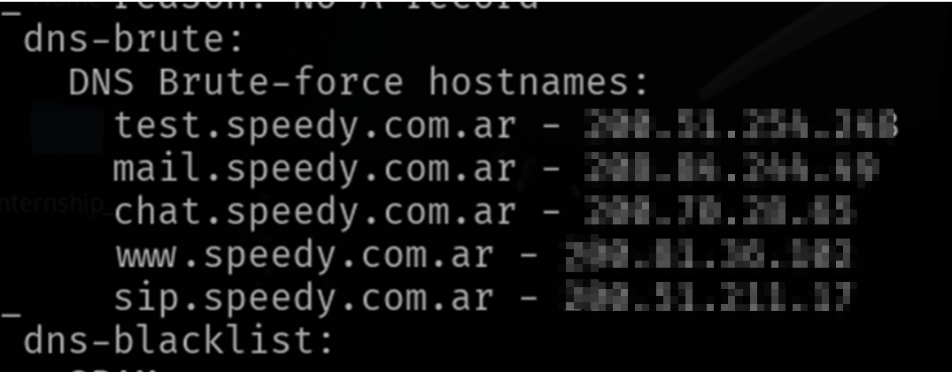

**Potential Business Impact**:

Exploitation can lead to:

* Unauthorized mapping of the organization's network.
* Identification of additional vulnerable hosts or services for targeted attacks.
* Enhanced reconnaissance capabilities for attackers, potentially leading to data breaches or further system compromise.

**CVSS 3.1 Score**

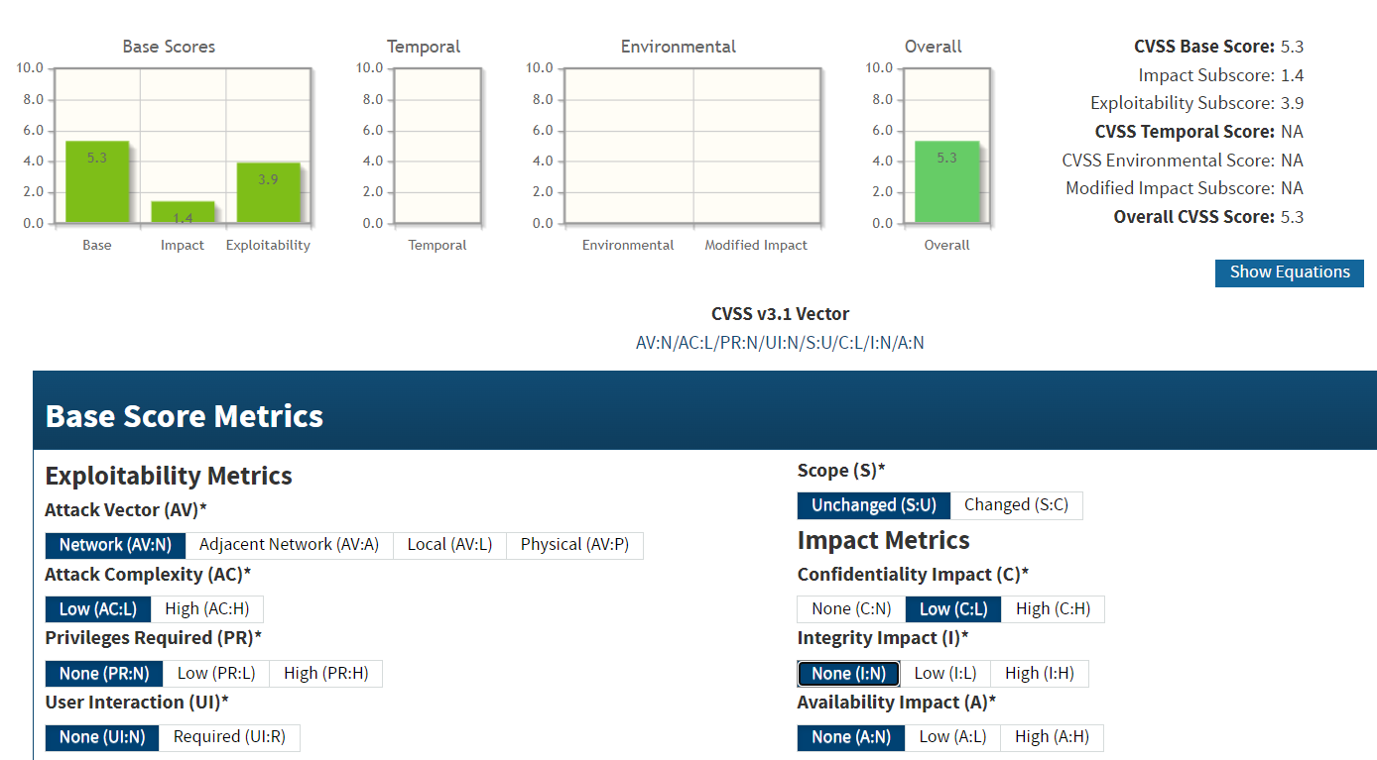

**CVE IDs:**

• N/A

**Affected Host**:

• 191.82.121.191

**Exploitation Details**:

Attackers can perform DNS subdomain enumeration by querying public DNS servers or using automated tools to discover subdomains. The information gathered may include hostnames, IP addresses, and details about internal infrastructure, which can be leveraged to launch further targeted attacks.

**Recommended Remediation**:

* **Harden DNS Configurations**: Configure DNS servers to minimize unnecessary disclosure of subdomain information.
* **Implement Access Controls**: Limit public exposure of internal DNS records by using split-horizon DNS or other segmentation techniques.
* **Monitor DNS Queries**: Use DNS monitoring tools to detect and alert on unusual enumeration activities.
* **Review Public Records**: Regularly audit publicly available DNS records to ensure that sensitive subdomain information is not exposed.

**References**:

<https://www.infoblox.com/dns-security-resource-center/dns-security-best-practices/>

<https://www.linkedin.com/pulse/subdomain-enumeration-kamal-suryawanshi>

<https://workbook.securityboat.net/Pentesting/Web%20Application/subdomain-enumeration/>

* + 1. **Incomplete Certificate Chain  
       Threat Level**: **Medium (5.3)**

**Description**:

The SSL/TLS configuration on the affected systems is misconfigured with an incomplete certificate chain. This means that the server’s certificate is not accompanied by all necessary intermediate certificates, which can lead to validation errors in client browsers and applications. As a result, users may receive security warnings or be forced to bypass these warnings, potentially exposing them to man-in-the-middle (MITM) attacks. The incomplete chain also undermines the overall trust of the secure connection and may cause compliance issues.



**Potential Business Impact**:

Exploitation may result in:

* Users encountering certificate warnings and potentially bypassing security checks.
* Increased risk of MITM attacks due to weakened trust in the SSL/TLS connection.
* Regulatory non-compliance and reputational damage if secure communications are compromised.

**CVSS 3.1 Score**



**CVE IDs:**

• N/A

**Affected Host**:

•124.117.225.66:44344 •124.117.225.66:44344 •2.74.193.188:9001 •142.132.207.118:8006

**Exploitation Details**:

Attackers might take advantage of the incomplete certificate chain by intercepting connections where clients have been conditioned to ignore security warnings. This can allow them to present a fraudulent certificate that appears valid to users, enabling MITM attacks.

**Recommended Remediation**:

* **Complete the Certificate Chain**: Reconfigure the server to include all necessary intermediate certificates along with the server certificate.
* **Verify Configuration**: Use SSL/TLS configuration testing tools (e.g., SSL Labs) to ensure that the certificate chain is complete and trusted.
* **Enforce Strict Validation**: Configure client applications to enforce strict certificate validation and reject incomplete chains.
* **Monitor and Audit**: Regularly audit SSL/TLS configurations to maintain a robust chain of trust.

**References**:

<https://cheatsheetseries.owasp.org/cheatsheets/Transport_Layer_Security_Cheat_Sheet.html>

<https://connect.mozilla.org/t5/ideas/developer-certifications-by-mozilla/idi-p/23904>

* + 1. **Use of SHA-I Signature Algorithm  
       Threat Level**: **Medium (5.3)**

**Description**:

The affected systems are configured to use the SHA-1 signature algorithm in their cryptographic processes. SHA-1 is considered weak due to its vulnerability to collision attacks, where an attacker can generate two different inputs producing the same hash value. This can compromise the integrity of digital signatures, making it possible for an attacker to forge signatures and undermine the authenticity of data or communications. Although no CVE ID is assigned to this specific misconfiguration, its use presents a significant security risk and should be replaced with a stronger hash algorithm such as SHA-256.



**Potential Business Impact**:

Exploitation of this vulnerability may result in:

* Forged digital signatures that undermine the authenticity of software, documents, and communications.
* Increased risk of man-in-the-middle (MITM) attacks, as attackers may use collision techniques to substitute legitimate data with malicious content.
* Potential compliance issues and reputational damage if outdated cryptographic practices are discovered.

**CVSS 3.1 Score**



**CVE IDs:**

• N/A

**Affected Host**:

• 124.117.225.66:44333 • 185.216.120.11:483 • 2.74.193.188:9001

**Exploitation Details**:

Attackers can exploit the weakness in SHA-1 by generating hash collisions, potentially allowing them to forge digital signatures and impersonate trusted entities. Such exploitation undermines the reliability of secure communications and can be used as a stepping stone for further attacks.

**Recommended Remediation**:

* **Upgrade Cryptographic Algorithms**: Replace SHA-1 with more secure alternatives like SHA-256 or SHA-3 in all cryptographic operations.
* **Update Software and Configurations**: Ensure that cryptographic libraries and application settings are configured to use strong, modern hash algorithms.
* **Regular Auditing**: Periodically review cryptographic practices to verify that outdated algorithms are not in use and compliance with current security standards is maintained.

**References**:

<https://en.wikipedia.org/wiki/SHA-1>

<https://csrc.nist.gov/pubs/sp/800/107/r1/final>

<https://cheatsheetseries.owasp.org/cheatsheets/Cryptographic_Storage_Cheat_Sheet.html>

* + 1. **LOGJAM Vulnerability  
       Threat Level**: **Medium (4.3)**

**Description**:

The Logjam vulnerability, identified by CVE-2015-4000, exploits weaknesses in the Diffie-Hellman key exchange process. By leveraging weak Diffie-Hellman parameters, an attacker can downgrade the encryption used in TLS connections, potentially enabling the decryption of sensitive communications. Although the base score is 4.3, which indicates a medium severity level, the impact can be significant in environments relying on the affected key exchange mechanism.



**Potential Business Impact**:

Exploitation can result in:

* Reduced confidentiality of encrypted communications.
* Potential interception and decryption of sensitive data.
* Increased risk of man-in-the-middle (MITM) attacks when weak Diffie-Hellman parameters are used.

**CVSS 3.1 Score**

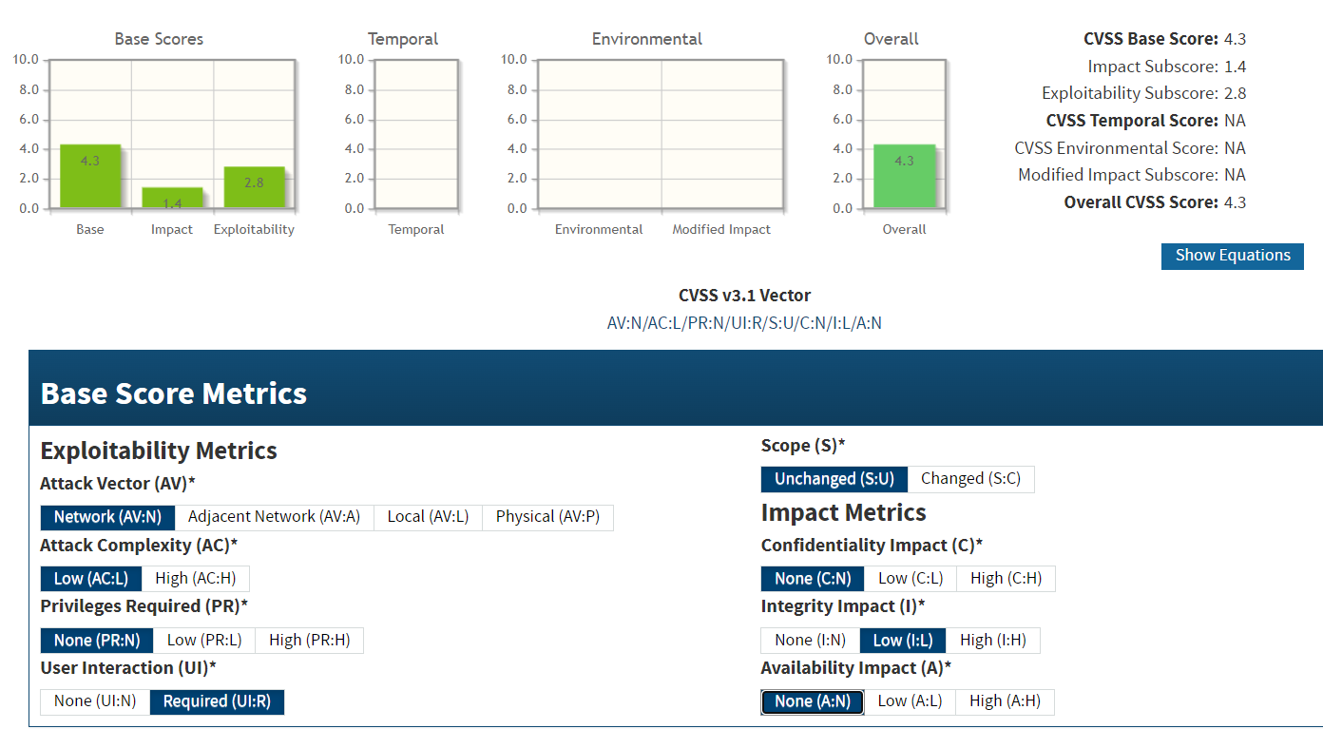

**CVE IDs:**

• CVE-2015-4000

**Affected Host**:

• 124.117.225.66:44333 • 20.239.145.15:443

**Exploitation Details**:

Attackers can exploit the weakness in SHA-1 by generating hash collisions, potentially allowing them to forge digital signatures and impersonate trusted entities. Such exploitation undermines the reliability of secure communications and can be used as a stepping stone for further attacks.

**Recommended Remediation**:

* **Upgrade Cryptographic Algorithms**: Replace SHA-1 with more secure alternatives like SHA-256 or SHA-3 in all cryptographic operations.
* **Update Software and Configurations**: Ensure that cryptographic libraries and application settings are configured to use strong, modern hash algorithms.
* **Regular Auditing**: Periodically review cryptographic practices to verify that outdated algorithms are not in use and compliance with current security standards is maintained.

**References**:

<https://nvd.nist.gov/vuln/detail/CVE-2015-4000>

<https://owasp.org/www-community/attacks/Log_Injection>

<https://crypto.stackexchange.com/questions/81992/should-i-use-self-generated-or-predefined-rfc-7919-dh-groups>

* + 1. **Weak SSL/TLS Configuration  
       Threat Level**: **Medium (5.3)**

**Description**:

The affected systems are configured with weak SSL/TLS settings that do not adhere to current security best practices. This misconfiguration may include support for outdated protocols, weak cipher suites, and suboptimal security settings, all of which reduce the overall strength of encrypted connections. As a result, these servers are more susceptible to downgrade attacks, man-in-the-middle (MITM) interceptions, and other cryptographic attacks that can compromise the confidentiality and integrity of data.

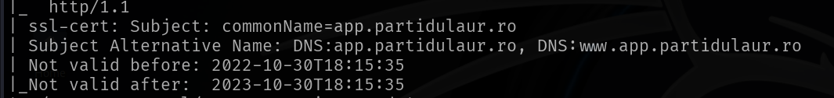

**Potential Business Impact**:

Insecure SSL/TLS configurations can lead to:

* Increased risk of MITM attacks that intercept or modify sensitive data.
* Unauthorized disclosure of confidential information.
* Degradation of trust in the organization’s online services.
* Potential non-compliance with regulatory standards regarding data protection.

**CVSS 3.1 Score**



**CVE IDs:**

• N/A

**Affected Host**:

•185.146.86.135:443 •185.146.86.135:110 •185.146.86.135:143 •184.74.137.227 • 2.74.193.188:9100

**Exploitation Details**:

Attackers may exploit weak SSL/TLS configurations by forcing connections to use insecure protocols or cipher suites. This can facilitate downgrade attacks or enable cryptographic analysis that weakens the encryption, ultimately allowing the attacker to intercept or manipulate data transmitted over these connections.

**Recommended Remediation**:

* **Upgrade Protocols**: Disable support for outdated protocols (e.g., SSL 3.0, TLS 1.0) and enforce the use of TLS 1.2 or higher.
* **Update Cipher Suites**: Configure servers to use strong, modern cipher suites while disabling weak ciphers.
* **Review SSL/TLS Settings**: Audit the SSL/TLS configuration regularly using tools such as SSL Labs to ensure compliance with best practices.
* **Implement Strict Security Policies**: Enforce policies that require secure configurations for all SSL/TLS deployments.

**References**:

<https://developer.mozilla.org/en-US/docs/Web/Security>

<https://csrc.nist.gov/pubs/sp/800/52/r2/final>

* + 1. **Open NRPE Service  
       Threat Level**: **Medium (5.3)**

**Description**:

The affected system is running the Nagios Remote Plugin Executor (NRPE) service, which is accessible on the public network via port 5666. NRPE is designed for secure, authenticated execution of monitoring plugins on remote hosts. However, when left open to the public without proper access controls or encryption, it can allow unauthorized users to connect, execute commands, or enumerate sensitive information about the monitored system. This misconfiguration increases the risk of unauthorized access and potential subsequent exploitation.



**Potential Business Impact**:

Exploitation of an open NRPE service may result in:

* Unauthorized execution of monitoring commands, leading to disclosure of sensitive system details.
* Increased risk of lateral movement and further attacks on the network.
* Potential compromise of the system if attackers gain additional footholds through misused NRPE functionality.

**CVSS 3.1 Score**



**CVE IDs:**

• N/A

**Affected Host**:

• 185.146.86.135:5666

**Exploitation Details**:

Attackers can target the NRPE service by directly connecting to it and attempting to execute allowed commands. Without proper access restrictions, the service may disclose configuration details and system status information, aiding further attacks.

**Recommended Remediation**:

* **Restrict Access:** Limit NRPE access to trusted IP addresses using firewalls, VPNs, or access control lists.
* **Harden NRPE Configuration:** Configure strong authentication mechanisms and consider encrypting NRPE traffic to prevent interception.
* **Disable Public Access:** If NRPE is not required to be publicly accessible, bind it only to internal network interfaces.
* **Monitor and Audit:** Continuously monitor network activity for unauthorized NRPE access attempts and audit service configurations regularly.

**References**:

<https://owasp.org/www-project-secure-coding-practices-quick-reference-guide/>

<https://exchange.nagios.org/directory/Documentation/Official-NRPE-Documentation/details>

* + 1. **Risky HTTP Methods Enabled  
       Threat Level**: **Medium (5.3)**

**Description**:

The affected web server at 20.239.145.15 is configured to allow risky HTTP methods. Enabling methods such as PUT, DELETE, TRACE, or CONNECT (if applicable) increases the attack surface by potentially allowing unauthorized file manipulation, information disclosure, or other malicious actions. This misconfiguration may allow attackers to exploit these methods to bypass intended security controls, leading to further compromise of the web infrastructure.

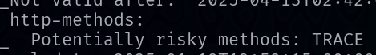

**Potential Business Impact**:

Exploitation of this vulnerability can lead to:

* Unauthorized file uploads, deletions, or modifications.
* Disclosure of sensitive information through methods like TRACE or OPTIONS.
* Increased risk of defacement or further penetration into the network.

**CVSS 3.1 Score**



**CVE IDs:**

• N/A

**Affected Host**:

• 20.239.145.15:80 • 20.239.145.15:443

**Exploitation Details**:

Attackers may exploit the enabled HTTP methods to perform various malicious actions such as uploading a web shell via PUT, deleting or modifying web content via DELETE, or gathering sensitive server information using TRACE or OPTIONS. This can be used as a stepping stone for further attacks on the server or internal network.

**Recommended Remediation**:

* **Restrict HTTP Methods**: Configure the web server to disable non-essential and risky HTTP methods (e.g., PUT, DELETE, TRACE, CONNECT) unless absolutely required.
* **Implement Access Controls**: Use firewall rules or server configuration settings to limit allowed HTTP methods to only those necessary for legitimate operations.
* **Audit Server Configurations**: Regularly review and update HTTP method settings in accordance with security best practices.
* **Deploy a WAF**: Utilize a web application firewall to monitor, detect, and block malicious requests exploiting risky HTTP methods.

**References**:

<https://developer.mozilla.org/en-US/docs/Web/HTTP/Methods>

<https://cheatsheetseries.owasp.org/cheatsheets/REST_Security_Cheat_Sheet.html>

* + 1. **FTP Service Exposed  
       Threat Level**: **Medium (6.5)**

**Description**:

The FTP service on the affected host is openly exposed on standard (port 21) and secure (port 990) channels without proper access restrictions. This exposure increases the risk of unauthorized access, file enumeration, and potential misuse of the FTP service. Attackers may attempt brute-force attacks, exploit misconfigurations, or leverage the open service to upload and download files, which could lead to data disclosure or further compromise of the system.

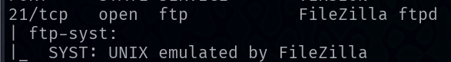



**Potential Business Impact**:

Exploitation of the exposed FTP service can result in:

* Unauthorized access to files stored on the server.
* Exposure of sensitive data if access controls are weak.
* Potential misuse of the service for uploading malicious content or pivoting to further internal attacks.
* Disruption of normal business operations if the service is compromised.

**CVSS 3.1 Score**

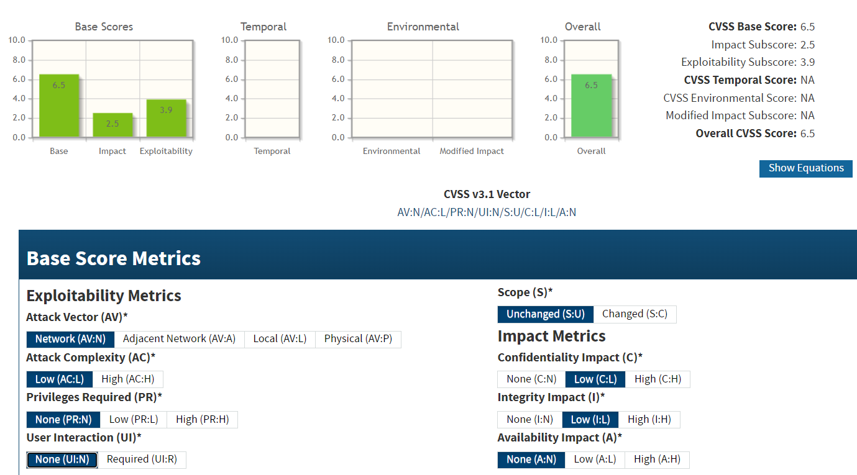

**CVE IDs:**

• N/A

**Affected Host**:

• 20.239.145.15:21 • 20.239.145.15:990

**Exploitation Details**:

Attackers can connect to the FTP service without proper authentication if anonymous access is enabled, or they may exploit weak credentials to gain access. This can lead to file enumeration, data theft, and possibly the insertion of malicious files into the server’s file system.

**Recommended Remediation**:

* **Restrict Access:** Limit FTP access to trusted IP addresses using firewalls or VPNs.
* **Harden Authentication:** Disable anonymous FTP login and enforce strong authentication methods.
* **Secure Configuration:** Configure the FTP server to use secure options (for example, FTPS on port 990 should be properly hardened) and disable any unnecessary features.
* **Regular Auditing:** Monitor FTP logs and conduct regular security audits to detect unauthorized access attempts.

**References**:

<https://owasp.org/www-project-web-security-testing-guide/v41/4-Web_Application_Security_Testing/02-Configuration_and_Deployment_Management_Testing/01-Test_Network_Infrastructure_Configuration>

<https://support.cerberusftp.com/hc/en-us/articles/360000499020-Securing-Cerberus-FTP-Server-Best-Practices-for-Enhanced-Security>

* + 1. **MikroTik Bandwidth Test Service Exposure  
       Threat Level**: **Medium (5.3)**

**Description**:

The MikroTik Bandwidth Test service, running on port 2000, is publicly exposed. This service is typically used for testing network throughput between devices, but when left exposed, it can be exploited by attackers to perform network scanning, data exfiltration, or even launch denial-of-service (DoS) attacks by overloading the service. The exposure of such administrative or testing services increases the attack surface and may lead to unauthorized access or misuse of network resources.



**Potential Business Impact**:

Exploitation of this service may result in:

* Unauthorized access to network performance metrics.
* Potential use of the service to launch further network-based attacks.
* Disruption of network testing capabilities and degradation of overall network security posture.

**CVSS 3.1 Score**



**CVE IDs:**

• N/A

**Affected Host**:

• 102.212.121.116:2000

**Exploitation Details**:

Attackers can probe the exposed MikroTik Bandwidth Test service to gather information about network capacity and performance. In some cases, attackers may also leverage the service to trigger unexpected behavior or overload the system, leading to service disruption. Although no specific CVE IDs have been assigned, the risk arises from the unnecessary exposure of a service that is intended for internal diagnostic use.

**Recommended Remediation**:

* **Restrict Access:** Limit access to the MikroTik Bandwidth Test service by using firewall rules or VPNs to ensure that it is only accessible from trusted internal networks.
* **Disable if Unnecessary:** If the service is not required for regular operations, consider disabling it entirely.
* **Harden Configuration:** Ensure that the service is securely configured with appropriate access controls and monitoring.
* **Regular Auditing:** Periodically audit exposed services to ensure that only essential services are accessible from the Internet.

**References**:

<https://cheatsheetseries.owasp.org/cheatsheets/Web_Service_Security_Cheat_Sheet.html>

<https://help.mikrotik.com/docs/spaces/ROS/pages/328059/RouterOS>

* + 1. **ETag Header Information Leakage  
       Threat Level**: **Medium (5.3)**

**Description**:

The affected web server is disclosing sensitive information through the ETag HTTP header. ETags are used for caching purposes, but when they include details such as file metadata or inode numbers, they can inadvertently reveal internal server information. This vulnerability (CVE-2003-1418) may allow an attacker to gather insights into the server's file system structure and other sensitive details, potentially aiding further reconnaissance and targeted attacks.



**Potential Business Impact**:

Exploitation of this vulnerability may lead to:

* Disclosure of internal file system metadata and configuration details.
* Enhanced ability for attackers to conduct targeted reconnaissance and plan further attacks.
* Possible compromise of user privacy or system integrity if the leaked information is leveraged in subsequent exploits.

**CVSS 3.1 Score**



**CVE IDs:**

• CVE-2003-1418

**Affected Host**:

• 102.212.121.116:443

**Exploitation Details**:

An attacker can simply monitor HTTP responses to extract the ETag header values. If these headers contain sensitive information (such as file inode numbers or other metadata), the attacker can use this data to deduce server configurations and file system structure, which can be valuable for further targeted attacks.

**Recommended Remediation**:

* **Modify ETag Generation:** Reconfigure the web server to generate generic ETag values that do not disclose internal details.
* **Disable ETag Headers:** If caching is not critical, consider disabling the ETag header entirely.
* **Review Server Configuration:** Ensure that no sensitive information is inadvertently included in HTTP headers.
* **Regular Auditing:** Periodically audit HTTP responses for leakage of sensitive metadata.

**References**:

<https://owasp.org/www-project-secure-headers/>

<https://nvd.nist.gov/vuln/detail/CVE-2003-1418>

* + 1. **Cross-Site Request Forgery (CSRF)  
       Threat Level**: **Medium (6.1)**

**Description**:

This vulnerability arises when a web application does not properly implement protections against Cross-Site Request Forgery (CSRF) attacks. In such scenarios, an attacker can trick an authenticated user into executing unwanted actions on a web application without their consent. Although no CVE ID has been assigned to this particular misconfiguration, the risk is significant because it may allow unauthorized modifications or actions to be carried out on behalf of the user.

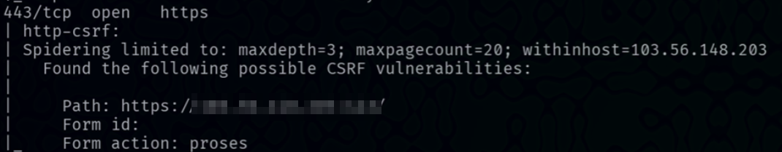

**Potential Business Impact**:

Exploitation can lead to:

* Unauthorized actions executed in the context of a legitimate user’s session.
* Modification of sensitive data or user settings without consent.
* Potential escalation of privileges if critical operations are triggered.
* Loss of data integrity and increased risk of further attacks through compromised sessions.

**CVSS 3.1 Score**

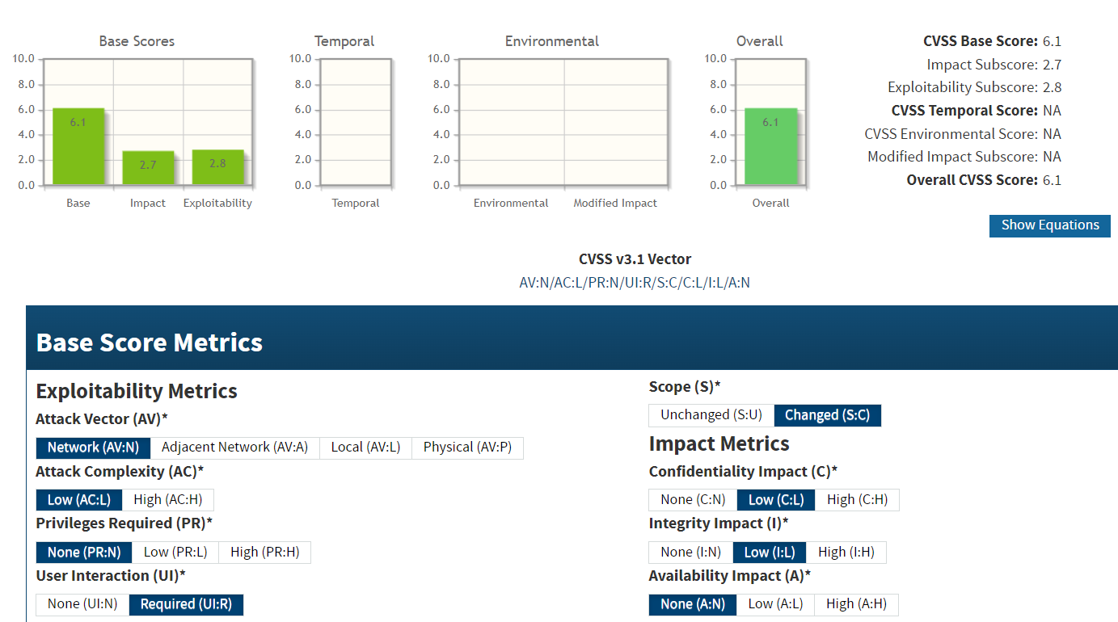

**CVE IDs:**

• CVE-2003-1418

**Affected Host**:

• 103.56.148.203:443 • 207.148.103.159 • 128.32.220.18:443

**Exploitation Details**:

An attacker may craft a malicious webpage or email containing hidden requests that, when visited by an authenticated user, automatically submits forms or triggers actions on the vulnerable application. This can occur without the user's explicit knowledge, leveraging their existing session credentials to perform harmful operations.

**Recommended Remediation**:

* **Implement Anti-CSRF Tokens**: Ensure that all state-changing requests include a secure, unpredictable token that is verified on the server side.
* **Use SameSite Cookies**: Configure cookies with the "SameSite" attribute to restrict cross-origin requests.
* **Validate the Referer Header**: Where possible, verify that requests originate from trusted sources.
* **User Education**: Inform users about the dangers of clicking on links from untrusted sources and ensure that web interfaces provide clear warnings when suspicious activities are detected.

**References**:

<https://developer.mozilla.org/en-US/docs/Glossary/CSRF>

<https://owasp.org/www-project-web-security-testing-guide/latest/4-Web_Application_Security_Testing/06-Session_Management_Testing/05-Testing_for_Cross_Site_Request_Forgery>

* + 1. **Session Tickets are Supported  
       Threat Level**: **Medium (4.8)**

**Description**:

The affected server at 103.56.148.203:443 has TLS session tickets enabled. While session tickets improve performance by allowing session resumption without a full handshake, they introduce security risks if the ticket encryption key is not managed properly. Without regular key rotation and secure storage, an attacker who compromises the session ticket key may be able to decrypt or replay sessions. Although no CVE ID is assigned to this specific misconfiguration, the use of session tickets without adequate security measures can undermine the overall strength of TLS connections.



**Potential Business Impact**:

* Attackers may capture and decrypt session tickets if the encryption key is compromised, leading to exposure of sensitive data.
* Session resumption may be abused to replay sessions, bypassing full authentication.
* Overall trust in the secure communication channel is reduced, increasing the risk of further exploitation.

**CVSS 3.1 Score**

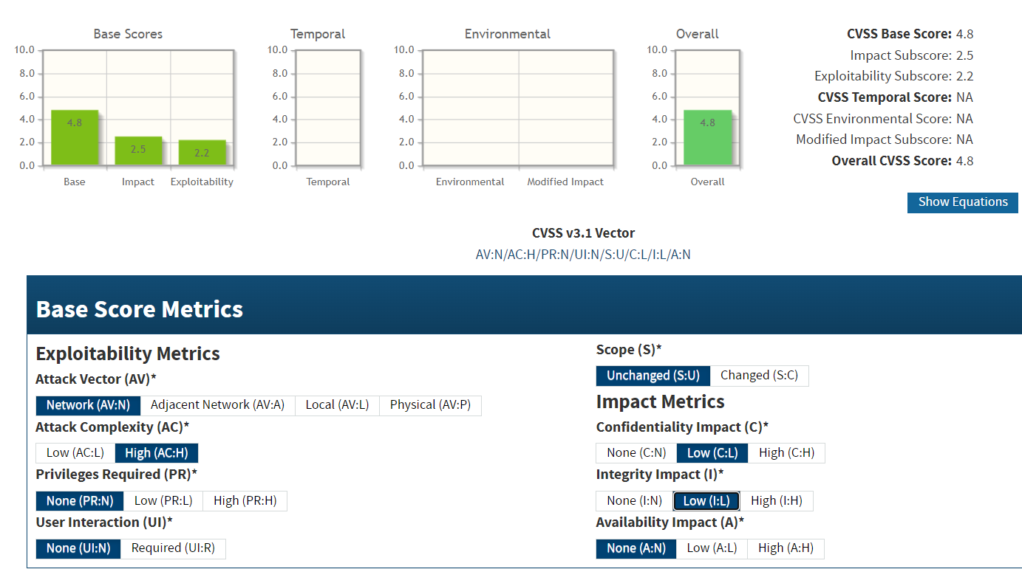

**CVE IDs:**

• N/A

**Affected Host**:

• 103.56.148.203:443

**Exploitation Details**:

An attacker positioned to intercept TLS traffic could capture session tickets. If the ticket encryption key is weak or not rotated regularly, the attacker may be able to decrypt the tickets to recover session details or use them for replay attacks, undermining the confidentiality and integrity of the connection.

**Recommended Remediation**:

* **Implement Robust Key Management:** Ensure that session ticket encryption keys are rotated frequently and stored securely.
* **Assess Necessity of Session Tickets:** If session tickets are not essential, consider disabling them to eliminate this risk.
* **Enforce Strong TLS Configurations:** Update the TLS configuration to support only modern cipher suites and disable features that are not required.
* **Regular Auditing:** Periodically review and test the TLS setup to verify that session ticket mechanisms are securely configured.

**References**:

<https://csrc.nist.gov/pubs/sp/800/52/r2/final>

<https://datatracker.ietf.org/doc/html/rfc5077>

<https://cheatsheetseries.owasp.org/cheatsheets/Transport_Layer_Security_Cheat_Sheet.html>

* + 1. **Cookies Are Not Marked as Secure  
       Threat Level**: **Medium (6.5)**

**Description**:

The affected web application does not mark its cookies with the Secure attribute. Without this flag, cookies can be transmitted over non-encrypted HTTP connections if users inadvertently access the site using HTTP, potentially exposing sensitive session data to interception. This misconfiguration can facilitate session hijacking and man-in-the-middle (MITM) attacks, thereby compromising user sessions and sensitive information.



**Potential Business Impact**:

Exploitation of this vulnerability can lead to:

* Unauthorized access to user sessions via session hijacking.
* Exposure of sensitive data if cookies containing authentication tokens are intercepted.
* Increased risk of MITM attacks, especially on untrusted networks.

**CVSS 3.1 Score**

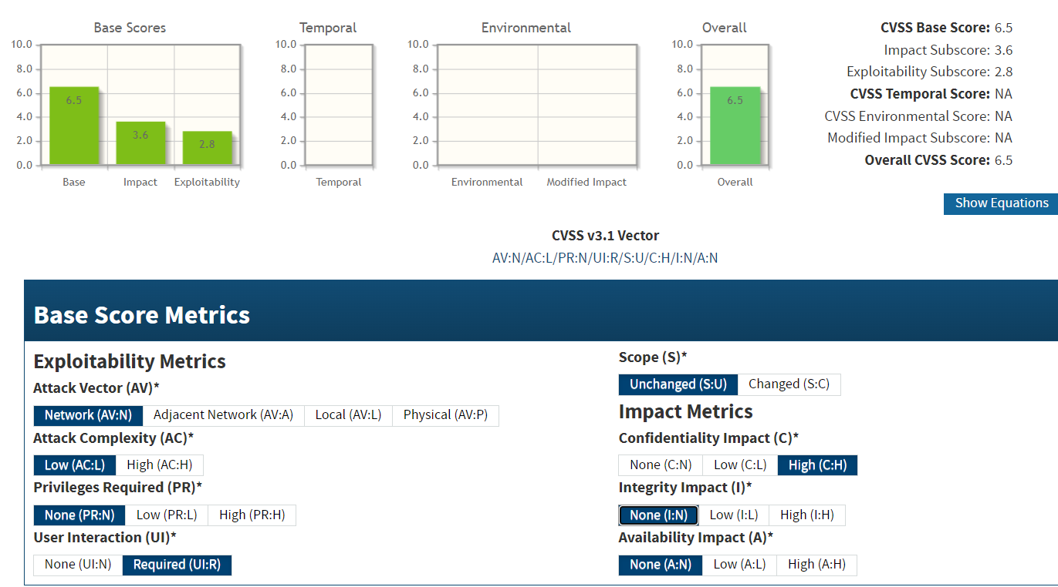

**CVE IDs:**

• N/A

**Affected Host**:

• 103.56.148.203:443 • 219.94.189.215:443

**Exploitation Details**:

Attackers can intercept cookies that lack the Secure attribute by exploiting insecure network channels or by inducing users to connect over HTTP instead of HTTPS. This can allow the attacker to capture and reuse session cookies, ultimately impersonating legitimate users.

**Recommended Remediation**:

* **Mark Cookies as Secure:** Configure the web server or application framework to include the Secure flag on all cookies that contain sensitive or authentication information.
* **Use HttpOnly Flag:** In addition to the Secure attribute, use the HttpOnly flag to reduce the risk of client-side script access to cookie data.
* **Enforce HTTPS:** Ensure that the application enforces HTTPS for all connections to prevent accidental use of unsecured channels.
* **Regular Auditing:** Periodically audit cookie configurations and web application security settings to confirm adherence to best practices.

**References**:

<https://developer.mozilla.org/en-US/docs/Web/HTTP/Cookies>

<https://cheatsheetseries.owasp.org/cheatsheets/Session_Management_Cheat_Sheet.html>

* + 1. **Invalid or Misconfigured Bucket  
       Threat Level**: **Medium (5.3)**

**Description**:

The affected system (47.108.37.191) is hosting a bucket that is either invalidly configured or misconfigured, leading to unintended public access. This misconfiguration can result in overly permissive access controls—allowing unauthorized users to list, view, or even modify the stored content. Exposure of such a bucket increases the risk of sensitive data leakage and may provide attackers with valuable insights into the system's structure and data, potentially facilitating further attacks.

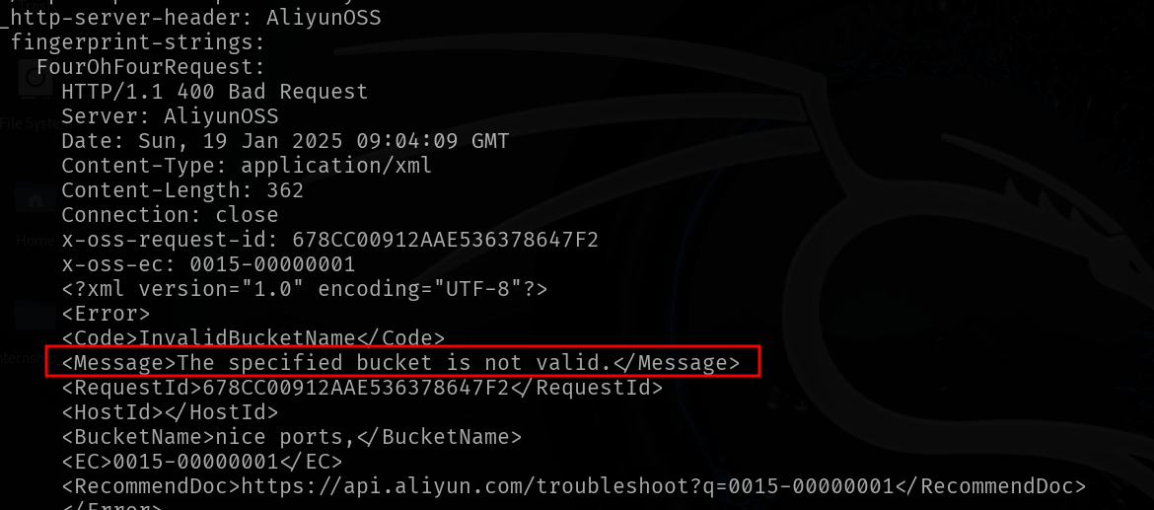

**Potential Business Impact**:

Exploitation of the misconfigured bucket can result in:

* Unauthorized disclosure of sensitive data stored in the bucket.
* Potential data manipulation or deletion, leading to service disruption or data loss.
* Increased risk of compliance violations and reputational damage due to data leakage.

**CVSS 3.1 Score**



**CVE IDs:**

• N/A

**Affected Host**:

**•** 47.108.37.191

**Exploitation Details**:

Attackers can easily access the bucket if it is publicly exposed or if its access controls are not properly configured. Simple URL browsing or automated scanning tools can enumerate the bucket’s contents, revealing file structures and sensitive information that could be used to launch more targeted attacks.

**Recommended Remediation**:

* **Review Bucket Configuration:** Audit and correct the bucket’s access control policies to ensure that only authorized users have access.
* **Enforce Authentication:** Implement robust authentication and authorization mechanisms to restrict access to the bucket.
* **Monitor and Audit:** Regularly review access logs and monitor bucket activity for signs of unauthorized access.
* **Apply Best Practices:** Follow industry guidelines and vendor recommendations for secure bucket configuration, such as those provided for cloud storage services.

**References**:

<https://docs.aws.amazon.com/AmazonS3/latest/userguide/security-best-practices.html>

<https://owasp.org/www-project-mobile-top-10/2023-risks/m9-insecure-data-storage>

<https://cloud.google.com/trust-center/security>

* + 1. **Exposed Backup/Certificate Files  
       Threat Level**: **Medium (5.3)**

**Description**:

The affected systems are exposing backup and certificate files, which may contain sensitive configuration data, private keys, and other critical information. This vulnerability is linked to known issues (CVE-2017-12627, CVE-2018-19207) that highlight the risks associated with unintended public access to such files. If attackers gain access to these files, they could leverage the information to compromise secure communications or further infiltrate the system.



**Potential Business Impact**:

Exploitation may result in:

* Disclosure of sensitive cryptographic keys and certificates, undermining the security of encrypted communications.
* Exposure of backup data containing configuration files and confidential information.
* Increased risk of unauthorized access, data breaches, and further compromise of the affected systems.

**CVSS 3.1 Score**



**CVE IDs:**

• CVE-2017-12627 • CVE-2018-19207

**Affected Host**:

• 185.216.120.11:80 • 185.216.120.11:443 • 51.79.65.16:9100 • 207.148.103.159:80

**Exploitation Details**:

Attackers can access these exposed files by navigating directly to their URLs if directory listing or improper access controls are in place. Once obtained, the leaked files may provide detailed insights into the server’s configuration and sensitive data, facilitating further targeted attacks.

**Recommended Remediation**:

* **Restrict Access:** Ensure that backup and certificate files are stored in non-public directories and are not accessible via the web server.
* **Secure Storage:** Protect sensitive files with strong access controls and encryption at rest.
* **Disable Directory Listing:** Configure the web server to prevent directory listing, thereby reducing the chance of accidental file exposure.
* **Regular Auditing:** Conduct periodic security audits to verify that sensitive files are not inadvertently exposed and that access permissions are properly configured.

**References**:

<https://nvd.nist.gov/vuln/detail/CVE-2017-12627>

<https://nvd.nist.gov/vuln/detail/CVE-2018-19207>

<https://owasp.org/www-project-secure-coding-practices-quick-reference-guide/>

* + 1. **Use of Default or Weak SSH Keys  
       Threat Level**: **Medium (5.3)**

**Description**:

The affected systems are using default or weak SSH keys that have not been replaced or securely generated. This vulnerability can allow attackers to bypass the intended authentication process and gain unauthorized access to the systems via SSH. Using default or weak keys significantly undermines the security of the SSH service, potentially enabling remote code execution, data exfiltration, or further network compromise.

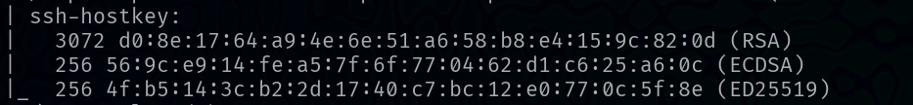

**Potential Business Impact**:

* Unauthorized remote access via SSH, leading to potential system takeover.
* Exposure of sensitive data and configuration settings.
* Increased risk of lateral movement within the network by compromising a trusted system.

**CVSS 3.1 Score**



**CVE IDs:**

• CVE-2017-12627 • CVE-2018-19207

**Affected Host**:

• 144.217.240.87 • 51.79.65.16

**Exploitation Details**:

Attackers can exploit this vulnerability by leveraging known default SSH keys or by using brute-force methods to crack weak keys. Once access is gained, the attacker can execute commands remotely, change system configurations, and potentially use the compromised system as a pivot point to launch further attacks within the network.

**Recommended Remediation**:

* **Replace Default Keys:** Immediately replace all default SSH keys with securely generated ones using a strong random number generator.
* **Enforce Strong Key Policies:** Require the use of robust key types and lengths (e.g., RSA 2048-bit or higher, or strong ECDSA keys).
* **Regular Auditing:** Periodically review SSH configurations and key management practices to ensure compliance with security best practices.
* **Restrict SSH Access:** Limit SSH access to known and trusted IP addresses, and consider implementing multi-factor authentication (MFA) for SSH sessions.

**References**:

<https://csrc.nist.gov/pubs/sp/800/52/r2/final>

<https://cheatsheetseries.owasp.org/index.html>

* + 1. **Outdated Python Version  
       Threat Level**: **Medium (5.3)**

**Description**:

The affected system is running an outdated version of Python that lacks the latest security patches and improvements. Using an unsupported or obsolete Python version increases the risk that known vulnerabilities—either within Python itself or in its associated libraries—can be exploited. This misconfiguration may allow attackers to execute arbitrary code, access sensitive data, or disrupt system operations.



**Potential Business Impact**:

Exploitation of this vulnerability could lead to:

* Unauthorized execution of code on the server.
* Exposure of sensitive data or compromise of applications that rely on Python.
* Increased risk of further system compromise as attackers leverage known weaknesses in the outdated environment.

**CVSS 3.1 Score**



**CVE IDs:**

• CVE-2017-12627 • CVE-2018-19207

**Affected Host**:

• 51.79.65.16:8081 • 198.245.53.101:8081 • 198.245.53.101:8005

**Exploitation Details**:

Attackers may exploit vulnerabilities present in older Python versions or in outdated libraries to execute arbitrary code, perform injection attacks, or escalate privileges. The lack of recent security patches makes it easier for adversaries to leverage publicly known exploits against the system.

**Recommended Remediation**:

* **Upgrade Python:** Update to the latest supported version of Python that includes all recent security patches.
* **Review Dependencies:** Ensure that all Python libraries and dependencies are updated to secure versions.
* **Harden Configurations:** Follow Python security best practices to configure the environment securely.
* **Regular Auditing:** Periodically audit the Python environment and its components for compliance with current security standards.

**References**:

<https://cheatsheetseries.owasp.org/index.html>

<https://www.python.org/dev/security/>

* + 1. **GoAhead WebServer Exposure  
       Threat Level**: **Medium (6.5)**

**Description**:

The affected GoAhead WebServer is exposed on multiple ports, potentially revealing sensitive administrative interfaces or internal server information. Vulnerabilities in the web server can allow remote attackers to gain unauthorized access or gather valuable intelligence about the system, which could be used as a foothold for further attacks.

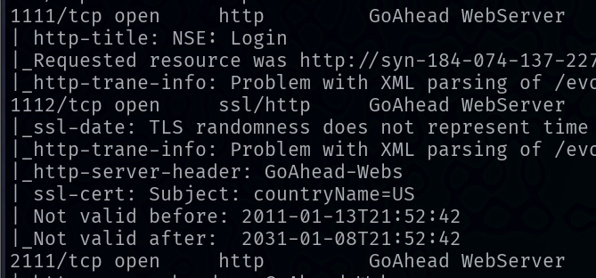

**Potential Business Impact**:

Exploitation of this vulnerability may result in:

* Unauthorized access to administrative functions or sensitive configuration data.
* Disclosure of internal server information that could facilitate further exploitation.
* Compromise of system integrity and potential service disruption, leading to operational and reputational damage.

**CVSS 3.1 Score**

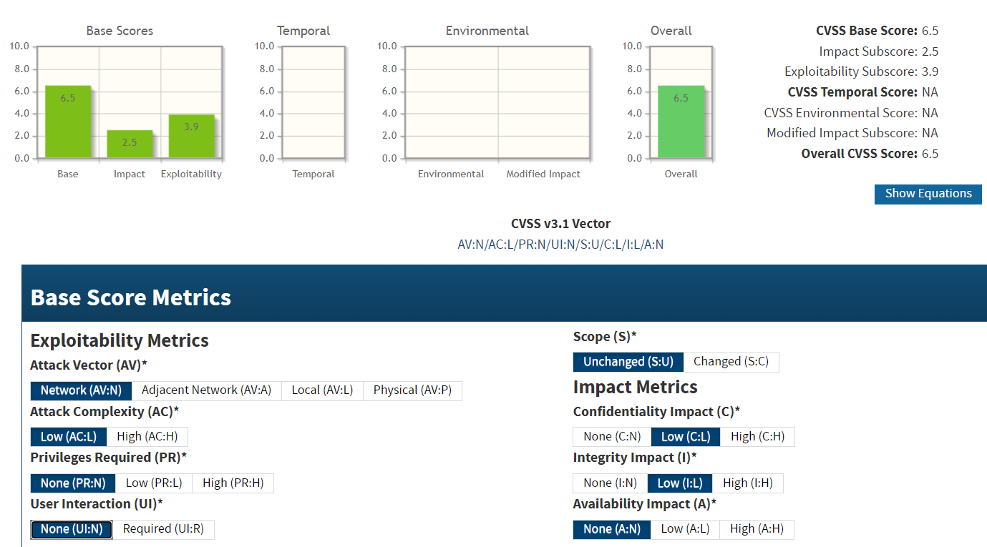

**CVE IDs:**

• CVE-2017-17562 • CVE-2021-42342

**Affected Host**:

• 184.74.137.227:1111 • 184.74.137.227:1112 • 184.74.137.227:2111

**Exploitation Details**:

Remote attackers may probe the exposed GoAhead WebServer for misconfigurations and vulnerabilities. By exploiting CVE-2017-17562 or CVE-2021-42342, an attacker could bypass access controls or retrieve sensitive information, which can be used to orchestrate further attacks against the infrastructure.

**Recommended Remediation**:

* **Apply Patches/Updates:** Update the GoAhead WebServer to a version that addresses CVE-2017-17562 and CVE-2021-42342.
* **Restrict Access:** Use firewall rules, VPNs, or IP whitelisting to limit external access to the web server, particularly its administrative interfaces.
* **Harden Configuration:** Review and adjust the server’s configuration to disable unnecessary services and to enforce strict access controls.
* **Monitor Activity:** Implement logging and continuous monitoring to detect any unauthorized access attempts or probing activities targeting the web server.

**References**:

<https://nvd.nist.gov/vuln/detail/CVE-2017-17562>

<https://nvd.nist.gov/vuln/detail/CVE-2021-42342>

<https://owasp.org/www-project-secure-coding-practices-quick-reference-guide/>

* + 1. **Stored Cross-Site Scripting (XSS) Vulnerability  
       Threat Level**: **Medium (6.5)**

**Description**:

The web application hosted on the affected server is vulnerable to stored cross-site scripting (XSS). This vulnerability occurs when user-supplied input is not properly sanitized before being stored in the database and later displayed to other users. An attacker can inject malicious scripts that are persistently stored and executed in the context of a victim’s browser, potentially leading to session hijacking, data theft, or defacement.

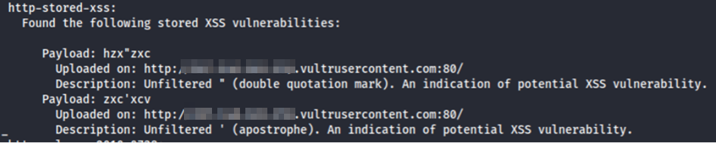

**Potential Business Impact**:

Exploitation can result in:

* Unauthorized disclosure of sensitive information, such as session tokens and personal data.
* Execution of malicious actions in the user’s browser without their consent.
* Damage to the organization’s reputation if users are exposed to harmful content.
* Potential for further attacks leveraging the compromised user sessions.

**CVSS 3.1 Score**

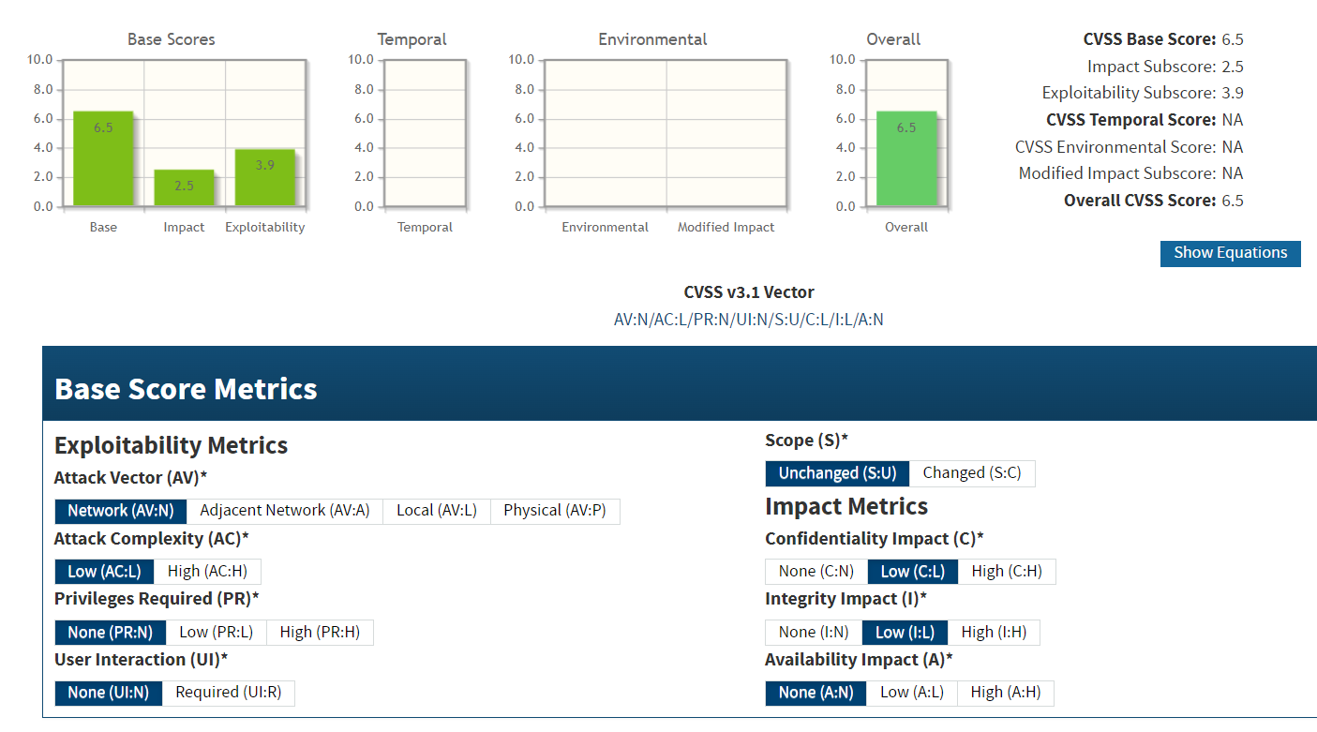

**CVE IDs:**

• N/A

**Affected Host**:

• 207.148.103.159

**Exploitation Details**:

Attackers can inject malicious JavaScript into vulnerable input fields. Once stored, this script is delivered to users when they access affected pages. When executed, it may capture sensitive data or perform unauthorized actions within the user’s session.

**Recommended Remediation**:

* **Sanitize Input and Encode Output:** Ensure all user-supplied data is properly sanitized on input and safely encoded when displayed to prevent script execution.
* **Implement Content Security Policy (CSP):** Deploy CSP headers to restrict the execution of untrusted scripts and mitigate the impact of XSS attacks.
* **Conduct Regular Security Testing:** Perform periodic vulnerability assessments and code reviews to identify and remediate XSS flaws.
* **User Awareness:** Educate users on the risks of XSS and advise them to report any unusual behavior.

**References**:

<https://owasp.org/www-community/attacks/xss/>

<https://cheatsheetseries.owasp.org/cheatsheets/Cross_Site_Scripting_Prevention_Cheat_Sheet.html>

* + 1. **Missing Forward Secrecy  
       Threat Level**: **Medium (5.3)**

**Description**:

The affected systems are not configured to support Forward Secrecy in their SSL/TLS settings. Forward Secrecy ensures that session keys are ephemeral and not derivable from the server's long-term private key. Without Forward Secrecy, if the private key is compromised, past encrypted sessions can be decrypted, putting sensitive data at risk. Although there is no CVE ID assigned to this misconfiguration, its absence undermines the confidentiality of historical communications.



**Potential Business Impact**:

* Historical encrypted data may be compromised if the server’s private key is exposed.
* Attackers could decrypt past sessions, leading to unauthorized disclosure of sensitive information.
* This weakness can undermine overall trust in the organization’s encryption practices, potentially affecting compliance and reputation.

**CVSS 3.1 Score**



**CVE IDs:**

• N/A

**Affected Host**:

• 184.74.137.227:1112 • 207.148.103.159:443 • 2.74.193.188:9001

**Exploitation Details**:

Without Forward Secrecy, the same long-term key is used for multiple sessions. If an attacker obtains the server’s private key, they can decrypt any previously recorded sessions, even if the sessions themselves were encrypted. This lack of ephemeral key exchange increases the risk of retrospective data breaches.

**Recommended Remediation**:

* **Enable Forward Secrecy:** Configure the server to use ephemeral Diffie-Hellman (DHE) or Elliptic Curve Diffie-Hellman (ECDHE) key exchange methods.
* **Update Cryptographic Settings:** Ensure that the SSL/TLS configuration only supports strong cipher suites that provide Forward Secrecy.
* **Review and Test:** Regularly audit SSL/TLS settings using tools like SSL Labs to verify that Forward Secrecy is properly implemented.
* **Educate Stakeholders:** Inform administrators of the risks associated with not using Forward Secrecy and ensure that security policies enforce its use.

**References**:

<https://developer.mozilla.org/en-US/docs/Web/Security>

<https://cheatsheetseries.owasp.org/cheatsheets/Transport_Layer_Security_Cheat_Sheet.html>

<https://crypto.stackexchange.com/questions/81992/should-i-use-self-generated-or-predefined-rfc-7919-dh-groups>

* + 1. **Apache mod_negotiation Enabled  
       Threat Level**: **Medium (5.3)**

**Description**:

The Apache web server on the affected host is configured with the mod_negotiation module enabled. While mod_negotiation is designed to facilitate content negotiation (allowing the server to serve different variants of a document based on client capabilities), an overly permissive or misconfigured setup can inadvertently disclose information about available file types, directory structures, or internal server settings. This exposure may help attackers to enumerate files and directories, gather intelligence about server configuration, and potentially plan further targeted attacks.



**Potential Business Impact**:

Exploitation can lead to unauthorized disclosure of information such as file listings and server configuration details. This intelligence may facilitate additional attacks, including targeted reconnaissance and exploitation of other vulnerabilities, thereby compromising the overall security posture of the server.

**CVSS 3.1 Score**



**CVE IDs:**

• N/A

**Affected Host**:

• 219.94.189.215:80 • 219.94.189.215:443

**Exploitation Details**:

An attacker can send crafted HTTP requests that trigger the mod_negotiation functionality, causing the server to reveal details about available file types and directories. This information disclosure can provide attackers with a roadmap of the server’s file system and configuration, which may be used to mount more sophisticated attacks.

**Recommended Remediation**:

* **Review and Harden Configuration:** Adjust mod_negotiation settings to minimize information disclosure. Disable unnecessary negotiation options and restrict directory listings.
* **Restrict Access:** Implement access controls to limit exposure of sensitive directories and files.
* **Regular Auditing:** Continuously monitor and audit the web server configuration to ensure that only required functionalities are enabled and that no sensitive information is inadvertently exposed.

**References**:

<https://owasp.org/www-project-application-security-verification-standard/>

<https://httpd.apache.org/docs/current/mod/mod_negotiation.html>

* + 1. **Outdated Sendmail Version  
       Threat Level**: **Medium (6.5)**

**Description**:

The affected Sendmail service is running an outdated version that contains known vulnerabilities, including CVE-2016-10009 and CVE-2016-10010. These vulnerabilities may allow remote attackers to exploit weaknesses in the mail transfer agent, potentially leading to information disclosure, unauthorized access, or disruption of email services. Running an outdated version of Sendmail increases the risk of exploitation and can compromise the confidentiality and integrity of email communications.

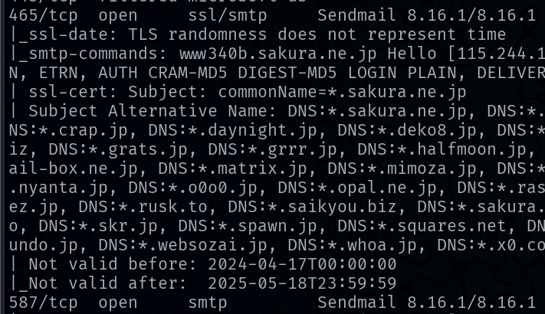

**Potential Business Impact**:

Exploitation of these vulnerabilities can lead to:

* Unauthorized access to sensitive email communications.
* Disruption of email services, potentially causing downtime and operational issues.
* Exposure of internal network information, which could facilitate further attacks.
* Damage to the organization’s reputation and potential financial loss.

**CVSS 3.1 Score**



**CVE IDs:**

• CVE-2016-10009 • CVE-2016-10010

**Affected Host**:

• 219.94.189.215:465 • 219.94.189.215:587

**Exploitation Details**:

Attackers can remotely exploit the vulnerabilities in the outdated Sendmail version by sending specially crafted requests to the mail service. Successful exploitation might allow the attacker to intercept email traffic or gain access to the mail server’s functionality, potentially using this as a foothold for additional network attacks

**Recommended Remediation**:

* **Upgrade Sendmail:** Immediately update the Sendmail software to a version that has patched CVE-2016-10009 and CVE-2016-10010.
* **Harden Configuration:** Review and secure Sendmail configurations to minimize exposure, ensuring that only necessary functionalities are enabled.
* **Restrict Access:** Limit access to the mail service using firewalls or IP whitelisting, ensuring that only trusted systems can communicate with the server.
* **Monitor Activity:** Implement logging and continuous monitoring of mail server activity to detect and respond to any unauthorized access attempts.

**References**:

<https://nvd.nist.gov/vuln/detail/CVE-2016-10009>

<https://nvd.nist.gov/vuln/detail/CVE-2016-10010>

### Low Risk

* + 1. **ASP.NET Framework Disclosure  
       Threat Level**: **Low (3.7)**

**Description**:

The ASP.NET framework on the affected server appears to be disclosing sensitive information, potentially revealing internal configuration details, error messages, or other system data that should remain confidential. This misconfiguration can facilitate information gathering by attackers, aiding in further targeted exploitation. Although no CVE ID is associated with this vulnerability, the risk is rated low (CVSS Score 3.7) due to its limited direct impact, but it can still weaken the overall security posture if combined with other vulnerabilities.



**Potential Business Impact**:

Exploitation of this vulnerability may lead to:

* Disclosure of internal server details (e.g., configuration settings, error messages).
* Enhanced reconnaissance capabilities for attackers, potentially aiding in the identification of additional vulnerabilities.
* A reduction in overall security posture that might contribute to more severe future attacks.

**CVSS 3.1 Score**

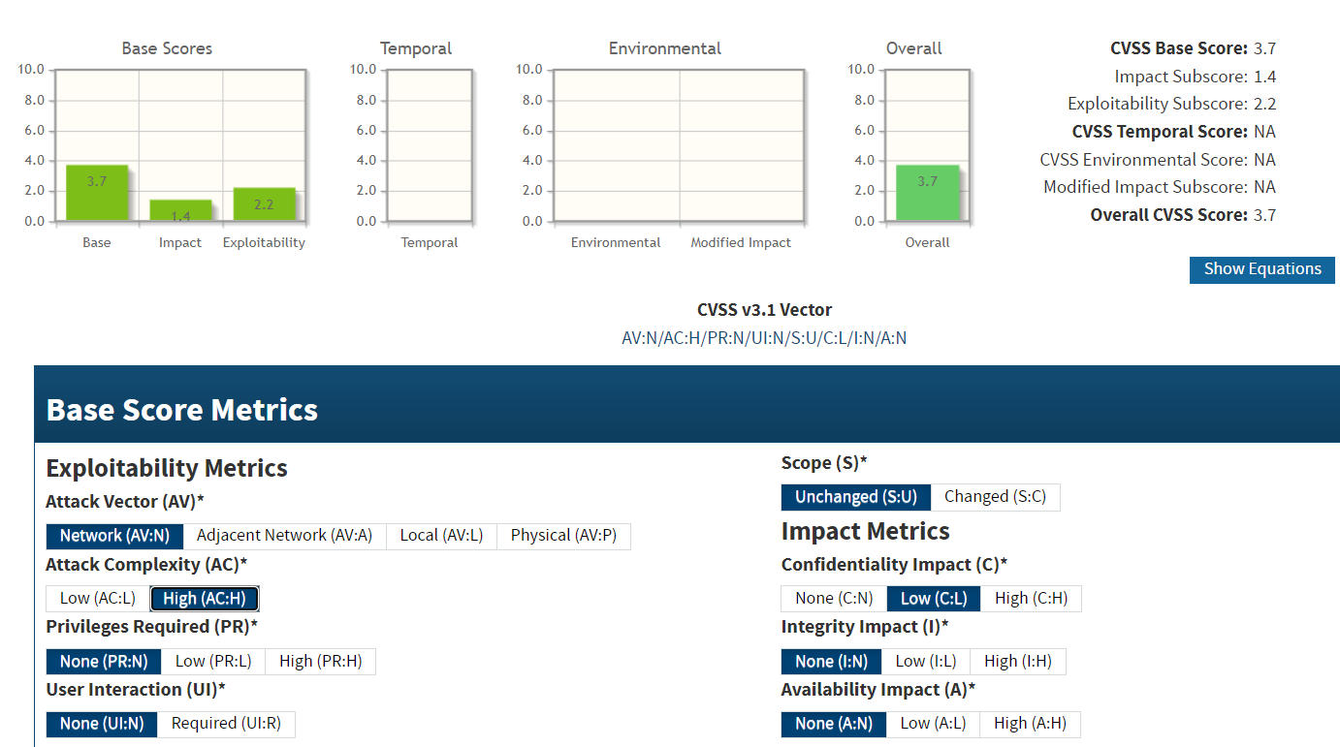

**CVE IDs:**

• N/A

**Affected Host**:

• 47.241.101.3:83

**Exploitation Details**:

An attacker could trigger the ASP.NET information disclosure by sending specially crafted requests that force the application to return detailed error messages or system information. This data could then be used to plan further attacks or uncover additional vulnerabilities in the system.

**Recommended Remediation**:

* **Configure Custom Error Pages:** Implement custom error handling to prevent sensitive information from being disclosed in error messages.
* **Disable Detailed Error Reporting:** Ensure that detailed error messages are turned off in production environments.
* **Review Application Settings:** Audit the application configuration to remove or mask any sensitive data that might be inadvertently exposed.
* **Regular Security Audits:** Conduct periodic security assessments to detect and remediate information disclosure vulnerabilities.

**References**:

<https://portswigger.net/web-security/information-disclosure>

<https://learn.microsoft.com/en-us/aspnet/core/security/?view=aspnetcore-6.0>

* + 1. **DNS Blacklist Issues  
       Threat Level**: **Low (3.7)**

**Description**:

The affected systems are experiencing issues with their DNS blacklist configuration. This may involve misconfigured or outdated blacklist entries, leading to inadequate filtering of malicious domains or erroneous blocking of legitimate ones. Although this vulnerability does not directly allow code execution or data loss, it weakens the overall security posture by potentially permitting harmful traffic or causing unnecessary service disruptions when legitimate domains are blocked.

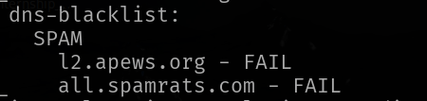

**Potential Business Impact**:

* Inadequate filtering may allow access to malicious domains, increasing the risk of phishing, malware distribution, or other cyberattacks.
* Erroneous blocking of legitimate domains can disrupt business operations and degrade user experience.
* Overall, the misconfiguration contributes to a weaker security posture by undermining trust in DNS-based threat mitigation measures.

**CVSS 3.1 Score**

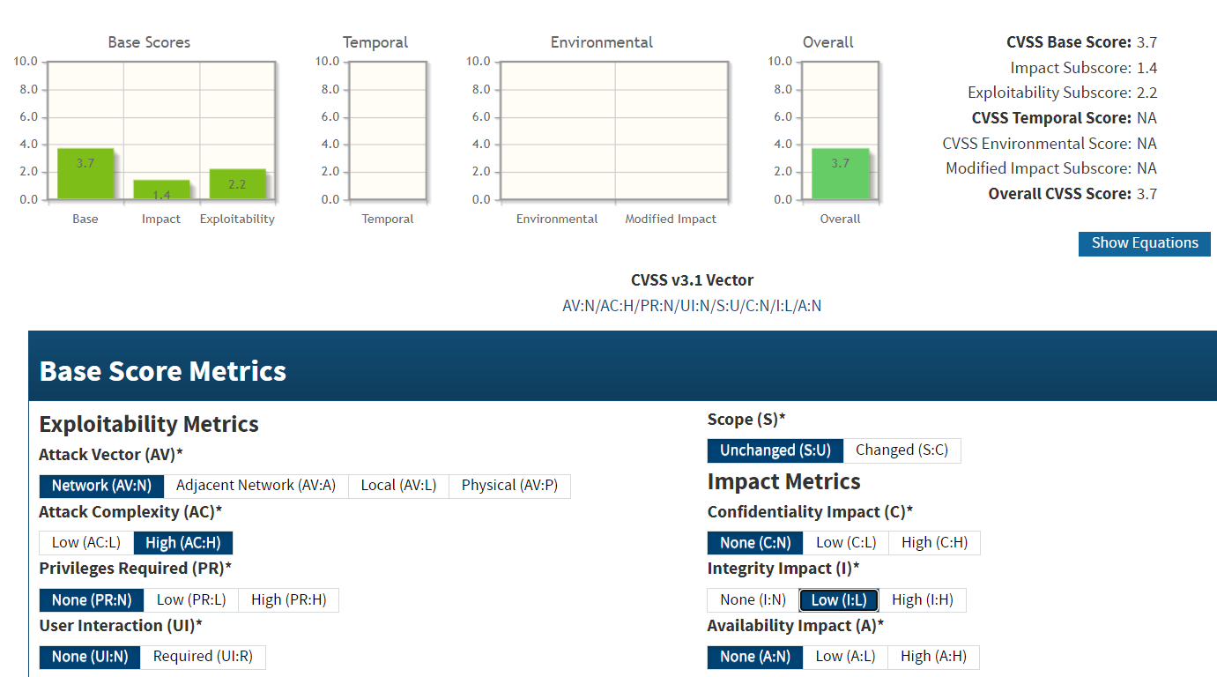

**CVE IDs:**

• N/A

**Affected Host**:

• 47.241.101.3 • 191.82.121.191 • 124.117.225.66

**Exploitation Details**:

Attackers may exploit this misconfiguration by taking advantage of the inadequate blacklist filtering to route malicious traffic or evade detection. Although this does not typically lead to immediate compromise, it can facilitate further attacks by providing adversaries with a less secure environment to operate within.

**Recommended Remediation**:

* **Review and Update DNS Blacklist:** Ensure that the DNS blacklist is current, accurately maintained, and properly configured to filter out malicious domains while minimizing false positives.
* **Implement Redundancy:** Use multiple reputable threat intelligence feeds to cross-verify and enhance blacklist accuracy.
* **Monitor DNS Traffic:** Regularly audit DNS query logs and network traffic to identify any anomalies or bypass attempts that could indicate a failure in the blacklist system.
* **Periodic Security Audits:** Conduct routine assessments of the DNS security configuration to ensure compliance with best practices and to promptly address any misconfigurations.

**References**:

<https://en.wikipedia.org/wiki/DNS-based_Authentication_of_Named_Entities>

<https://owasp.org/www-project-domain-protect/>

* + 1. **No OCSP Stapling  
       Threat Level**: **Low (3.7)**

**Description**:

The affected systems are not configured to support OCSP stapling, which is a mechanism that allows a server to include certificate revocation status information during the TLS handshake. Without OCSP stapling, clients must individually contact the certificate authority to verify the revocation status of the server's certificate. This can lead to delays or failures in revocation checking and may force clients to rely on outdated revocation information. Although the absence of OCSP stapling does not directly allow an attacker to decrypt communications, it weakens the overall security of the TLS connection and can increase the risk of man-in-the-middle (MITM) attacks if revocation status is not properly verified.



**Potential Business Impact**:

* Clients may rely on outdated or incomplete certificate revocation data, increasing the risk of accepting a compromised certificate.
* In scenarios where an attacker has compromised a certificate, the lack of immediate revocation status can enable man-in-the-middle attacks.
* Overall trust in the secure communication channel is reduced, which may affect compliance and user confidence.

**CVSS 3.1 Score**

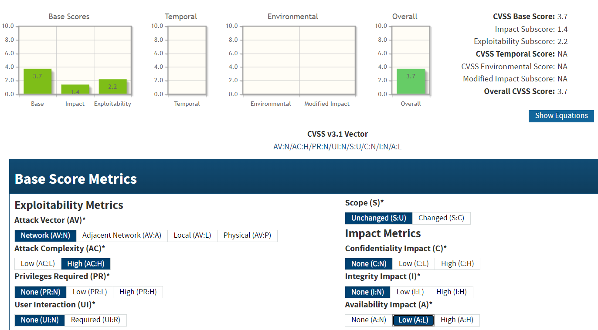

**CVE IDs:**

• N/A

**Affected Host**:

•67.20.124.65:443 •67.20.124.65:2087 •67.20.124.65:2083

•67.20.124.65:2096 •124.117.225.66:44333 •124.117.225.66:44344 •185.146.86.135:443 •185.146.86.135:2096 •103.56.148.203:443 •47.108.37.191:443 •185.216.120.11:443 •185.216.120.11:5001

•187.251.108.186:3389 • 184.74.137.227 •219.94.189.215:443

• 5.135.137.222:443

**Exploitation Details**:

Without OCSP stapling, each client must independently query the certificate authority to determine whether a certificate has been revoked. If these queries fail or are intercepted, the client might accept an invalid certificate. While this misconfiguration does not enable direct exploitation, it degrades the security of TLS sessions by making revocation checking less reliable.

**Recommended Remediation**:

* **Enable OCSP Stapling:** Configure the server to support OCSP stapling so that certificate revocation information is included during the TLS handshake.
* **Ensure Proper Certificate Management:** Regularly update and verify that the certificate chain and revocation mechanisms are functioning as expected.
* **Audit TLS Configurations:** Periodically review the TLS settings to ensure they comply with modern security best practices and standards.

**References**:

<https://csrc.nist.gov/pubs/sp/800/52/r2/final>

<https://cheatsheetseries.owasp.org/cheatsheets/Transport_Layer_Security_Cheat_Sheet.html>

<https://www.rfc-editor.org/rfc/rfc7507>

* + 1. **BREACH Vulnerability  
       Threat Level**: **Low (3.7)**

**Description**:

BREACH (Browser Reconnaissance and Exfiltration via Adaptive Compression of Hypertext) is a vulnerability that exploits HTTP response compression to leak sensitive information. By carefully observing the size of compressed responses, an attacker can infer secret data, such as tokens or session identifiers, if certain conditions are met. While the vulnerability requires specific conditions (e.g., the use of HTTP compression and attacker-controlled input), its presence can weaken the overall security posture of the affected services.



**Potential Business Impact**:

Exploitation of BREACH may lead to:

* Disclosure of confidential data (e.g., CSRF tokens, session cookies) through analysis of compressed responses.
* Increased risk of further attacks as leaked information can be used to bypass security controls.
* A reduction in overall trust in the security of the affected web services.

**CVSS 3.1 Score**

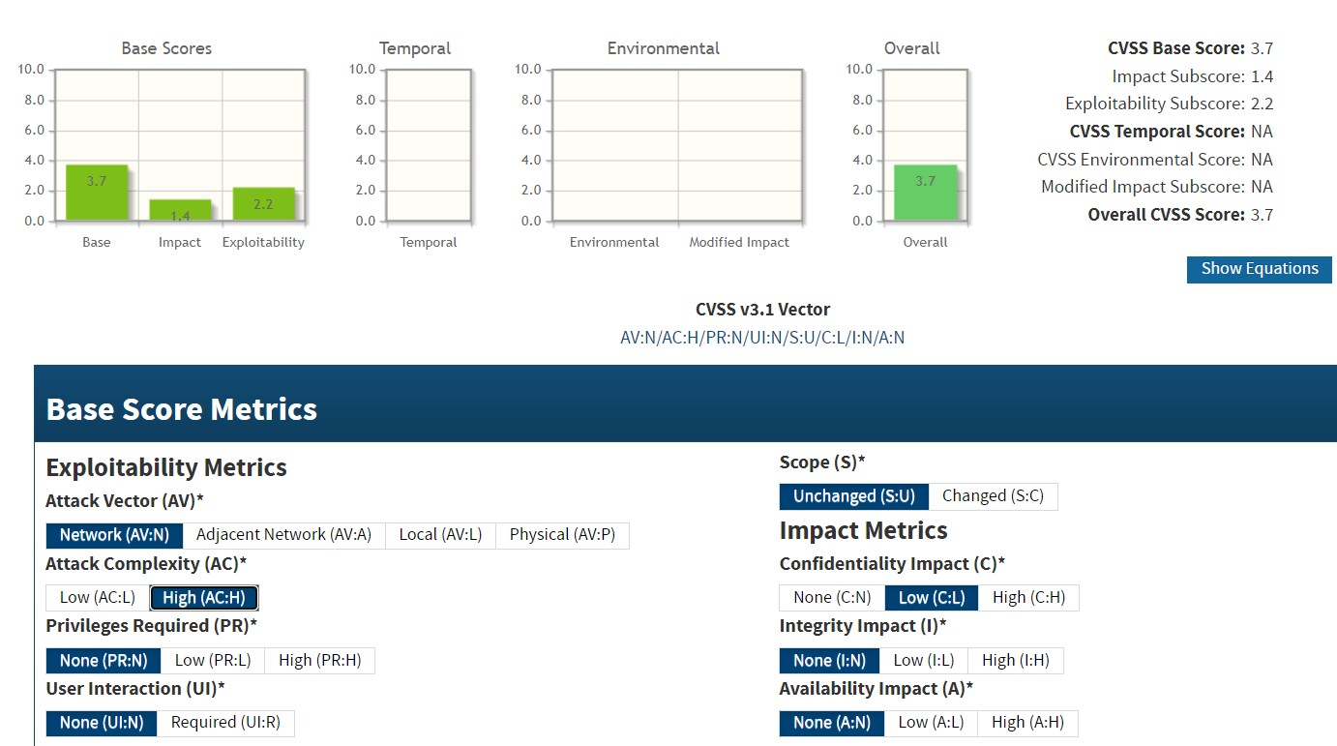

**CVE IDs:**

• CVE-2013-3587

**Affected Host**:

• 67.20.124.65:2087 • 67.20.124.65:2083 • 67.20.124.65:2096 • 20.239.145.15:443 • 142.132.207.118:443

**Exploitation Details**:

An attacker who can observe the size variations of compressed HTTP responses may be able to perform a BREACH attack by injecting attacker-controlled data into the response and analyzing the resulting changes in compression size. This side-channel can be exploited to reveal sensitive information, even when the communication is secured via TLS.

**Recommended Remediation**:

* **Disable or Limit Compression:** For pages containing sensitive data, disable HTTP compression or apply selective compression controls.
* **Apply Response Padding:** Introduce random padding to responses to obscure the true length of the data.
* **Separate Secrets:** Avoid mixing secret tokens with user-controlled input in HTTP responses to reduce the potential for leakage.
* **Regularly Audit and Monitor:** Use security tools to monitor for unusual response size patterns that may indicate an ongoing BREACH attack.

**References**:

<https://owasp.org/blog/2024/03/29/OWASP-data-breach-notification>

<https://nvd.nist.gov/vuln/detail/CVE-2013-3587>

* + 1. **Long Certificate Validity Period  
       Threat Level**: **Low (6.5)**

**Description**:

The affected systems are using SSL/TLS certificates with an extended validity period that exceeds industry-recommended durations. Extended certificate validity increases the risk that compromised keys remain active for a prolonged period, thereby extending the window of opportunity for potential misuse. Modern best practices recommend shorter validity periods (typically no more than 398 days) to ensure regular updates to cryptographic standards and timely revocation if a compromise occurs.



**Potential Business Impact**:

* Increased risk of prolonged exposure if a private key is compromised, as the certificate remains valid for an extended period.
* Use of outdated cryptographic standards over time, reducing overall security.
* Potential non-compliance with industry guidelines and regulatory requirements, which mandate shorter certificate lifetimes.

**CVSS 3.1 Score**



**CVE IDs:**

• N/A

**Affected Host**:

•124.117.225.66:44344 •184.74.137.227 •2.74.193.188:9001 •142.132.207.118:8006

**Exploitation Details**:

While a long validity period does not directly enable remote code execution or data breaches, it extends the period during which a compromised certificate remains active. This increases the likelihood that attackers can leverage a stolen or otherwise compromised certificate to decrypt communications or impersonate the server.

**Recommended Remediation**:

* **Shorten Validity Period:** Reissue SSL/TLS certificates with a validity period that conforms to current industry standards (e.g., no more than 398 days).
* **Implement Regular Certificate Rotation:** Establish a process for periodic certificate renewal to ensure that outdated cryptographic practices are not used.
* **Update Certificate Policies:** Align organizational certificate issuance policies with modern best practices and regulatory requirements.
* **Monitor Compliance:** Regularly audit certificate configurations to verify adherence to recommended validity durations.

**References**:

<https://wiki.mozilla.org/index.php?title=CA:CertPolicy&redirect=no>

<https://github.com/google/certificate-transparency>

<https://cabforum.org/working-groups/server/baseline-requirements/>

* + 1. **TLS 1.3 Not Supported  
       Threat Level**: **Low (3.1)**

**Description**:

The affected servers do not support TLS 1.3, meaning they are limited to older versions such as TLS 1.2 and below. While TLS 1.2 remains secure when properly configured, TLS 1.3 introduces several improvements in performance and security, including simplified handshake mechanisms and enhanced protection against certain attacks. The absence of TLS 1.3 support indicates that the systems have not been updated to the latest TLS standards, which may suggest a generally outdated security posture. Although the risk is assessed as low (CVSS 3.1 score of 3.1), it is recommended to upgrade to TLS 1.3 where possible to benefit from its advanced security features.



**Potential Business Impact**:

* Limited protection against emerging cryptographic attacks that TLS 1.3 mitigates.
* Possible perception of an outdated security posture, which might affect compliance and customer confidence.
* While TLS 1.2 is still acceptable if configured correctly, the lack of TLS 1.3 may prevent the use of the latest performance and security enhancements.

**CVSS 3.1 Score**

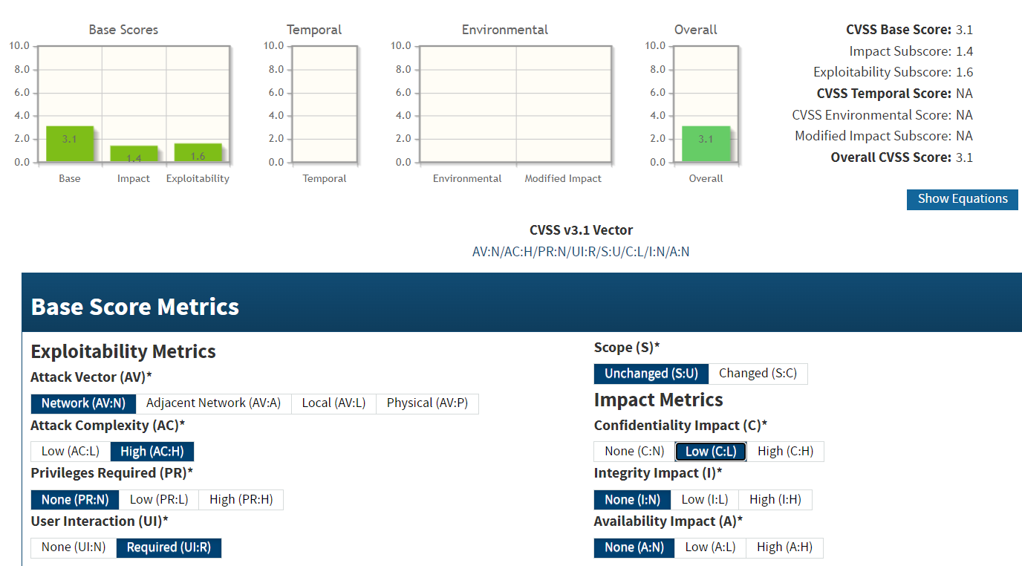

**CVE IDs:**

• N/A

**Affected Host**:

• 67.20.124.65:2087 • 67.20.124.65:2096 • 185.146.86.135:2096 • 184.74.137.227

**Exploitation Details**:

There is no direct exploitation vector solely due to the absence of TLS 1.3; however, systems that do not support the latest protocols may indicate a broader issue of outdated security configurations. This can make it more challenging to defend against new attack vectors that target older protocol implementations.

**Recommended Remediation**:

* **Enable TLS 1.3:** Update the server software and cryptographic libraries to support TLS 1.3, taking advantage of its improved security and performance features.
* **Review TLS Configuration:** Audit and update the TLS settings to ensure that the server uses modern, secure protocols and cipher suites.
* **Monitor Security Updates:** Stay informed about the latest security recommendations and apply patches promptly to maintain a robust security posture.

**References**:

<https://datatracker.ietf.org/doc/html/rfc8446>

<https://cheatsheetseries.owasp.org/cheatsheets/Transport_Layer_Security_Cheat_Sheet.html>

<https://developer.mozilla.org/en-US/docs/Web/Security>

* + 1. **DNS Service Information Disclosure  
       Threat Level**: **Low (3.7)**

**Description**:

The DNS server on the affected host is disclosing sensitive information due to misconfiguration. When DNS services are improperly configured, they can leak details such as zone data, version information, and other internal configuration parameters. Although this vulnerability does not directly lead to code execution or immediate data breaches, it facilitates reconnaissance by attackers, potentially enabling further targeted attacks against the infrastructure.

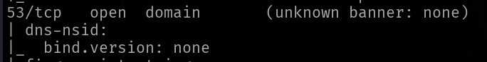

**Potential Business Impact**:

Exploitation may lead to:

* Enhanced reconnaissance capabilities for attackers by revealing DNS server details (e.g., software version and zone data).
* Assistance in identifying additional vulnerabilities or misconfigurations within the network.
* Indirect exposure of sensitive information, increasing the overall risk profile of the environment.

**CVSS 3.1 Score**



**CVE IDs:**

• N/A

**Affected Host**:

• 185.146.86.135:53

**Exploitation Details**:

Attackers can leverage misconfigured DNS servers by querying for information (such as version.bind queries in the CHAOS class) that reveals sensitive internal details. While this issue alone may not cause immediate harm, the disclosed data can be used to plan more sophisticated attacks against the network.

**Recommended Remediation**:

* **Restrict Information Disclosure:** Configure the DNS server to limit responses to unauthorized queries and disable unnecessary informational responses.
* **Disable Version Queries:** Prevent the server from answering version.bind or similar queries that reveal the DNS software version and other internal details.
* **Monitor DNS Traffic:** Regularly audit DNS logs for unusual query patterns that may indicate probing for internal information.
* **Adopt Best Practices:** Follow security best practices and vendor guidelines to minimize the amount of sensitive information exposed through DNS responses.

**References**:

<https://kb.isc.org/docs/bind-best-practices-authoritative>

<https://owasp.org/www-project-domain-protect/>

<https://www.icann.org/en/ssac/publications/details/icann-dns-security-update-04-01-2002-en>

* + 1. **ALPN/HTTP2 Not Offered  
       Threat Level**: **Low (3.7)**

**Description**:

The affected server does not support ALPN (Application-Layer Protocol Negotiation), preventing it from offering HTTP/2. Although the lack of HTTP/2 support does not directly expose the server to critical attacks, it indicates that the server may be using an outdated or suboptimal TLS configuration. This can lead to reduced performance and less efficient use of network resources, as clients are forced to fall back to older protocols.

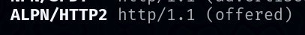

**Potential Business Impact**:

Exploitation may lead to:

* Clients may experience slower connection speeds and increased latency due to the fallback to older protocols.
* The absence of HTTP/2 support may reflect a broader lack of modernization in the server’s TLS configuration.
* While the risk of direct exploitation is low, the use of outdated protocols may indirectly expose the system to additional vulnerabilities.

**CVSS 3.1 Score**

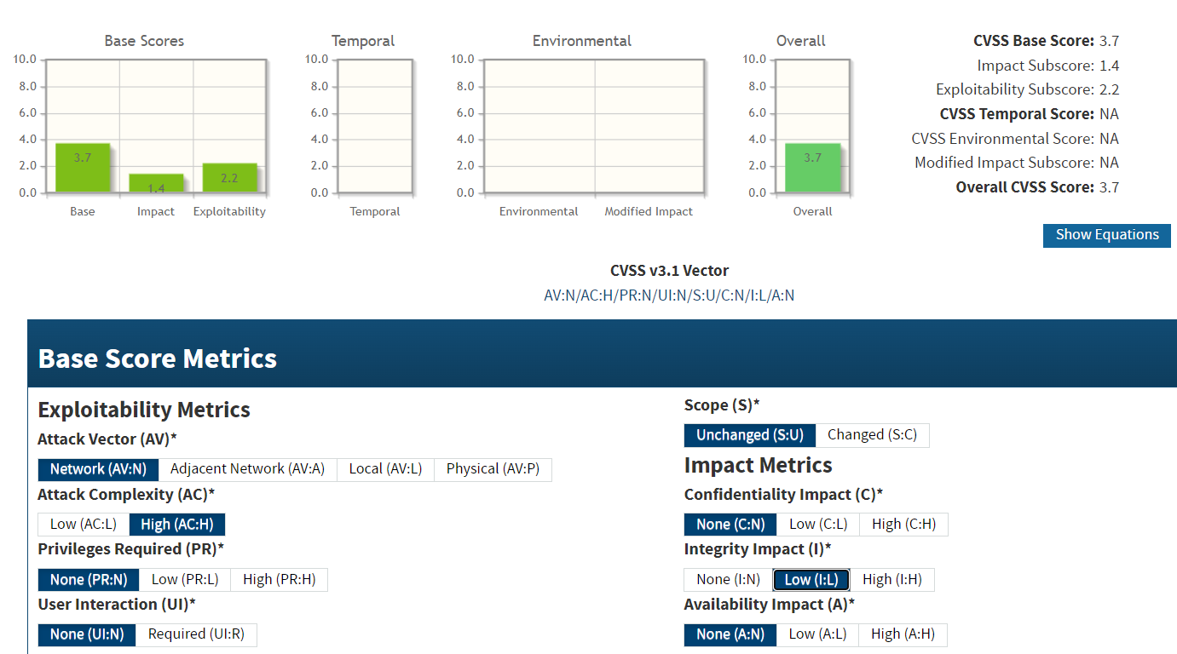

**CVE IDs:**

• N/A

**Affected Host**:

• 47.108.37.191:443

**Exploitation Details**:

There is no direct exploitation mechanism solely due to the lack of ALPN support. However, this limitation forces clients to use older protocols, which might not benefit from the performance and security enhancements provided by HTTP/2. This could potentially lead to a suboptimal user experience and, in combination with other misconfigurations, may increase the overall risk profile.

**Recommended Remediation**:

* **Enable ALPN Support:** Upgrade or reconfigure the web server and TLS libraries to support ALPN, allowing negotiation of HTTP/2.
* **Modernize TLS Configuration:** Ensure the server supports current TLS versions and secure cipher suites to enhance overall security and performance.
* **Regular Auditing:** Periodically review the server’s TLS and protocol configurations to align with modern security best practices.

**References**:

<https://datatracker.ietf.org/doc/html/rfc7301>

<https://datatracker.ietf.org/doc/html/rfc7540>

<https://cheatsheetseries.owasp.org/cheatsheets/Transport_Layer_Security_Cheat_Sheet.html>

* + 1. **Cross-Domain Policy File Vulnerability  
       Threat Level**: **Low (3.7)**

**Description**:

The affected server is exposing a cross-domain policy file that is misconfigured or overly permissive. Such a file governs the domains that are allowed to access resources hosted on the server (commonly used for Adobe Flash and similar applications). An improperly configured policy can permit unauthorized domains to interact with sensitive data or services, bypassing the same-origin policy. Although this vulnerability is rated low (3.7), it can facilitate additional attacks such as cross-site scripting or data exfiltration if exploited in combination with other vulnerabilities..



**Potential Business Impact**:

* Unauthorized cross-domain access to resources, potentially exposing sensitive data.
* Increased risk of secondary attacks (e.g., cross-site scripting or data exfiltration) by malicious domains.
* Erosion of the trust model inherent in the same-origin policy, which could lead to broader security weaknesses.

**CVSS 3.1 Score**

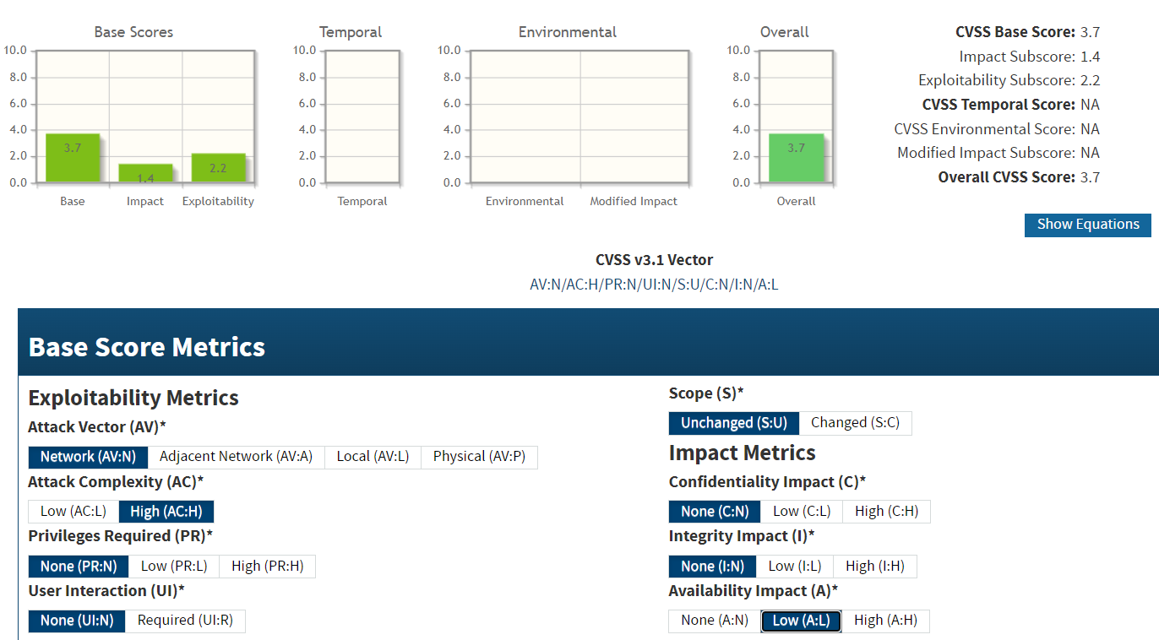

**CVE IDs:**

• N/A

**Affected Host**:

• 185.216.120.11:483

**Exploitation Details**:

Attackers can exploit this vulnerability by hosting a malicious domain that takes advantage of the permissive policy, thereby gaining access to resources or sensitive data that would normally be restricted by the same-origin policy.

**Recommended Remediation**:

* **Review and Harden the Policy File:** Ensure the cross-domain policy file only allows access from explicitly trusted domains and restricts permissions to the minimum necessary.
* **Disable Unnecessary Access:** If cross-domain requests are not required, consider disabling the policy file entirely or configuring it to deny access by default.
* **Regular Auditing:** Periodically review the cross-domain policy settings and test them to ensure they conform to current security best practices.

**References**:

<https://docs.digicert.com/en/certcentral/certificate-tools/discovery-user-guide/tls-ssl-endpoint-vulnerabilities/cross-domain-policy.html>

<https://enterprise.arcgis.com/en/web-adaptor/10.3/install/iis/about-cross-domain-policy-files.htm>

* + 1. **Jetty Server Version Disclosure  
       Threat Level**: **Low (3.7)**

**Description**:

The affected Jetty servers are disclosing version information via HTTP response headers and error messages. This information disclosure can provide attackers with precise details about the server's software version, enabling them to identify and exploit known vulnerabilities associated with that version. Although the direct impact is low, the disclosed version data can be used as a stepping stone for more targeted attacks.



**Potential Business Impact**:

* Provides attackers with detailed version information, aiding in vulnerability research.
* May enable targeted exploitation if specific version-related vulnerabilities exist.
* Contributes to an overall weaker security posture when combined with other misconfigurations.

**CVSS 3.1 Score**



**CVE IDs:**

• N/A

**Affected Host**:

•144.217.240.87:4444 •51.79.65.16:4444 •198.245.53.101:4444 •149.56.129.34:4444

**Exploitation Details**:

Attackers can simply review HTTP response headers or error pages to extract the Jetty version. This information can then be used to search for and exploit known vulnerabilities specific to that version, although the immediate risk is considered low.

**Recommended Remediation**:

* **Suppress Version Information:** Configure Jetty to hide version details in HTTP headers (e.g., modify the Server header) and error responses.
* **Implement Generic Banners:** Use generic, non-descriptive banners for server responses to avoid revealing internal software details.
* **Regular Auditing:** Periodically audit server responses with security scanning tools to ensure that version information is not being inadvertently disclosed.

**References**:

<https://developer.mozilla.org/en-US/docs/Web/HTTP/Headers>

<https://jetty.org/docs/>

<https://owasp.org/www-project-top-ten/2017/A3_2017-Sensitive_Data_Exposure>

## Conclusion

The tested public IP addresses host critical services that are essential for maintaining the operational excellence and reliability expected in modern infrastructure. The stability and integrity of these systems are vital to supporting the luxuries of contemporary life. The vulnerabilities outlined in this report are significant and must be remedied immediately. An attacker with the same level of access achieved during this engagement could potentially gain direct control over these systems, leading to severe operational disruption, financial penalties, and reputational damage. Sure Trust, the organization that conducted this penetration test as part of our internship project, looks forward to partnering with the client to remediate these vulnerabilities and continually enhance the overall security posture.

**References**

1. *PCI Compliance Fees, Fines, and Penalties: What Happens After a Breach?* Apr. 2020.

url: <https://www.lbmc.com/blog/pci-compliance-fees-fines-penalties/>.

1. *Main Page*. url: <http://www.pentest-standard.org/index.php/Main_Page>.
2. *Mitre ATT&CK®*. url: <https://attack.mitre.org/>.
3. *Introduction*. url: <https://owasp.org/Top10/>.
4. Joint Task Force. *Security and Privacy Controls for Information Systems and Organi- zations*. Dec. 2020. url: [https://csrc.nist.gov/publications/detail/sp/800-53](https://csrc.nist.gov/publications/detail/sp/800-53/rev-5/final)

[/rev-5/final](https://csrc.nist.gov/publications/detail/sp/800-53/rev-5/final).

1. Forum of Incident Response and Inc Security Teams. *CVSS v3.1 Specification Document*.

<https://www.first.org/cvss/v3.1/specification-document>. 2019.

1. National Institute of Standards and Technology. *Common Vulnerability Scoring System Calculator*. <https://nvd.nist.gov/vuln-metrics/cvss/v3-calculator>.
2. *Financial Affairs*. url: [https://financial.ucsc.edu/pages/security_penalties](https://financial.ucsc.edu/pages/security_penalties.aspx)

[.aspx](https://financial.ucsc.edu/pages/security_penalties.aspx).

## Tools

|  |  |  |
| --- | --- | --- |
| **Name** | **Description** | **Link** |
| Nmap | Network and vulnerability scanner | <https://nmap.org/> |
| Metasploit | Exploitation framework | [https://github.com/rapid7/metasplo](https://github.com/rapid7/metasploit-framework) [it-framework](https://github.com/rapid7/metasploit-framework) |
| DIRB | Directory Brute Force Tool | <https://github.com/v0re/dirb> |
| Gobuster | Directory Brute Force Tool | <https://github.com/OJ/gobuster> |
| Meterpreter | Reverse Shell | [https://github.com/rapid7/meterpre](https://github.com/rapid7/meterpreter) [ter](https://github.com/rapid7/meterpreter) |
| hydra | Brute Forcing tool | [https://github.com/vanhauser-thc/t](https://github.com/vanhauser-thc/thc-hydra) [hc-hydra](https://github.com/vanhauser-thc/thc-hydra) |
| Wireshark | Network traffic analyzer | <https://www.wireshark.org/> |
| Portswigger Burp Suite | Web traffic analysis tool | <https://portswigger.net/burp> |
| nikto | Vulnnerability Scanner | https://github.com/sullo/nikto |
| Testssl | TLS Scanner | https://github.com/testssl/testssl.sh |